On the Dominant Local Resolving Set of Vertex Amalgamation Graphs
Reni Umilasari^{1,2}, Liliek Susilowati^{1*}, Slamin³, Savari Prabhu⁴
^{1,2}Department of Mathematics, Airlangga University, Surabaya 60115, Indonesia
²Department of Informatics Engineering, University of Muhammadiyah Jember, Jember 69121 Indonesia
³Study Program of Informatics, University of Jember, Jember 68121 Indonesia
⁴Mathematics Department, Rajalakshmi Engineering College, Chennai 602105, Tamil Nadu, India
Email: reni.umilasari@unmuhjember.ac.id, liliek-s@fst.unair.ac.id, slamin@unej.ac.id, drsavariprabhu@gmail.com

Abstract
Basically, the new topic of the dominant local metric dimension which be symbolized by $Ddim_{l}(H)$ is a combination of two concepts in graph theory, they were called the local metric dimension and dominating set. There are some terms in this topic that is dominant local resolving set and dominant local basis. An ordered subset $W_{l}$ is said a dominant local resolving set of $G$ if $W_{l}$ is dominating set and also local resolving set of 𝐺. While dominant local basis is a dominant local resolving set with minimum cardinality. This study uses literature study method by observing the local metric dimension and dominating number before detecting the dominant local metric dimension of the graphs. After obtaining some new results, the purpose of this research is how the dominant local metric dimension of vertex amalgamation product graphs. Some special graphs that be used are star, friendship, complete graph and complete bipartite graph. Based on all observation results, it can be said that the dominant local metric dimension for any vertex amalgamation product graph depends on the dominant local metric dimension of the copied graphs and how the terminal vertex is constructed.
Keywords: dominant local metric dimension, vertex amalgamation, star, friendship, complete bipartite.

Introduction
Metric dimension and dominating set are graph topics with numerous variations. For metric dimensions, there are more than five development concepts, such as partition dimension, local metric dimension, complement metric dimension, central metric dimension, fractional metric dimension, and star metric dimension. More results about metric dimension and its expansion can be seen at [1] [2][3][4][5][6].
Let $G$ be a connected graph with vertex set $V(G)$ and edge set $E(G)$. The distance between any two $a$ and $b$ of $V(G)$ is denoted by $d(a,b)$. It be defined as shortest path from $a$ to $b$. The resolving set of $G$ is an ordered set which can be written as $W$, where $W=\{w_{1}, w_{2},…,w_{k}\}⊆V(G)$ and $r\left(v | W\right)=(d\left(v, w_{1}\right), d\left(v, w_{2}\right),…., d\left(v, w_{k}\right))$ is defined as representation of $v⊆V(G)$ to $W$ by using the concept of distance. The rule to select resolving set of $G$ is every vertex of $V(G)$ should have different representation to $W$. The minimum cardinality of $W$ is called the basis of $G$ [7]. The number of basis is referred to as the metric dimension because the concept of this topic is based on distance. Next, we introduce the differences between metric dimension and local metric dimension. In the metric dimension, all vertices must have different representations to the resolving set, whereas in the local metric dimension, only any two adjacent vertices must be different; a vertex can have the same representation as another not adjacent vertex [8]. In 2021, Umilasari et al introduced the new concept, which is a combination of dominating set and local metric dimension. They defined that an ordered subset $W_{l}$ is said a dominant local resolving set of $G$ if $W_{l}$ is dominating set and also local resolving set of 𝐺. For more clarity about this definition, you can see the illustration in Figure 1.
All the vertices in the graph of Figure 1 (a) can be dominated by $x_{4}$. But the vertices which adjacent $\{V\left(G\right)\backslash x_{4}\}$ have same representation to $x_{4}$. While $\{x_{2},x_{3}\}$ in Figure 1 (b) is a local resolving set. As can be seen, each pair of adjacent vertices has a different representation to $\left\{x_{2},x_{3}\right\}$. The problem is $x_{5}$ and $x_{6}$ cannot be dominated by $x_{2}$ or $x_{3}$. If we take two vertices like in Figure 1(c), $\{x_{2},x_{4}\}$ can dominate all vertices of the graph, the representation of any two vertices to $\{x_{2},x_{4}\}$ is different. Therefore, $\{x_{2},x_{4}\}$ are elements of a dominant local metric dimension of the graph.

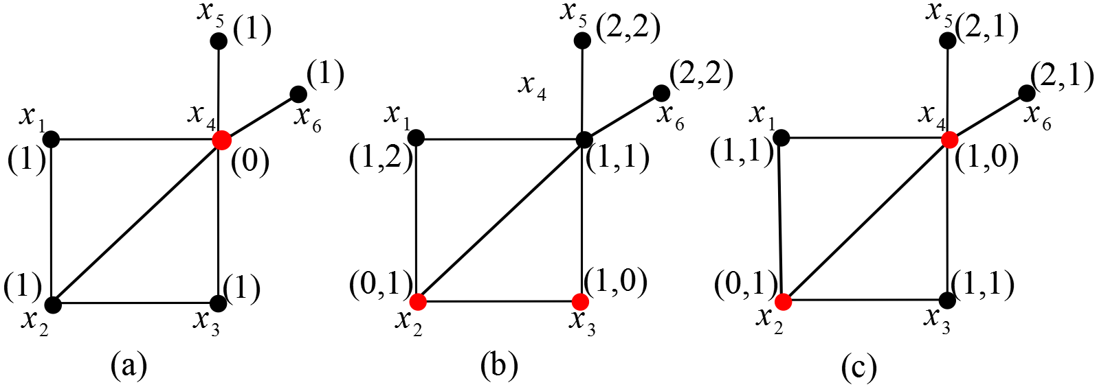
Figure 1. The Illustration of Dominant Local Metric Dimension of Graphs

After obtaining some new results, in this paper we continue to expand on how the dominant local metric dimension of a vertex amalgamation product graphs. The vertex amalgamation product of a graph $H$, denoted by $amal(H,v,k)$, is defined as creating a new graph by gluing $k$-copies of $H$ in a terminal vertex $v$ [9]. In this paper, we determine the dominant local metric dimension of the vertex amalgamation for some special graphs, which are star, complete graph, complete bipartite graph, and friendship graph. To make it easier to present each of the theorems produced, several theorems are given below, which can be seen in [10].

Lemma 1. Let $G$ be a connected graph. If there is no local dominant resolving set with cardinality $p$, then for every $S⊆V(G)$ with $\left|S\right|<p$ is not a local dominant resolving set.
Lemma 2. Let $G$ be a connected graph and $W_{l}⊆V\left(G\right)$. For every $v_{i},v_{j}∈W_{l}$ then $r\left(v_{i} | W_{l}\right)≠r\left(v_{j} | W_{l}\right)$.
Some new results about the dominant local metric dimension of star, complete graph, complete bipartite graph, and friendship graph are given in Table 1.

Table 1. Dominant Local Metric Dimension of Special Graphs [10][11][12]
Graphs | Dominating Number ($γ(G)$) | Local Metric Dimension  ($\dim_{l}{(G)}$) | Dominan Local Metric Dimension ($\dim_{l}{(G)}$)
Star ($S_{n}$) | $$γ \left(S_{n}\right)=1$$ | $$\dim_{l} \left(S_{n}\right)=1$$ | $${Ddim}_{l}{(S_{n})}=1$$
Complete ($K_{n}$) | $γ$ ($K_{n})=1$ | $\dim_{l}$ ($K_{n})=n-1$ | $${Ddim}_{l}{(K_{n})}=n-1$$
Complete Bipartite ($K_{m,n}$) | $$γ\left(K_{m,n}\right)=2$$ | $$\dim_{l}\left(K_{m,n}\right)=2$$ | $${Ddim}_{l}{(K_{m,n})}=2$$
Friendship ($F_{n}$) | $$γ\left(F_{n}\right)=1$$ | $$\dim_{l}\left(F_{n}\right)=n$$ | $${Ddim}_{l}\left(F_{n}\right)=n$$

Methods
In this research, there are several procedures. We start by determining the special graphs to be operated by the vertex amalgamation product and observing the local metric dimensions and dominating number of the graphs. Then, we construct the vertex amalgamation product graphs from the special graphs that we have chosen. We continue by labeling the vertex and attempting to find the least dominant local basis. This is accomplished by observing and recording the representation of each vertex which can be dominated and has different representation from the local resolving set (two non-neighbouring vertex can have the same representation). The minimum local dominant basis is then determined. In summary, the procedures of the research can be seen in the following flowchart in Figure 2. We also give some examples of each step below.
- Let $G=P_{4}$
- $\dim_{l}{(P_{4})}=1$ and $γ{(P_{4})}=2$ , it can be seen at [12]
- Let $\left|W_{l}\right|=1$, $W_{l}=\{v_{1}\}$
Illustration: | 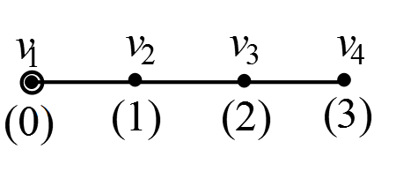

Based on the illustration above, $v_{1}$ can’t dominate $v_{3}$ and $v_{4}$. When we choose $W_{l}=\{v_{2}\}$, $W_{l}=\{v_{3}\}$, $W_{l}=\{v_{4}\}$ the condition remains the same. Minimally, there exist one vertex that can’t be dominated.
- Let $\left|W_{l}\right|=2$, $W_{l}=\{v_{1},v_{2}\}$
Illustration: | 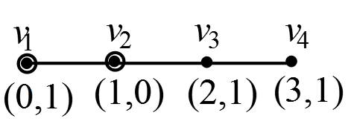

We can see that $v_{4}$ can’t be dominated by $v_{1}$ or $v_{2}$ .
- Let $\left|W_{l}\right|=2$, $W_{l}=\{v_{2},v_{3}\}$
Illustration: | 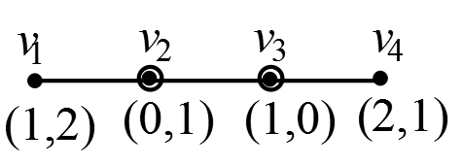
Since $∀v_{i}v_{j}∈E(P_{4})$, $r\left(v_{i} | W_{l}\right)≠r\left(v_{j} | W_{l}\right)$ then $W_{l}$ is basis local of $P_{4}$. All vertices of $V(P_{4})$ can be dominated by $v_{2}$ and $v_{3}$. Therefore, $W_{l}$ is dominant local basis of $P_{4}$ or $Ddim_{l}\left(P_{4}\right)=2$.
To more clearly understand this research method, we can see the flowchart in Figure 2.
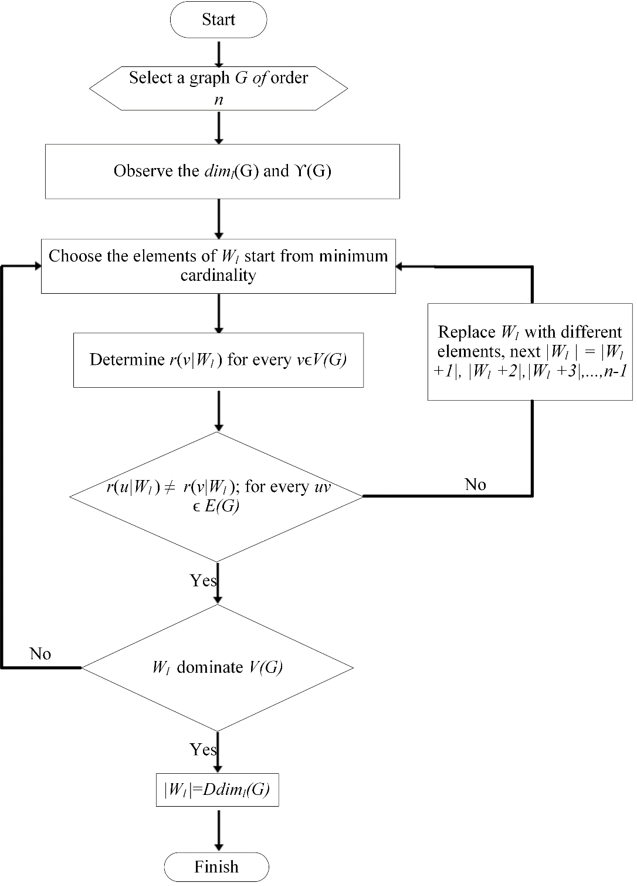
Figure 2. Flowchart for Determining the Dominant Local Metric Dimension of Graphs

Results and Discussion
In this section, we determine the dominant local metric dimension of the vertex amalgamation product for some special graphs, which are star, complete graph, complete bipartite graph, and friendship graph.
Theorem 1. Let $amal(S_{n},v,k)$ is a vertex amalgamation of star with the order of star is $n≥3$, then
$$Ddim_{l} (amal\left(S_{n},v,k\right))=\left\{\begin{aligned}1, v is center vertex of S_{n} \\ k, v is pendant of S_{n}\end{aligned}\right.$$
Proof.
Case 1. $v$ is center vertex of star
It is very clearly to see that $amal\left(S_{n},v,k\right)≅S_{n}$, then by the Table 1 we can conclude that $Ddim_{l} \left(amal\left(S_{n},v,k\right)\right)=1$. $∎$
Case 2. $v$ is pendant vertex of star
Let the vertex set of $amal\left(S_{n},v,k\right)$ is $V\left(amal\left(S_{n},v,k\right)\right)=\left\{{v,v_{j},u}_{1j}{,u}_{2j},…,u_{ij} | v,u_{i}∈V\left(S_{n}\right),i=1,2,…,n-2,j=1,2,…,k\right\}$ and the edge set is $E\left(amal\left(S_{n},v,k\right)\right)=\left\{{vv_{j},v}_{j}u_{ij} | i=1,2,3,…,n-2,j=1,2,3,…,k\right\}$. Choose $W_{l}=\{v_{j}\}$ is the local basis of $amal\left(S_{n},v,k\right)$ for every $j=1,2,3,…,k$, $\left|W_{l}\right|=k$. We can show below that the representation of every two adjacent vertices of $V(amal\left(S_{n},v,k\right))$ is different.
- For $u_{ij}v_{j}∈E\left(amal\left(S_{n},v,k\right)\right)$
Since $v_{j}$ is element of $W_{l}$, then there exist $0$ on $i$^{th} element in $r\left(v_{j} | W_{l}\right)$, while for $r\left(u_{ij} | W_{l}\right)$ there are no zero elements, hence $r\left(v_{j} | W_{l}\right)≠r\left(u_{ij} | W_{l}\right)$.
- For $vv_{j}∈E\left(amal\left(S_{n},v,k\right)\right)$
Since $v_{j}$ is element of $W_{l}$, then there exist $0$ on $i$^{th} element in $r\left(v_{j} | W_{l}\right)$, while for $r\left(v | W_{l}\right)$ there are no zero elements, hence $r\left(v_{j} | W_{l}\right)≠r\left(v | W_{l}\right)$.
By i and ii therefore $W_{l}$ is a local resolving set of $amal\left(S_{n},v,k\right)$. Further, because $v_{j}$ is adjacent to $v$ and $u_{ij}$, so we can said that $W_{l}$ is a dominant local resolving set of $amal\left(S_{n},v,k\right)$. Next, take any $S⊆V(amal\left(S_{n},v,k\right))$ with $\left|S\right|<\left|W_{l}\right|$. Without loss of generality, let $\left|S\right|=\left|W_{l}\right|-1$ with $W_{l}=\{v_{j}|j=1,2,3,…,k-1\}$, so $u_{ik}$ are not adjacent to $S$. So $S$ is not a dominant local resolving set of $amal\left(S_{n},v,k\right)$. Based on Lemma 1, any set $T$ with $\left|T\right|<\left|S\right|$ is not a dominant local resolving set of $G$. Therefore, $W_{l}=\{v_{j}\}$ is a dominant local basis of $amal\left(S_{n},v,k\right)$. Then its is proven that $Ddim_{l}\left(amal\left(S_{n},v,k\right)\right)=k$ for $v i$s pendant vertex of star of $S_{n}$. $∎$
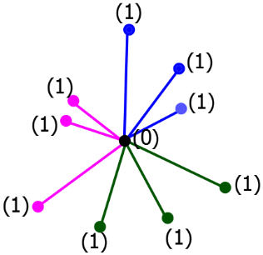
Figure 3. $Ddim_{l}\left(amal\left(S_{4},v,3\right)\right)=1$.

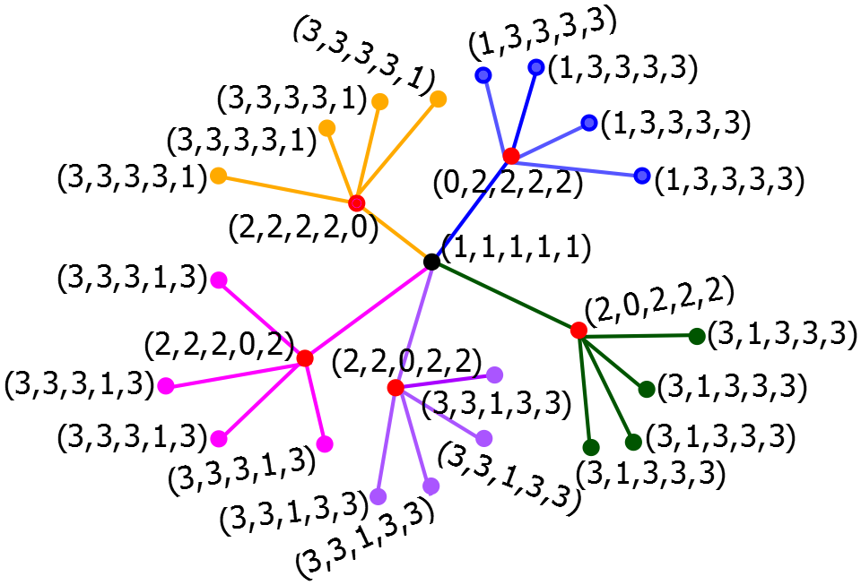
Figure 4. $Ddim_{l}\left(amal\left(S_{6},v,5\right)\right)=5$.

Figure 3 gives the illustration of dominant local metric dimension of $amal\left(S_{n},v,k\right)$ for $v$ is the center vertex of $S_{n}$. While in Figure 4, $v$ is the pendant of Star. The next theorem, we will show the dominan local metric dimension of complete graph. Because the graphs are regular, then we can select any vertex of complete graph as the linkage vertex.

Theorem 2. Let $amal\left(K_{n},v,p\right)$ is a vertex amalgamation of complete graph with the order of complete graph is $n≥3$, then $Ddim_{l} \left(amal\left(K_{n},v,p\right)\right)=p×(Ddim_{l}\left(K_{n}\right)-1)$.

Proof. Let $V\left(amal\left(K_{n},v,p\right)\right)=\left\{v,v_{ij} | i=1,2,3,…,n-1,j=1,2,3,…,p\right\}$ and the edge set of $amal\left(K_{n},v,p\right)$ is $E\left(amal\left(K_{n},v,p\right)\right)=\left\{{vv_{ij},v}_{xj}v_{yj} | i=1,2,3,…,n-1,j=1,2,3,…,p,v_{x}v_{y}∈E\left(K_{n}\right),x≠y \right\}$. The $j$-th copy of $K_{n}$ with $j=1,2,3,…,p$ is called ${\left(K_{n}\right)}_{j}$. Let $B$ be a local dominant basis of $K_{n}$, $B_{j}$ is a local dominant basis of ${\left(K_{n}\right)}_{j}$, so that for every $j=1,2,3,…,p$, $\left|B_{i}\right|=\left|B\right|$. Select $W_{l}=\bigcup_{j=1}^{m}{B_{j}}$, with $B_{j}=\left\{v_{ij} | j=1,2,3,…,n-2\right\}$ for every $j=1,2,3,…,p$, then $\left|W_{l}\right|=p\left(n-2\right)$. By Lemma 2 for every $v_{ij}{,v}_{kl}∈B_{i}$ then $r\left(v_{ij} | W_{l}\right)≠r\left(v_{kl} | W_{l}\right)$. Next, we take any two adjacent vertices in $V\left(amal\left(K_{n},v,p\right)\right)\backslash W_{l}$. Let $x,y∈V\left(amal\left(K_{n},v,p\right)\right)\backslash W_{l}$, then for $xy=v{,v}_{nj}∈V\left(amal\left(K_{n},v,p\right)\right)\backslash W_{l}$ with $j=1,2,3,…,p$. Since $amal\left(K_{n},v,p\right)$ is a connected graph, $d\left(v_{nj},z\right)=d\left(v_{nj},v\right)+d(v,z)$for every $z∈B_{i}$ so that$d\left(z,v_{nj}\right)≠d\left(z,v\right)$ caused $r\left(v_{nj} | B_{i}\right)≠r\left(v | B_{i}\right)$. Because of $B_{i}⊆W_{l}$ then $r\left(v_{nj} | W_{l}\right)≠r\left(z | W_{l}\right)$.
Based on the explanation above, $W_{l}=\bigcup_{i=1}^{m}{B_{i}}$ is a local resolving set of $amal\left(K_{n},v,p\right)$. Since, every $v_{ij}∈W_{l}$ with $i=1,2,3,…,n-2$ and $j=1,2,3,…,p$ is adjacent to $v$and $v_{nj}$, then $W_{l}$ is a dominating set. So that, $W_{l}=\bigcup_{j=1}^{p}{B_{j}}$ is a local dominant resolving set of $amal\left(K_{n},v,p\right)$. Take any $S⊆V\left(G\right)$ with $\left|S\right|<\left|W_{l}\right|$. Let $\left|S\right|=\left|W_{l}\right|-1$, then there exists $j$ such as $S$ contains maximal $\left|B_{j}\right|-1$ elements of ${\left(K_{n}\right)}_{j}$. Since $B_{j}$ is a local dominant basis of ${\left(K_{n}\right)}_{j}$ then there exist two vertices in ${\left(K_{n}\right)}_{j}$ that have the same representation toward $S$, so that $S$ is not a local dominant resolving set of $amal\left(K_{n},v,p\right)$. Based on Lemma 1 then $W_{l}=\bigcup_{j=1}^{p}{B_{j}}$ is a local dominant basis of $amal\left(K_{n},v,p\right)$. By Table 1 we know that $\left|B_{i}\right|=Ddim_{l}\left({\left(K_{n}\right)}_{i}\right)-1$, then it has been proven that $Ddim_{l} \left(amal\left(K_{n},v,p\right)\right)=p×(Ddim_{l}\left(K_{n}\right)-1)$.$∎$
The example of dominant local metric dimension of vertex amalgamation complete graph be given in Figure 5. The graph show that $amal\left(K_{4},v,3\right)$ has the dominant local metric dimension equals six.

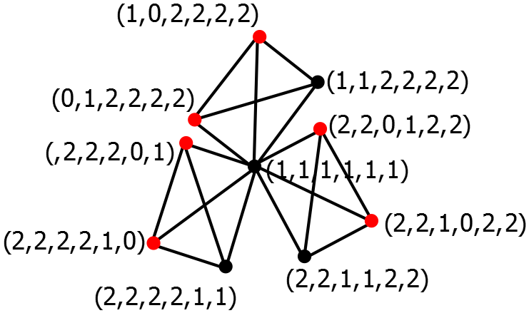
Figure 5. $Ddim_{l} \left(amal\left(K_{4},v,3\right)\right)=6$.

Theorem 3. Let $amal\left(K_{m,n},v,p\right)$ is a vertex amalgamation of complete bipartite graph with the order is $m,n≥2$, then $Ddim_{l} \left(amal\left(K_{m,n},v,p\right)\right)=p+1$.
Proof. Let the vertex set of $K_{m,n}$ is $V\left(K_{m,n}\right)=\left\{a_{i} | i=1,2,…,m\right\}∪\left\{b_{j} | j=1,2,…,n\right\}$, and the edge set is $E\left(K_{m,n}\right)=\left\{a_{i}b_{j} | i=1,2,…,m;j=1,2,…,n\right\}$. $V\left(amal\left(K_{m,n},v,p\right)\right)=\left\{{v,a_{ik},b}_{jk} | i=2,3,…,m,j=1,2,…,n,k=1,2,…,p\right\}$ and the edge set is $E\left(amal\left(K_{m,n},v,p\right)\right)=\{{vb}_{jk},{a_{ik}b}_{jk}|i=2,3,…,m,j=1,2,…,n,k=1,2,…,p\}$. Choose, $W_{l}=\{v,b_{1k}\}$ for every $k=1,2,3,…,p$, then $\left|W_{l}\right|=p+1$. We can show below that the representation of every two adjacent vertices of$V\left(amal\left(K_{m,n},v,p\right)\right)$ is different.
- For ${vb}_{jk}∈E\left(amal\left(K_{m,n},v,p\right)\right)$
Since $v$ is element of $W_{l}$, then there exist $0$ on $1^{st}$ element in $r\left(v | W_{l}\right)$, while for $r\left(b_{jk} | W_{l}\right)$ there are no zero elements except $b_{1k}$ the representation to $W_{l}$ is $r\left(b_{1k} | W_{l}\right)=(1,0)$, hence $r\left(v | W_{l}\right)≠r\left(b_{jk} | W_{l}\right)$.
- For ${a_{ik}b}_{jk}∈E\left(amal\left(K_{m,n},v,p\right)\right)$
Since for $i=2,3,…,m,j=1,2,…,n$, $d\left(a_{ik},v\right)=d\left(a_{ik},b_{jk}\right)+d\left(b_{jk},v\right)$ hence $r\left(a_{ik} | W_{l}\right)≠r\left(b_{jk} | W_{l}\right)$.
From the two explanations above we know that $W_{l}$ is the local resolving set of $amal\left(K_{m,n},v,p\right)$. Since $v$ is adjacent to $b_{jk}$ for $j=1,2,…,n$ and $k=1,2,…,p$. The vertex $b_{1k}$ is adjacent to $a_{ik}$ for $i=2,3,…,m$ and $k=1,2,…,p$, thus $W_{l}$ is dominant local resolving set of $amal\left(K_{m,n},v,p\right)$. Take any $S⊆V\left(G\right)$ with $\left|S\right|<\left|W_{l}\right|$. Let $\left|S\right|=\left|W_{l}\right|-1$ the two possibilities below:
- If $v∉W_{l}$
$v∉W_{l}$, then all vertices $b_{jk}$ with $j=2,3,…,n$ and $k=1,2,…,p$ cannot be dominated by $W_{l}$.
- If $v∈W_{l}$
$v∈W_{l}$, then there exist $b_{1k}∉W_{l}$ for $k=1,2,…,p$. Without loss of generality suppose that $b_{11}∉W_{l}$. It means that $a_{i1}$ cannot be dominated by $W_{l}$ for $i=2,3,…,m$.
Therefore, from two possibilities above $S$ is not a local dominant resolving set of $amal\left(K_{m,n},v,p\right)$ or we can conclude that $W_{l}=p+1$ is dominant local basis of $amal\left(K_{m,n},v,p\right)$. Hence, we get $Ddim_{l}\left(amal\left(K_{m,n},v,p\right)\right)=p+1$.$∎$
The example of a dominant local basis for vertex amalgamation of a complete bipartite graph is depicted as red vertices in Figure 5, where $Ddim_{l}\left(amal\left(K_{3,3},v,3\right)\right)=4$.

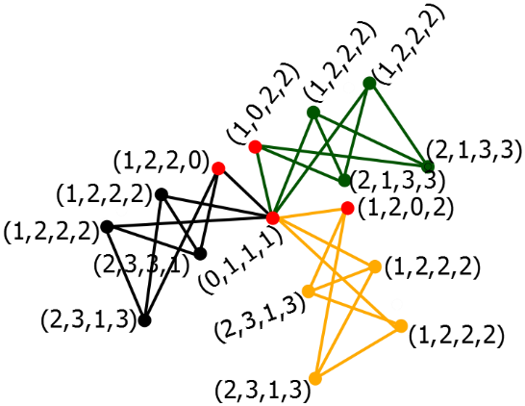
Figure 6. $Ddim_{l}\left(amal\left(K_{3,3},v,3\right)\right)=4$.

Theorem 4. Let $amal\left(F_{n},v,p\right)$ is a vertex amalgamation of friendship graph with the order is $n≥3$ then
$$Ddim_{l} \left(amal\left(F_{n},v,p\right)\right)=\left\{\begin{aligned}Ddim_{l}\left(F_{n}\right), v is a center vertex of F_{n} \\ 1+p\left(Ddim_{l}\left(F_{n}\right)-1\right), v is not a center vertex of F_{n}\end{aligned}\right.$$

Proof.
Case 1. $v$ is a center vertex of $F_{n}$
It is very clearly to see that $amal\left(F_{n},v,p\right)≅F_{n}$, then by the Table 1 we can conclude that $Ddim_{l} \left(amal\left(F_{n},v,p\right)\right)=Ddim_{l}\left(F_{n}\right)$. $∎$
Case 2. $v$ is not a center vertex of $F_{n}$
Let $V\left(amal\left(F_{n},v,p\right)\right)=\left\{v,v_{i},{x_{ik},y}_{ij} | i=1,2,3,…,p;j=1,2,3,…,n;k=2,3,4,…,n\right\}$ and $E\left(amal\left(F_{n},v,p\right)\right)=\left\{{v_{i}x}_{ik},v_{i}y_{ij},x_{ik}y_{ij},vy_{i1} | i=1,2,…,p;j=1,2,…,n;k=2,3,4,…,n \right\}$. The $i$-th copy of $F_{n}$ with $i=1,2,3,…,p$ is called ${\left(F_{n}\right)}_{i}$. Let $B$ be a local dominant basis of $F_{n}$, $B_{i}$ is a local dominant basis of ${\left(F_{n}\right)}_{i}$, so that for every $i=1,2,3,…,p$, $\left|B_{i}\right|=\left|B\right|=n$. Select $W_{l}=\{v\}\bigcup_{i=1}^{p}{(B_{i}-1)}$, suppose $B_{i}-1=\left\{x_{ik} | k=2,3,…,n\right\}$ for every $i=1,2,3,…,p$, then $\left|W_{l}\right|=1+p\left(n-1\right)$. By Lemma 2 for every $x_{ab},x_{cd}∈B_{i}$ then $r\left(x_{ab} | W_{l}\right)≠r\left(x_{cd} | W_{l}\right)$. Next, we take any two adjacent vertices in $V\left(G\right)\backslash W_{l}$. Let $v_{i}{,y}_{ij}∈V\left(G\right)\backslash W_{l}$ with $i=1,2,3,…,p$ and $j=2,3,…,n$. Since $amal\left(F_{n},v,p\right)$ is a connected graph, for $d\left(y_{ij},v\right)=d\left(y_{ij},v_{i}\right)+d(v_{i},v)$ for $j≠1,v∈W_{l}$ so that$d\left(v,y_{ij}\right)≠d\left(v,v_{i}\right)$ caused $r\left(y_{ij} | W_{l}\right)≠r\left(v_{i} | W_{l}\right)$. Then, $W_{l}$ is local resolving set of $amal\left(F_{n},v,p\right)$. Moreover, since $v$ adjacent to $v_{i}$ and $x_{ik}$ adjacent to $y_{ij}$, hence $W_{l}$ is dominant local resolving set of $amal\left(F_{n},v,p\right)$. Take any $S⊆V\left(amal\left(F_{n},v,p\right)\right)$ with $\left|S\right|<\left|W_{l}\right|$. Let $\left|S\right|=\left|W_{l}\right|-1$ the two possibilities below.
- If $v∉W_{l}$
$v∉W_{l}$, then all vertices $y_{i1}$ with $i=1,2,…,p$ cannot be dominated by $W_{l}$.
- If $v∈W_{l}$
$v∈W_{l}$, then there exist $x_{ik}∉W_{l}$ for $k=2,3…,n$. Without loss of generality suppose that $x_{1n}∉W_{l}$. It means that $y_{1n}$ cannot be dominated by $W_{l}$.
Therefore, from two possibilities above $S$ is not a local dominant resolving set of $amal\left(F_{n},v,p\right)$ or we can conclude that ${|W}_{l}|=1+p\left(n-1\right)$ is dominant local basis of $amal\left(F_{n},v,p\right)$. Hence, we get ${Ddim}_{l}\left(amal\left(F_{n},v,p\right)\right)=1+p\left(Ddim_{l}\left(F_{n}\right)-1\right)$ .$∎$

Figure 6 gives an axample of $amal\left(F_{3},v,3\right)$, where $v$ is not the center vertex of friendship. Those graph has dominant local resolving set equals seven.

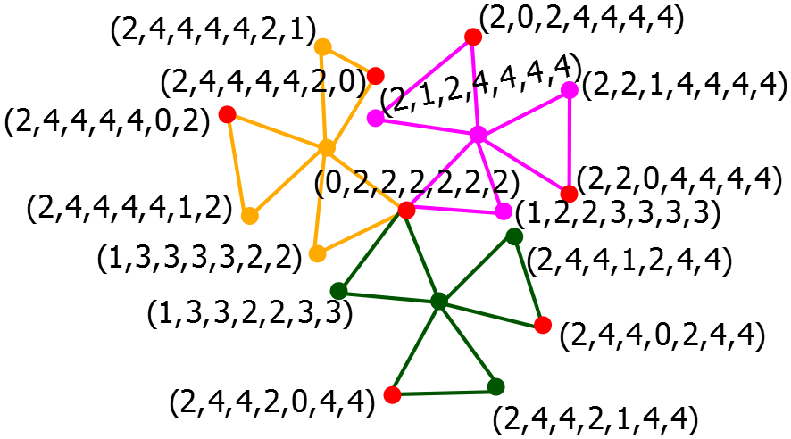
Figure 7. $Ddim_{l} \left(F_{3},v,3\right)=7$

CONCLUSION
Based on the findings of this study, it is possible to conclude that the dominant local metric dimension for any vertex amalgamation product graph is determined by the dominant local metric dimension of the copied graphs and how the terminal vertex is chosen. This topic can be expanded by observing the dominant local metric dimension for the vertex amalgamation product with the special graphs that will be glued are different graphs. Next, we can determined the dominant local metric dimension for another product of graphs. Moreover, the program application of this concept can be generated for any connected graph.

Acknowledgments
This work was supported by DRPM, KEMENRISTEK of Indonesia, Dcree 672/UN3/2022, Contract No. 75/UN3.15/PT/2022 and 010/E5/PG.02.00.PT/2022, year 2022.

References

[1] G. A. Barragán-Ramírez, A. Estrada-Moreno, Y. Ramírez-Cruz, and J. A. Rodríguez-Velázquez, “The simultaneous local metric dimension of graph families,” Symmetry (Basel)., vol. 9, no. 8, pp. 1–22, 2017, doi: 10.3390/sym9080132.
[2] G. Barragan-Ramirez and R. Simanjuntak, “The local metric dimension of subgraph-amalgamation of graphs,” Ctw, no. March 2016, pp. 285–288, 2015.
[3] S. Khoiriah and T. Atmojo Kusmayadi, “The local metric dimension of generalized broken fan graph and edge corona product of star graph and path graph,” J. Phys. Conf. Ser., vol. 1306, no. 1, 2019, doi: 10.1088/1742-6596/1306/1/012015.
[4] L. Susilowati and A. Rosfiana, “Article ID: IJCIET_10_03_239 Cite this Article: L. Susilowati, Slamin and A. Rosfiana, the Complement Metric Dimension of Graphs and its Operations,” Int. J. Civ. Eng. Technol., vol. 10, no. 3, pp. 2386–2396, 2019.
[5] C. X. Kang, I. G. Yero, and E. Yi, “The fractional strong metric dimension in three graph products,” Discret. Appl. Math., vol. 251, pp. 190–203, Dec. 2018, doi: 10.1016/j.dam.2018.05.051.
[6] R. Umilasari, I. Saifudin, and I. L. Lestari, “Star metric dimension of complete , bipartite , complete bipartite and fan graphs,” vol. 5, no. 2, pp. 199–205, 2022.
[7] G. Chartrand, L. Eroh, M. A. Johnson, and O. R. Oellermann, “Resolvability in graphs and the metric dimension of a graph,” Discret. Appl. Math., vol. 105, no. 1–3, pp. 99–113, 2000, doi: 10.1016/S0166-218X(00)00198-0.
[8] F. Okamoto, L. Crosse, B. Phinezy, and P. Zhang, “The local metric dimension of a graph,” vol. 135, no. 3, pp. 239–255, 2010.
[9] A. I. Kristiana, A. Aji, E. Wihardjo, and D. Setyawan, “on Graceful Chromatic Number of Vertex amalgamation of Tree Graph Family,” vol. 7, no. 3, pp. 432–444, 2022.
[10] R. Umilasari, L. Susilowati, and M. K. Siddiqui, “On the Dominant Local Metric Dimension of Graphs On the Dominant Local Metric Dimension of Graphs.”
[11] R. Umilasari, L. Susilowati, and s Slamin, “On the Dominant Local Metric Dimension of Graphs,” SSRN Electron. J., no. 1976, 2021, doi: 10.2139/ssrn.3917477.
[12] R. Umilasari, L. Susilowati, and Slamin, “Dominant Local Metric Dimension of Wheel Related Graphs,” IOP Conf. Ser. Mater. Sci. Eng., vol. 1115, no. 1, p. 012029, 2021, doi: 10.1088/1757-899x/1115/1/012029.

