INTEGRATION OF DBSCAN CLUSTER ANALYSIS WITH MULTIGROUP MODERATION PATH ANALYSIS
Hafizh Syihabuddin Al Jauhar¹, Solimun², Rahma Fitriani³
¹Brawijaya University
Email: aljauhar.hafizh@student.ub.ac.id, solimun@ub.ac.id, fitrianirahma094@gmail.com

Abstract
This study examines the application of integration between DBSCAN cluster analysis and multigroup moderation path analysis to analyse patterns of waste management behaviour in Batu City. DBSCAN was used to cluster the data based on density, resulting in two main clusters as well as some noise data. The first cluster consisted of 189 respondents, while the second cluster included 196 respondents, with the remaining 10 data identified as noise. The DBSCAN clustering results showed a silhouette index of 0.664, indicating good clustering quality in terms of compactness and separation between clusters. After the data was clustered, each cluster was analysed using multigroup moderation path analysis to assess the relationship between environmental quality, understanding of 3R-based waste management, and economic usefulness of waste with facilities and infrastructure variables as moderators. The results showed that clusters with good quality facilities had a stronger understanding of 3R-based waste management and its economic usefulness. This finding underscores the importance of facilities and infrastructure in influencing community waste management behaviour patterns.
Keywords: DBSCAN; path analysis; multigroup moderation; waste management; facilities and infrastructure; Batu City

Introduction
Path analysis is an extension of regression analysis designed to handle multiple structural equations. A key feature of structural equations in path analysis is the inclusion of at least one exogenous variable, one intervening endogenous variable, and a purely endogenous variable [1]. In path analysis, exogenous variables are those that influence other variables. Pure endogenous variables, on the other hand, are influenced by other variables but do not exert influence on any others. Meanwhile, intervening endogenous variables both influence and are influenced by other variables.
Path analysis also includes moderating variables, which serve to enhance or diminish the effect of exogenous variables on endogenous variables. These variables function by working alongside exogenous variables to influence endogenous variables. Broadly speaking, there are two approaches to analysing moderating variables, namely the moderation regression analysis approach (interaction method) and the multi-group approach [2].
Path analysis has several limitations, especially when the sample tested shows grouped characteristics, which can result in suboptimal modelling results. Therefore, a more in-depth preliminary analysis is required before conducting path analysis. One approach that can be applied is to integrate cluster analysis with path analysis. In this approach, the clustering results from cluster analysis are used to divide the dataset, and then each subset is analysed using path analysis methods.
Cluster analysis is a type of multivariate analysis categorized under the interdependency method, where no distinction is made between independent (explanatory) variables and dependent (response) variables. [3]. Cluster analysis is generally categorized into two main methods: hierarchical and non-hierarchical. Hierarchical methods encompass techniques such as the Single Linkage, Average Linkage, Complete Linkage, Centroid Linkage, and Ward's methods. Meanwhile, the K-Means method represents the primary approach within non-hierarchical methods.
In cluster analysis, there is usually a problem that not all objects in the study have characters that can be classified in a particular cluster. Some objects with unique characters are much different from other objects. This object is noise that if included in a cluster can affect character identification and reduce the accuracy of the cluster results formed [4].
Objects identified as noise can provide information that cannot be provided by other objects in the data, for example because noise arises from an unusual combination of circumstances that may be very important and need to be investigated [5]. Several clustering algorithms are effective in handling noise and outliers. These include Density-Based Spatial Clustering of Applications with Noise (DBSCAN), K-Medoids, Self-Organizing Map (SOM), and Fuzzy C-Means (FCM). [4] The Density-Based Spatial Clustering of Applications with Noise (DBSCAN) algorithm is designed to effectively detect noise in data while clustering based on data density. This algorithm identifies points that do not belong to any cluster as noise and groups points with high similarity into clusters.
DBSCAN, introduced by Ester, is a non-parametric clustering technique that does not require prior specification of the number of clusters. Instead, it identifies clusters based on the density of data points in the feature space [6]. This algorithm was awarded the test of the time award in 2014 by ACM (Association for Computing Machinery) during the data mining conference. DBSCAN is a partition-based clustering method that identifies denser regions in the data as clusters, while areas with low density are classified as noise. This approach allows for the effective detection of clusters of arbitrary shapes and the handling of outliers [7]. In DBSCAN there is no need to provide an input value for the number of clusters. Therefore, clusters are formed based on density, not from any form of assumption [8]. The primary advantage of the DBSCAN algorithm is its ability to exclude data identified as noise from all clusters. This is particularly beneficial, as noise data often exhibit characteristics significantly different from the overall dataset, ensuring more accurate and meaningful clustering results.
This study explores the integration of DBSCAN cluster analysis with moderation path analysis using a multigroup approach. The combination of these methods is anticipated to yield distinct and potentially insightful results, leveraging the strengths of DBSCAN's noise-handling capabilities and the multigroup approach's ability to analyze moderated relationships across different groups.

Methods

Data
This study uses secondary data taken from research conducted by [9]. The population in the study included the people of Batu City, totalling 217,871 families. The sample of this study consisted of people living in Batu sub-district and Bumiaji sub-district, with a total sample determined using qouta sampling of 395 respondents.

Research Model
The proposed research model is presented in Figure 1.
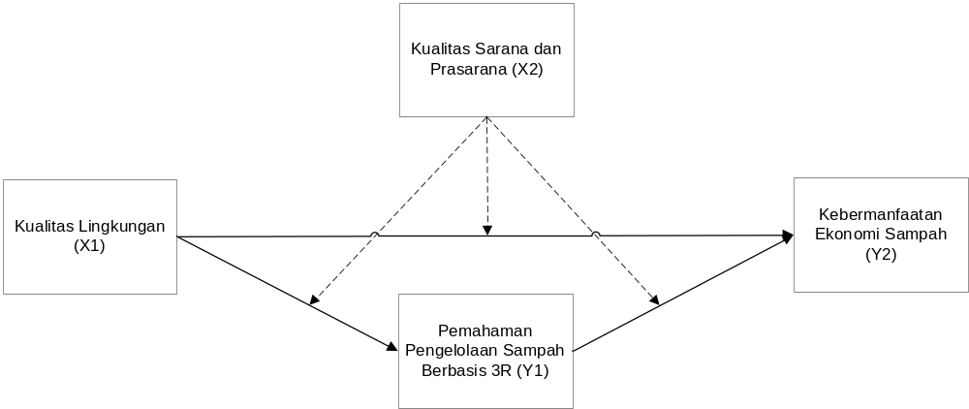
Figure 1. Research Model

DBSCAN Algorithm
The DBSCAN algorithm requires two important parameters, namely Eps (ε) and the minimum number of neighbouring data to form a group (MinPts). The algorithm of DBSCAN is as follows (Devi et al., 2015):
- Randomly select a starting point p.
- Initialise the input parameters MinPts and Eps.
- Calculate Eps or all affordable density distances to p using euclidean distance
$$d_{ij}=\sqrt{\sum_{a}^{p}{{\left(x_{ia}-x_{ja}\right)}^{2}}}$$
Where $x_{ia}$ is the a-th variable of object $i (i=1, ..., n; a=1, ...., p)$ and $d_{ij}$ is the Euclidean Distance value.
- If the number of points that satisfy Eps is more than MinPts then point p is the centre point (core) and the cluster is formed.
- Repeat steps 3 - 4 until all points are processed. If p is a border point and there is no point whose density is affordable to p, then the process continues to another point.

Analisis Jalur Moderasi Multigrup
Moderating variables are variables that strengthen or weaken the effect of exogenous variables (predictor or independent) on endogenous variables (response or dependent) (Solimun et al., 2017).
Graphically the path diagram for moderation of the multigroup method can be seen in Figure 2.
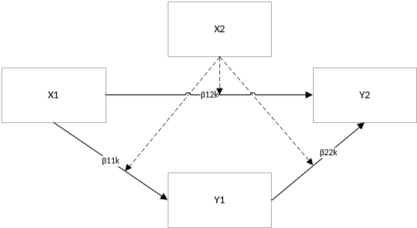
Figure 2. Path Diagram for Multigroup with Moderating Variables
Based on Figure 2, the equation that can be formed is

$$Z_{Y_{1ki}}=β_{11k}Z_{X_{1ki}}+ε_{1ki}$$
$$Z_{Y_{2ki}}=β_{12k}Z_{X_{1ki}}+β_{22k}Z_{Y_{1ki}}+ε_{2ki}$$
Group 1 ($k=1$)
$$Z_{Y_{11i}}=β_{111}Z_{X_{11i}}+ε_{11i}$$
$$Z_{Y_{21i}}=β_{121}Z_{X_{11i}}+β_{221}Z_{Y_{11i}}+ε_{21i}$$
Group 2 ($k=2$)
$$Z_{Y_{12i}}=β_{112}Z_{X_{12i}}+ε_{12i}$$
$$Z_{Y_{22i}}=β_{122}Z_{X_{12i}}+β_{222}Z_{Y_{12i}}+ε_{22i}$$

Desain Sistem
In the DBSCAN model, the number of clusters is not determined at the beginning; the number of clusters is known only after the Epsilon (ε) value and MinPts threshold are determined. The selection of these two parameters is very important as it directly affects the quality and number of clusters formed. After the DBSCAN cluster analysis is completed, the dataset is divided based on the clusters formed, and each cluster is then further analysed using path analysis. The workflow of the integration algorithm between DBSCAN cluster analysis and multigroup moderation path analysis can be seen in Figure 3.
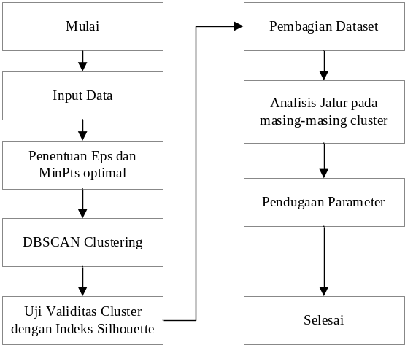
Figure 3. Algorithm Flow of Integration of DBSCAN Cluster Analysis and Multigroup Moderation Path Analysis

RESULTS AND DISCUSSION

DBSCAN Cluster Analysis
In this study to determine the optimal epsilon (ε) and MinPts values using the KNN method by calculating the distance in the point matrix to KNN. The value of k is shown in a rising curve where there is a sharp change in the curve is the optimal distance k as shown in Figure 4.
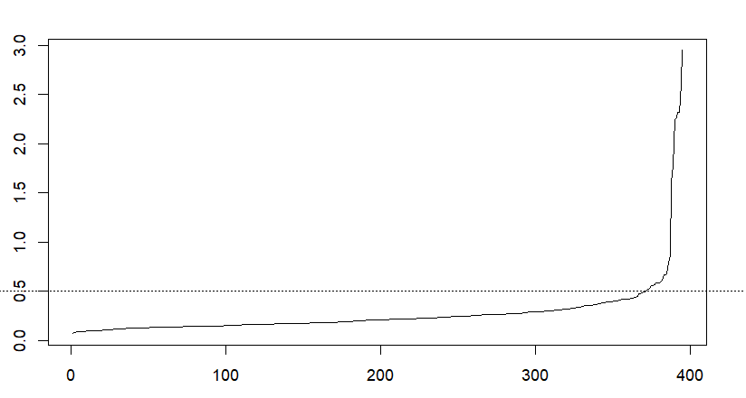
Figure 4. KNN Curve Determination of Optimal Eps Value
After obtaining the optimal epsilon (ε) value and MinPts with a value of ε = 0.5 and MinPts = 8 based on the highest Silhouette Coefficient value, the clustering process is then carried out with these two parameters as input. The clustering results are shown in Table 1.
Table 1. Cluster Analysis Results
MinPts | epsilon | Cluster | Many Members | Silhouette Index
8 | 0,5 | Noise | 10 | 0,664
8 | 0,5 | Cluster 1 | 189 | 0,664
8 | 0,5 | Cluster 2 | 196 | 0,664
Based on Table 1, the DBSCAN method with an epsilon value of 0.5 and MinPts value of 8 resulted in two clusters. The first cluster consists of 189 respondents, while the second cluster includes 196 respondents. In addition, there are 10 respondents who are categorised as noise. This noise refers to data that does not follow the main pattern in the cluster and is therefore excluded to maintain the quality of the clustering. The presence of noise indicates a significant variation in the data distribution, which may result from outliers or pattern mismatch. The DBSCAN clustering results showed a silhouette index of 0.664, indicating a clustering quality with a good degree of compactness and separation.

Estimation of Path Analysis Parameters
Estimating the path coefficient in this study using the least squares method. The results of estimating the path coefficient in group 1 based on DBSCAN grouping can be seen in equation (5).
$${\hat{Z}}_{Y_{1}}=0,977Z_{X_{1}}$$
$${\hat{Z}}_{Y_{2}}=0,439Z_{X_{1}}+0,519Z_{Y_{1}}$$
Based on Equation (5), it can be seen that the environmental quality variable has a positive relationship with the understanding of 3R-based waste management. This means that when environmental quality increases, understanding of 3R-based waste management will also be higher. In the second path model, environmental quality and understanding of 3R-based waste management also have a positive relationship with the economic usefulness of waste. In other words, improving environmental quality and understanding of 3R-based waste management will have an impact on increasing the economic usefulness of waste.
The estimation results of the group 2 path coefficient can be seen in equation (6).
$${\hat{Z}}_{Y_{1}}=0,988Z_{X_{1}}$$
$${\hat{Z}}_{Y_{2}}=0,614Z_{X_{1}}+0,349Z_{Y_{1}}$$
Based on Equation (6), it is known that environmental quality has a positive relationship with the understanding of 3R-based waste management. With the increase in environmental quality, understanding of 3R-based waste management will also increase. In the second path model, it can be seen that environmental quality and understanding of 3R-based waste management are positively related to the economic usefulness of waste. This means that improving environmental quality and understanding of 3R-based waste management will have an impact on increasing the economic benefits of waste.
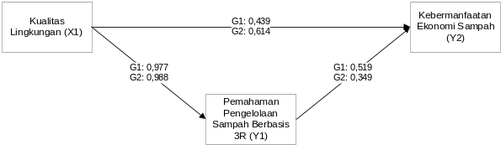
Figure 5. Group 1 and Group 2 Path Diagram based on DBSCAN clustering

Hypothesis Testing
Based on the structural equation model in Figure 5, hypothesis testing is carried out with the Jackknife resampling approach. The results of parameter significance testing based on DBSCAN clustering are presented in Table 2.
Table 2. Hypothesis Testing Results of Multigroup Direct Effect
Relationship | Group 1 |  | Group 2 |  | Difference Test
Relationship | Coefficient | p-value | Coefficient | p-value | Difference Test
X1 Y1 | 0,974 | <0,001 | 0,987 | <0,001 | <0,001
X1 Y2 | 0,446 | <0,001 | 0,623 | <0,001 | <0,001
Y1 Y2 | 0,512 | <0,001 | 0,339 | <0,001 | <0,001
Based on Table 2, it shows that in Group 1 (good facilities and infrastructure), all relationships between variables show significance. In this group, Environmental Quality (X1) has a significant positive effect on the Understanding of 3R-based Waste Management (Y1) and the Economic Benefit of Waste (Y2). This means that the better the environmental quality, the higher the community's understanding of 3R-based waste management, and the greater the economic benefits. This finding indicates that good environmental quality supports increased community awareness of sustainable waste management and provides more optimal economic benefits. In addition, Understanding of 3R-Based Waste Management (Y1) also has a significant positive effect on the Economic Benefit of Waste (Y2), which indicates that the higher the community's understanding of waste management, the greater the potential economic benefits that can be obtained.
In Group 2 (excellent facilities and infrastructure), the analysis results also show significance in all relationships between variables. In this group, Environmental Quality (X1) not only has a positive effect on the Understanding of 3R-Based Waste Management (Y1) but also on the Economic Benefit of Waste (Y2). This finding reinforces that high quality environmental conditions, supported by excellent facilities and infrastructure, contribute significantly to increasing people's awareness and understanding of 3R-based waste management and its economic benefits. In addition, Understanding of 3R-based Waste Management (Y1) also has a significant positive effect on Waste Economic Benefit (Y2), indicating that the higher the community's understanding of 3R-based waste management, the greater the economic benefits generated.
Table 2 also shows that the quality of facilities and infrastructure moderated three relationships, namely between 𝑋1 to 𝑌1, 𝑋1 to 𝑌2, and 𝑌1 to 𝑌2. Thus, the group with excellent facilities and infrastructure (group 2) strengthened the relationship between environmental quality (𝑋1) and understanding of 3R-based waste management (𝑌1), environmental quality (𝑋1) and economic usefulness of waste (𝑌2), and understanding of 3R-based waste management (𝑌1) and economic usefulness of waste (𝑌2).
From this description, it can be concluded that the people of Batu City who have excellent facilities and infrastructure tend to have a stronger understanding of 3R-based waste management. The higher the environmental quality supported by adequate facilities and infrastructure, the greater the increase in community understanding in 3R-based waste management compared to communities with inadequate facilities. In addition, excellent facilities and infrastructure also strengthen the relationship between environmental quality and the economic usefulness of waste compared to groups with lower facilities. This suggests that facilities and infrastructure play an important role in influencing people's behaviour in waste management.

CONCLUSIONS
Based on the results of the discussion above, the conclusion is obtained:
- The DBSCAN algorithm produces a total of 2 clusters with details of cluster 1 with 189 members, cluster 2 with 196 members, and noise with 10 members.
- Multigroup moderation path analysis showed different results between groups with good facilities and infrastructure and groups with inadequate facilities and infrastructure. This result shows that good facilities and infrastructure strengthen the relationship between environmental quality (X1) and understanding of 3R-based waste management (Y1) as well as the economic usefulness of waste (Y2). This finding underscores the importance of Batu city's community facilities and infrastructure in influencing waste management behaviour in the city.

[1] A. A. R. Fernandes and Solimun, Analisis Regresi dalam Pendekatan Fleksibel: Ilustrasi dengan Paket Program R. UB Press, 2021.
[2] Solimun, A. A. E. Fernandes, and Nurjannah, Metode Statistika Multivariat Pemodelan Persamaan Struktural (SEM) Pendekatan WarpPLS. UB Press, 2017.
[3] S. Nugroho, Statistika Multivariat Terapan. UNIB Press, 2008.
[4] I. D. Id, A. Astrid, and E. Mahdiyah, “Modifikasi DBSCAN (Density-Based Spatial Clustering With Noise) pada Objek 3 Dimensi,” Jurnal Komputer Terapan, vol. 3, no. 1, pp. 41–52, 2017, [Online]. Available: http://jurnal.pcr.ac.id
[5] E. T. K. Dewi, A. Agoestanto, and S. Sunarmi, “Metode Least Trimmed Square (LTS) Dan Mm-Estimation Untuk Mengestimasi Parameter Regresi Ketika Terdapat Outlier,” UNNES Journal of Mathematics, vol. 5, no. 1, pp. 47–54, 2016.
[6] T. N. Tran, K. Drab, and M. Daszykowski, “Revised DBSCAN algorithm to cluster data with dense adjacent clusters,” Chemometrics and Intelligent Laboratory Systems, vol. 120, pp. 92–96, Jan. 2013, doi: 10.1016/j.chemolab.2012.11.006.
[7] P. B. Nagpal and P. A. Mann, “Comparative Study of Density based Clustering Algorithms,” Int J Comput Appl, vol. 27, no. 11, pp. 44–77, Dec. 2011, doi: 10.5120/3341-4600.
[8] S. U. Rehman, S. Asghar, S. Fong, and S. Sarasvady, “DBSCAN: Past, present and future,” in The Fifth International Conference on the Applications of Digital Information and Web Technologies (ICADIWT 2014), IEEE, Feb. 2014, pp. 232–238. doi: 10.1109/ICADIWT.2014.6814687.
[9] S. Solimun, A. A. R. Fernandes, I. Rahmawati, R. Isaskar, L. Muflikhah, and F. L. N. Rasyidah, “Cluster Integration Path Analysis to Model PT Pelindo II’s Market Mapping,” International Journal of Circuits, Systems and Signal Processing, vol. 15, pp. 1833–1841, Jan. 2022, doi: 10.46300/9106.2021.15.198.

