Dynamics of Lumpy Skin Disease Model With Vaccination and Environmental Transmission
Nia Nurkhanifah, Agus Suryanto*, Isnani Darti
Department of Mathematics, Faculty of Mathematics and Natural Sciences
Brawijaya University, Indonesia

Email: suryanto@ub.ac.id

Abstract
Lumpy skin disease (LSD) is one of the cattle diseases that can spread rapidly, it is caused by lumpy skin disease virus (LSDV). LSDV can spread through direct contact, insect vectors, and contaminated environments. In this article, we propose the dynamics of a lumpy skin disease model that contains seven compartments: susceptible cattle, vaccinated cattle, infected cattle, recovered cattle, susceptible vector, infected vector, and LSDV in the environment. The non-negativity and boundedness of the solution of the proposed LSD model are shown. There are two equilibrium points: the disease-free equilibrium point which always exists, and the endemic equilibrium point which exists conditionally. The disease-free equilibrium point is locally and globally asymptotically stable when the basic reproduction number is less than unity. The endemic equilibrium is locally asymptotically stable if the Lienard-Chipart criteria is satisﬁed. In addition, based on the sensitivity analysis, we ﬁnd that the vaccination rate is the most sensitive parameter. All analytical results have been veriﬁed by our numerical simulations.
Keywords: LSD epidemic model; equilibrium point; stability; sensitivity analysis.

Introduction
Lumpy skin disease (LSD) is a cattle diseases that can spread in various transmissions and cause economic losses [3],[6],[14]. LSD caused by the Capripox virus from the Poxviridae family [3],[6],[14]. LSD is not classiﬁed as a zoonotic disease, a disease that can naturally be transmitted from animals to humans or conversly [14]. LSD can result in signiﬁcant economic losses for livestock farmers such as weight loss, reduction in milk production, abortion, infertility and death in cattle [5]. The first case of LSD in Indonesia was in February 9, 2022 especially in Riau [12]. According to the report from the Ministry of Agriculture of the Republic of Indonesia, the number of LSD are recorded 64.000 cases across 16 provinces, the highest number of cases is 23.000 cases in Central Java [15].
The primary transmission of LSDV is mechanically through arthropod vectors such as mosquitoes (Aedes aegypti), ﬂies (Stomoxys calcitrans), small insects (Culicoides nubeculosus), and ticks (Rhipicephalus appendiculatus). LSDV can spread rapidly during the rainy season because of the abundance of arthropods during this time. Additionally, LSD can spread through contact between cattle and contaminated environments by LSDV [11][15]. The recovered cattle have natural antibodies and can be resistant from LSDV. The healthy cattle can also develop antibodies if they get vaccination. The control policy for LSD in Indonesia include the emergency vaccination and the facility disinfection. Emergency vaccination and facility disinfection is important strategy to reduce the impact of a new infection, protect healthy cattle, and prevent widespread of the LSD outbreaks [1][13][15].
Several researchers have conducted studies related to the modeling of LSD disease. Onyejekwe et al [1] have introduced a SEIR model for the LSD by considering contact between cattle and providing some optimal control strategies, one of which is vaccination. Other model that showed the effectiveness of vaccination in reducing the rate of infection is the LSD model constructed by Falowo et al [9]. This model considered a transmission via contact between cattle and infected vectors. In addition, Alfwzan et al. [11] proposed an LSD model by considering transmission through contact between cattle, infected vectors, and environments contaminated by LSD virus.
In this study, we develop an LSD model which includes disease transmission due to contact between cattle, vector and LSD virus in the environment. We take into account the cattle vaccination to prevent the LSD spread. As we see in the following section, the proposed model is basically a combination of model developed by Falowo et al [9] and that by Alfwzan et al [11].

Methods
In this study, we develop the LSD model with vaccination and environmental transmission. In order to analyze our model, we perform the following steps.
- Constructing the proposed LSD model.
- Proving the non-negativity and boundedness solution.
- Determining the equilibrium point and basic reproduction number.
- Analyzing the local and global stability of the equilibrium point.
- Analyzing the sensitivity of parameters.
- Conducting numerical simulations to confirm the analytical result.

Results and Discussion

Model Formulation
To derive an LSD model, we assume that the total population of cattle is denoted by $(N_{c})$ which consists of susceptible cattle $(S_{c})$, vaccinated cattle $(V_{c})$, infected cattle $(I)$, and recovered cattle $(R_{c})$. Meanwhile, the total population of vector is denoted by $\left(N_{v}\right)$ which consists of susceptible vector $(S_{v})$ and infected vector $(I_{v})$. The population of pathogen or LSDV in environment is denoted by $(P)$.
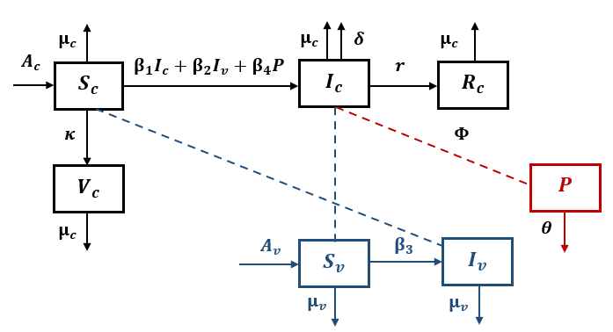
Figure 1. Compartment diagram for lumpy skin disease transmission

The susceptible cattle grow with constant birth rate $A_{c}$. The susceptible cattle become infected whenever they have contacted with infected cattle, infected vector and pathogen in the environment, where the infection rate of them are respectively $β_{1},β_{2}$ and $β_{4}$. To prevent from the LSD virus, we assume that the susceptible cattle is vaccinated with vaccination rate $κ$. The vaccination is assumed to be perfect such that the vaccinated cattle cannot be infected by the LSD virus. The number of infected cattle may be reduced due to they recover at rate $r$, or death caused by the LSD at rate $δ$. The natural death rate of catlle is denoted by $μ_{c}$. The birth rate of vector is assumed to be$A_{v}$and the death rate of vector is $μ_{v}$. After having contact (bite) with the infected cattle, the susceptible vector becomes infected with infection rate $β_{3}$. It is assumed that infected cattle can release LSD virus into the environment at a release rate $Φ$. To reduce pathogens in the environment, we apply disinfectants at a rate of $θ$. The LSD transmission schematic diagram can be seen in Figure 1, while the constructed mathematical model for LSD transmission is as follows

$$\begin{aligned}\frac{dS_{c}}{dt}&=A_{c}-ξS_{c}-\left(κ+μ_{c}\right)S_{c}, \\ \frac{dV_{c}}{dt}&=κS_{c}-μ_{c}V_{c}, \\ \frac{dI_{c}}{dt}=ξS_{c}-\left(r+δ+μ_{c}\right)I_{c}, \\ \frac{dR_{c}}{dt}&=rI_{c}-μ_{c}R_{c},\#\left(1\right) \\ \frac{dS_{v}}{dt}&=A_{v}-β_{3}S_{v}I_{c}-μ_{v}S_{v}, \\ \frac{dI_{v}}{dt}&=β_{3}S_{v}I_{c}-μ_{v}I_{v}, \\ \frac{dP}{dt}&=ΦI_{c}-θP\end{aligned}$$
where
$$\begin{aligned}ξ&=β_{1}I_{c}+β_{2}I_{v}+ β_{4}P\end{aligned}$$

Non-Negativity and Boundedness of Solution
System (1) describes the interaction of cattle, vector, and pathogen population. The solution of this model must be non-negative and bounded. The non-negativity of solution is stated in the following theorem.

Theorem 1. All solutions of system (1) with positive initial values $S_{c}(0)≥0,V_{c}(0)≥0, I_{c}(0)≥0, R_{c}\left(0\right)≥0, S_{v}(0)≥ 0, I_{v}(0) ≥ 0$ and $P(0) ≥ 0$are always non-negative.

Proof:
We first prove that $S_{c}(0)$ are non-negative. Assume on the contrary; suppose that $S_{c}(t)$ is negative for some $t>0$. If$t_{1}$ be the first time such that $S_{c}(t_{1})=0$. From the first equation of system (1), we get
$$\begin{aligned}{\left.\frac{dS_{c}}{dt}\right|}_{t=t_{1}}=A_{c}>0\end{aligned}$$
This means that $S_{c}(t)>0$ on $t∈(t_{1}, t_{1}+ϵ)$ for arbitrary small positive constant $ϵ$. This leads to a contradiction, thus $S_{c}\left(t\right)≥ 0$ for all $t≥0$. The non-negativity of $V_{c}\left(t\right),I_{c}\left(t\right),R_{c}\left(t\right),S_{v}\left(t\right),I_{v}(t), P(t)$ can be shown using the similar way. Therefore, all solutions of system (1) are non-negative.
To show the boundedness solutions of system (1), we apply the comparison lemma [8]. Let $N_{c} = S_{c} +V_{c} + I_{c} + R_{c}$ and $N_{v} = S_{v} + I_{v}.$ Based on system (1), we have
$$\begin{aligned}\frac{dN_{c}}{dt}&=A_{c}-μ_{c}\left(S_{c}+V_{c}+I_{c}+R_{c}\right)-δI_{c}≤A_{c}- μ_{c}N_{c}, \\ N_{c}≤\frac{A_{c}}{μ_{c}}+\left(N_{c}\left(0\right)-\frac{A_{c}}{μ_{c}}\right)e^{-μ_{c}t}⟹\lim_{t⟶∞}{N_{c}≤\frac{A_{c}}{μ_{c}}},\end{aligned}$$
$$\begin{aligned}\frac{dN_{v}}{dt}&=A_{v}-μ_{v}N_{v}, \\ N_{v}&=\frac{A_{v}}{μ_{v}}+\left(N_{v}\left(0\right)-\frac{A_{v}}{μ_{v}}\right)e^{-μ_{v}t}⟹\lim_{t⟶∞}{N_{v}≤\frac{A_{v}}{μ_{v}}}.\end{aligned}$$
and
$$\begin{aligned}\frac{dP}{dt}&=ΦI_{c}-θP<ΦN_{c}-θP≤\frac{ΦA_{c}}{μ_{c}}-θP, \\ P&≤\frac{A_{c}Φ}{μ_{c}θ}+\left(P\left(0\right)-\frac{A_{c}Φ}{μ_{c}θ}\right)e^{-θt}⟹\lim_{t⟶∞}{P≤\frac{A_{c}Φ}{μ_{c}θ}}.\end{aligned}$$
Thus, all the solution of the system (1) are bounded to the region
$$\begin{aligned}Ω=\left\{Γ_{1}∈R_{+}^{4}:N_{c}\left(t\right)≤\frac{A_{c}}{μ_{c}}, Γ_{2}∈R_{+}^{2}:N_{v}\left(t\right)=\frac{A_{v}}{μ_{v}},P\left(t\right)∈R:P(t)≤\frac{A_{c}Φ}{μ_{c}θ} \right\}\#\end{aligned}$$
where $Γ_{1}=\left(S_{c}, V_{c}, I_{c}, R_{c}\right)$ and $Γ_{2}=\left(S_{v}, I_{v}\right)$. A summary of the above analysis can be stated in the following theorem.
Theorem 2. All solutions of system (1) with initial values $S_{c}\left(0\right)≥0, V_{c}\left(0\right)≥0, I_{c}\left(0\right)≥0, R_{c}\left(0\right)≥0, S_{v}\left(0\right)≥0, I_{v}\left(0\right)≥0,P\left(0\right)≥0$ are bounded.

Equilibrium Point and Basic Reproduction Number
The equilibrium point is obtained when the right-hand side of the equation in system (1) are zero. In this way, we get two types of equilibrium points: the disease-free equilibrium point (DFE)$$\begin{aligned}E^{0}=\left(S_{C}^{0},V_{c}^{0}, I_{c}^{0}, R_{c}^{0}, S_{v}^{0}, I_{v}^{0}, P^{0}\right)=\left(\frac{A_{c}}{κ+μ_{c}},\frac{κA_{c}}{μ_{c}\left(κ+μ_{c}\right)},0,0,\frac{A_{v}}{μ_{v}},0,0\right),\#\end{aligned}$$
and the endemic equilibrium (EE)
$$\begin{aligned}E^{*}=\left(S_{C}^{*},V_{c}^{*}, I_{c}^{*}, R_{c}^{*}, S_{v}^{*}, I_{v}^{*}, P^{*}\right),\end{aligned}$$
where
$$S_{c}^{*}=\frac{A_{c}}{ξ+κ+μ_{c}}, V_{c}^{*}=\frac{κS_{c}^{*}}{μ_{c}}, R_{c}^{*}=\frac{rI_{c}^{*}}{μ_{v}}, S_{v}^{*}=\frac{A_{v}}{β_{3}I_{c}^{*}+μ_{v}}, I_{v}^{*}=\frac{β_{3}S_{v}^{*}I_{c}^{*}}{μ_{v}}, P^{*}=\frac{ΦI_{c}^{*}}{θ}.$$

Notice that $I_{c}^{*}$ are the real positive roots of the following quadratic equation
$$\begin{aligned}Π_{0}I_{c}^{*2}+ΠI_{c}^{*}+Π_{2}=0,\#\left(2\right)\end{aligned}$$
where
$$\begin{aligned}Π_{0}&=\left(r+δ+μ_{c}\right)\left(μ_{v}θβ_{3}+β_{3}β_{4}μ_{v}Φ\right), \\ Π_{1}&=\left(\left(r+δ+μ_{c}\right)\left(β_{1}μ_{v}^{2}θ+β_{2}β_{3}A_{c}θ+β_{4}Φμ_{v}^{2}\right)+\left(μ_{v}θβ_{3}\right)\left(κ+μ_{c}\right)\right) \\ -\left(A_{c}β_{1}μ_{v}θβ_{3}+A_{c}β_{3}β_{4}μ_{v}Φ\right) \\ Π_{2}&=μ_{v}^{2}θ\left(κ+μ_{c}\right)\left(r+δ+μ_{c}\right)\left(1-2\frac{β_{1}A_{c}θ+β_{4}A_{c}Φ }{2θ\left(κ+μ_{c}\right)\left(r+δ+μ_{c}\right)}-\frac{β_{3}A_{v}β_{2}A_{c}}{μ_{v}^{2}\left(κ+μ_{c}\right)\left(r+δ+μ_{c}\right)}\right)\end{aligned}$$
The detail discussion about the existence of EE will be given later. Instead, we first derive the basic reproduction number as follows. By only considering the subpopulation with infection in LSD model (1), we consider the following vector of individual displacement between compartments
$$F=\left(\begin{matrix}\left(β_{1}I_{c}+β_{2}I_{v}+ β_{4}P\right)S_{c} \\ β_{3}S_{v}I_{c} \\ 0\end{matrix}\right),V=\left(\begin{matrix}r+δ+μ_{c} \\ μ_{v}I_{v} \\ -ΦI_{c}+θP\end{matrix}\right).$$
Suppose that $F$ and $V$ are respectively the Jacobian matrices of $F$ and $V$ at the DFE, then we get the next generation matrix
$$FV^{-1}=\left(\begin{matrix}\frac{β_{1}A_{c}}{β_{1}A_{c}θ+β_{4}A_{c}Φ }+\frac{β_{4}A_{c}Φ }{\left(κ+μ_{c}\right)\left(r+δ+μ_{c}\right)θ} & \frac{β_{2}A_{c}}{\left(κ+μ_{c}\right)} & \frac{β_{4}A_{c}}{\left(κ+μ_{c}\right)θ} \\ \frac{β_{3}A_{v}}{\left(r+δ+μ_{c}\right)μ_{v}} & 0 & 0 \\ 0 & 0 & 0\end{matrix}\right).$$
The basic reproduction number is defined as the spectral radius of the matrix $FV^{-1}$, namely
$$R_{0}=ρ\left(FV^{-1}\right)=R_{1}^{*}+\sqrt{R_{1}^{*2}+R_{2}^{*}},$$
where
$$R_{1}^{*}=\frac{β_{1}A_{c}θ+β_{4}A_{c}Φ }{2θ(κ+μ_{c})\left(r+δ+μ_{c}\right)} \text{and} R_{2}^{*}=\frac{β_{3}A_{v}β_{2}A_{c}}{μ_{v}^{2}\left(κ+μ_{c}\right)\left(r+δ+μ_{c}\right)}$$By noticing that $R_{0}^{2}=2R_{1}^{*}R_{0}+R_{2}^{*}$, we can show that condition $\left(R_{0}≤1\text{ or} R_{0}>1\right)$ is equivalent to condition $\left(R_{0}^{*}≤1\text{ or} R_{0}^{*}>1\right)$where $R_{0}^{*}=2R_{1}^{*}+R_{2}^{*}$.
We can write the coefficient $Π_{2}$ of the quadratic equation (2) as
$$Π_{2}=μ_{v}^{2}θ\left(κ+μ_{c}\right)\left(r+δ+μ_{c}\right)\left(1-R_{0}^{*}\right).$$
By evaluating all possible roots of equation (2), we have the following existence of endemic equilibrium point:
- If $R_{0}^{*}<1, Π_{1}<0$ and $Π_{1}^{2}-4Π_{0}Π_{2}>0$ then there exist two endemic equilibrium points $I_{c_{1}}^{*}$ and $I_{c_{2}}^{*}$;
- If $R_{0}^{*}<1, { Π}_{1}<0$ and $Π_{1}^{2}-4Π_{0}Π_{2}=0$ then there exists a unique endemic equilibrium point $I_{c_{3}}^{*}$;
- If $R_{0}^{*}=1$ and ${ Π}_{1}<0$ then there exists a unique endemic equilibrium point $I_{c_{4}}^{*}$;
- If $R_{0}^{*}>1$ then there exists a unique endemic equilibrium point $I_{c_{1}}^{*}$;
- No equilibria otherwise;
where
$$I_{c_{1}}^{*}=\frac{-Π_{1}+\sqrt{Π_{1}^{2}-4Π_{0}Π_{2}}}{2Π_{0}}, I_{c_{2}}^{*}=\frac{-Π_{1}-\sqrt{Π_{1}^{2}-4Π_{0}Π_{2}}}{2Π_{0}}, I_{c_{3}}^{*}=-\frac{Π_{1}}{2Π_{0}}, I_{c_{4}}^{*}=-\frac{Π_{1}}{Π_{0}}.$$

Local Stability
In this section, we investigate the local stability of equilibrium point in model (1). The Jacobian matrix from the sytem (1) at a point $E^{k}=(S_{c}^{k},V_{c}^{k}, I_{c}^{k}, R_{c}^{k},S_{v}^{k}, I_{v}^{k},P^{k})$ is given by

$$\begin{aligned}J\left(E^{k}\right)=\left[\begin{matrix}-s_{1}^{k} & 0 & -β_{1}S_{c}^{k} & 0 & 0 & -β_{2}S_{c}^{k} & -β_{4}S_{c}^{k} \\ κ & -μ_{c} & 0 & 0 & 0 & 0 & 0 \\ s_{1}^{k} & 0 & s_{2}^{k} & 0 & 0 & β_{2}S_{c}^{k} & β_{4}S_{c}^{k} \\ 0 & 0 & r & - μ_{c} & 0 & 0 & 0 \\ 0 & 0 & -β_{3}S_{v}^{k} & 0 & -(β_{3}I_{c}^{k}+μ_{v}) & 0 & 0 \\ 0 & 0 & β_{3}S_{v}^{k} & 0 & β_{3}I_{c}^{k} & -μ_{v} & 0 \\ 0 & 0 & Φ & 0 & 0 & 0 & -θ\end{matrix}\right],\#\left(3\right)\end{aligned}$$

where
$$s_{1}^{k}=β_{1}I_{c}^{k}+β_{2}I_{v}^{k}+β_{4}P^{k}+κ+μ_{c}, \\ s_{2}^{k}=β_{1}S_{c}^{k}-δ-r-μ_{c}.$$
We substitute the equilibrium point $E^{k}$ into the Jacobian matrix to find out the eigenvalues thus we get the stability condition for the DFE and EE.
If we substitute the DFE point $E^{0}$ into the Jacobian matrix (3) then we get $J\left(E^{0}\right).$ By using $\left|J\left(E^{0}\right)-λI\right|=0$ to find out the eigenvalues of $J\left(E^{0}\right)$, we get the characteristic equation as follow

$$\begin{aligned}\left(-κ-μ_{c}-λ\right)\left(-μ_{c}-λ\right)\left(-μ_{c}-λ\right)\left(-μ_{v}-λ\right)\left(λ^{3}+a_{1}λ^{2}+a_{2}λ+a_{3}\right)=0,\#\left(4\right)\end{aligned}$$
where
$$a_{1}=\left(r+δ+μ_{c}\right)\left(1-\frac{β_{1}A_{c}}{\left(κ+μ_{c}\right)\left(r+δ+μ_{c}\right)}\right)+θ+μ_{v},$$
$$a_{2}=θ\left(r+δ+μ_{c}\right)\left(1-R_{1}^{*}\right)+μ_{v}^{2}\left(r+δ+μ_{c}\right)\left(1-R_{2}^{*}\right)+μ_{v}\left(θ-\frac{β_{1}A_{c}}{κ+μ_{c}}\right),$$
$$a_{3}=θ\left(r+δ+μ_{c}\right)μ_{v}^{2}\left(1-R_{0}^{*}\right).$$
It is clear that the real part of the fourth eigenvalues are
$$λ_{1}=-κ-μ_{c}<0, λ_{2,3}=-μ_{c}<0, λ_{4}=-μ_{v}<0.$$
Next we find the other eigenvalues in (4) by using the characteristic equation below
$$\begin{aligned}λ^{3}+a_{1}λ^{2}+a_{2}λ+a_{3}=0\#\left(5\right)\end{aligned}$$
Based on the Routh-Hurwitz criteria, the characteristic equation (5) has the negative real part in each of their eigenvalues if $a_{1}>0 \text{and} a_{1}a_{2}-a_{3}>0$. We see that if $R_{0}^{*}<1$ then$a_{3}>0$ and other criteria will be proven by numerical simulations. The DFE point is locally asymptotically stable if the LSD model satisfies all of the criteria then the following theorem holds.
Theorem 3. The DFE point $E^{0}$of the LSD model is locally asymptotically stable if $R_{0}^{*}<1, a_{1}>0, \text{and} a_{1}a_{2}-a_{3}>0$.
To prove the local stability of the EE point $E^{*}$, we substitute $E^{*}$ into the Jacobian matrix (3) then we get $J\left(E^{*}\right).$ By using $\left|J\left(E^{*}\right)-λI\right|=0$ then we get the eigenvalues of $J\left(E^{*}\right)$, from the characteristic equation below
$$\begin{aligned}\left(-μ_{c}-λ\right)\left(-μ_{c}-λ\right)\left(λ^{5}+b_{1}λ^{4}+b_{2}λ^{3}+b_{3}λ^{2}+b_{4}λ+b_{5}\right)=0.\#\left(6\right)\end{aligned}$$
It is clear that the real part of the first and second eigenvalues are negative $λ_{1,2}=-μ_{c}$.
We can find out the other eigenvalues by evaluating
$$\begin{aligned}λ^{5}+b_{1}λ^{4}+b_{2}λ^{3}+b_{3}λ^{2}+b_{4}λ+b_{5}=0,\#\left(7\right)\end{aligned}$$
where
$b_{1}=β_{3}I_{c}^{*}+θ+2μ_{v}+s_{1}^{*}-s_{2}^{*}$,
$$b_{2}=-S_{c}^{*} S_{v}^{*} β_{2}β_{3}-Φ S_{c}^{*} β_{4}+θ I_{c}^{*}β_{3}+I_{c}^{*} β_{3}μ_{v}+I_{c}^{*}β_{3}s_{1}^{*}-I_{c}^{*}β_{3}s_{2}^{*}+S_{c}^{*} \\ \begin{aligned}& +β_{1}s_{1}^{*}+2θμ_{v}θs_{1}^{*}-θs_{2}^{*}+μ_{v}^{2}+2μ_{v} s_{1}^{*}-2μ_{v}s_{2}^{*}-s_{1}^{*}s_{2}^{*}\end{aligned}, \\ b_{3}=-ΦI_{c}^{*}S_{c}^{*}β_{3}β_{4}-θS_{c}^{*}S_{v}^{*}β_{2}β_{3}-S_{c}^{*}S_{v}^{*} β_{2}β_{3}μ_{v}-2ΦS_{c}^{*}β_{4}μ_{v}+θI_{c}^{*}β_{3} (μ_{v}+s_{1}^{*}-s_{2}^{*}) \\ +S_{c}^{*}β_{1}s_{1}^{*}\left(I_{c}^{*}+2μ_{v}\right)+I_{c}^{*}β_{3}μ_{v} \left(s_{1}^{*}-s_{2}^{*}\right)- I_{c}^{*} β_{3}s_{1}^{*} s_{2}^{*}+θμ_{v}^{2}+2θ μ_{v}s_{1}^{*} -2θ μ_{v}s_{2}^{*} \\ -θs_{1}^{*}s_{2}^{*}+μ_{v}^{2} \left(s_{1}^{*}-s_{2}^{*}\right)-2μ_{v}s_{1}^{*}s_{2}^{*}, \\ b_{4}=-ΦI_{c}^{*}S_{c}^{*}β_{3}β_{4}μ_{v}+θI_{c}^{*}S_{c}^{*}β_{1}β_{3}s_{1}^{*}-θS_{c}^{*}S_{v}^{*}β_{2}β_{3}μ_{v} \\ +I_{c}^{*}S_{c}^{*} β_{1}β_{3}μ_{v}s_{1}^{*}-ΦS_{c}^{*}β_{4}μ_{v}^{2}θI_{c}^{*}β_{3}μ_{v}s_{1}^{*}-θI_{c}^{*}β_{3}μ_{v}s_{2}^{*}-θI_{c}^{*}β_{3}s_{1}^{*}s_{2}^{*} \\ + 2θS_{c}^{*}β_{1}^{*}μ_{v}s_{1}^{*}-I_{c}^{*}β_{3}μ_{v}s_{1}^{*}s_{2}^{*}+S_{c}^{*}β_{1}μ_{v}^{2}s_{1}^{*}+θμ_{v}^{2} s_{1}^{*}-θμ_{v}^{2}s_{2}^{*} \\ - 2θμ_{v}s_{1}^{*}s_{2}^{*}-μ_{v}s_{1}^{*}s_{2}^{*}, \\ b_{5}=θI_{c}^{*}S_{c}^{*}β_{1}β_{3}μ_{v}s_{1}^{*}-θI_{c}^{*}β_{3}μ_{v}s_{1}^{*}s_{2}^{*}+θS_{c}^{*}β_{1}μ_{v}^{2} s_{1}^{*}-θμ_{v}^{2}s_{1}^{*}s_{2}^{*},$$
Based on the Lienard-Chipart criteria, the characteristic equation (7) has the negative real part in each of their eigenvalues if and only if $b_{1}>0,b_{3}>0,b_{5}>0, H_{2}^{*}>0 \text{and} H_{4}^{*}>0$, where
$$H_{2}^{*}=b_{1}b_{2}-b_{3}$$
and$$H_{4}^{*}=b_{1}(2b_{4}b_{5}-b_{1}b_{4}-b_{2}^{2}b_{5}+b_{2}b_{3}b_{4})+b_{3}(b_{2}b_{5}-b_{3}b_{4})-b_{5}^{2}$$
Since the forms of $b_{i},i=1,…,5$ are too complicated, the Lienard-Chipart criteria will be calculated numerically. The EE point is locally asymptotically stable if the LSD model satisfies all of the criteria then the following theorem holds.
Theorem 4. Let the EE point $E^{*}$ of LSD model (1) exists. The EE point $E^{*}$ is locally asymptotically stable if $b_{1} > 0,b_{3}> 0,b_{5} 0,H_{2}^{*} > 0,H_{4}^{*} > 0$.

Global Stability
The method to examine the global stability of DFE is Castillo-Chavez method. The LSD model (1) can be transformed as follows:
$$\begin{aligned}\begin{aligned}\frac{d{\vec{Y}}_{1}}{dt}\end{aligned}&=P\left({\vec{Y}}_{1}, {\vec{Y}}_{2}\right), \\ \frac{d{\vec{Y}}_{2}}{dt}&=Q\left({\vec{Y}}_{1},{\vec{Y}}_{2}\right), Q\left({\vec{Y}}_{1},0\right)=0,\#\left(8\right)\end{aligned}$$
Where
$${\vec{Y}}_{1}={\left(S_{c},V_{c}, R_{c},S_{v}\right)}^{T},{\vec{Y}}_{2}={\left(I_{c}, I_{v}, P\right)}^{T}, \\ {\vec{Y}}_{1}^{0}={\left(S_{c}^{0},V_{c}^{0},R_{c}^{0}, S_{v}^{0}\right)}^{T}={\left(\frac{A_{c}}{κ+μ_{c}},\frac{κA_{c}}{μ_{c}\left(κ+μ_{c}\right)}, 0,\frac{A_{v}}{μ_{v}}\right)}^{T},$$
${\vec{Y}}_{2}^{0}={\left(I_{c}^{0},I_{v}^{0},P^{0}\right)}^{T}={\left(0,0,0\right)}^{T}=\vec{0},$ and $E^{0}$ is the DFE point.
To ensure the global asymptotic stability of the DFE point, the criteria below must be satisfied.
- For $\frac{d{\vec{Y}}_{1}}{dt}=P\left({\vec{Y}}_{1}, 0\right), {\vec{Y}}_{1}^{0}$is globally asymptotically stable.
- $Q\left({\vec{Y}}_{1},{\vec{Y}}_{2}\right)=M{\vec{Y}}_{2}-\hat{Q}\left({\vec{Y}}_{1}, {\vec{Y}}_{2}\right), \hat{Q}\left({\vec{Y}}_{1}, {\vec{Y}}_{2}\right)≥0$ for all ${\vec{Y}}_{1}, {\vec{Y}}_{2}∈Ω$ and $M=F-V$
where M is the matrix which the other elements than the main diagonal are non-negative and $Ω$ is the region where the model makes biological sense. Consequently, if the LSD model satisfies the conditions then the following theorem holds.
Theorem 5. The DFE point $E^{0}=\left({\vec{Y}}_{1}^{0}, 0\right)$ of the LSD model (1) is globally asymptotically stable in $Ω$ if $R_{0}^{*}<1.$
Proof:
From the system (1), we have $\frac{d{\vec{Y}}_{1}}{dt}$ and $\frac{d{\vec{Y}}_{2}}{dt}$ below
$$P\left({\vec{Y}}_{1}, {\vec{Y}}_{2}\right)=\left[\begin{matrix}A_{c}-ξS_{c}-(κ+μ_{c}) \\ κS_{c}-μ_{c}V_{c} \\ rI_{c}-μ_{c}R_{c} \\ A_{v}-β_{3}S_{v}I_{c}-μ_{v}S_{v}\end{matrix}\right],Q\left({\vec{Y}}_{1}, {\vec{Y}}_{2}\right)=\left[\begin{matrix}ξS_{c}-\left(r+δ+μ_{c}\right)I_{c} \\ β_{3}S_{v}I_{c}-μ_{v}I_{v} \\ ΦI_{c}-θP\end{matrix}\right],$$
where $ξ=β_{1}I_{c}+β_{2}I_{v}+β_{4}P$. If ${\vec{Y}}_{2}=\vec{0}$, we get $\frac{d{\vec{Y}}_{1}}{dt}$ as follows:
$$\begin{aligned}\frac{d{\vec{Y}}_{1}}{dt}=P\left({\vec{Y}}_{1}, \vec{0}\right)=\left[\begin{matrix}A_{c}-(κ+μ_{c}) \\ κS_{c}-μ_{c}V_{c} \\ rI_{c}-μ_{c}R_{c} \\ A_{v}-μ_{v}S_{v}\end{matrix}\right].\#\left(9\right)\end{aligned}$$
Next, we solve the equation (9) to get the solution as follows
$S_{c}=\frac{A_{c}}{κ+μ_{c}}+Ce^{-(κ+μ_{c})t},V_{c}=\frac{κA_{c}}{μ_{c}(κ+μ_{c})}+Ce^{-μ_{c}t},R_{c}=e^{-μ_{c}t},S_{v}=\frac{A_{v}}{μ_{v}}+Ce^{-μ_{v}t}.$
Note that the limiting sytem of $\frac{d{\vec{Y}}_{1}}{dt}=P\left({\vec{Y}}_{1}, \vec{0}\right)$ as follows:
$$\lim_{t→∞}{S_{c}=\frac{A_{c}}{κ+μ_{c}}+Ce^{-(κ+μ_{c})∞}=\frac{A_{c}}{κ+μ_{c}},} \\ \lim_{t→∞}{V_{c}=\frac{κA_{c}}{μ_{c}(κ+μ_{c})}+Ce^{-μ_{c}∞}=\frac{κA_{c}}{μ_{c}+(κ+μ_{c})},} \\ \lim_{t→∞}{R_{c}=e^{-μ_{c}∞}=0,} \\ \lim_{t→∞}{S_{v}=\frac{A_{v}}{μ_{v}}+Ce^{-μ_{c}∞}=\frac{A_{v}}{S_{v}}.}$$
Based on the limiting system, the solution converge to ${\vec{Y}}_{1}^{0}=\left(\frac{A_{c}}{κ+μ_{c}},\frac{κA_{c}}{μ_{c}\left(κ+μ_{c}\right)}, 0,\frac{A_{v}}{μ_{v}}\right)$ thus ${\vec{Y}}_{1}^{0}$globally asymptotically stable in $P\left({\vec{Y}}_{1}^{0},\vec{0}\right)$.
Next, we determine the matrix $M$ by calculating $F-V$. We get the matrices of $F$ and $V$ from the section of basic reproduction number then $M$ is stated by
$$M=\left[\begin{matrix}β_{1}S_{c}^{0}-(r+δ+μ_{c}) & β_{2}S_{c}^{0} & β_{4}S_{c}^{0} \\ β_{3}S_{v}^{0} & -μ_{v} & 0 \\ Φ & 0 & -θ\end{matrix}\right].$$
Next, based on the equation $Q\left({\vec{Y}}_{1},{\vec{Y}}_{2}\right)=M{\vec{Y}}_{2}- \hat{Q}\left({\vec{Y}}_{1}, {\vec{Y}}_{2}\right)$, we get $\hat{Q}\left({\vec{Y}}_{1}, {\vec{Y}}_{2}\right)$ below
$$\hat{Q}\left({\vec{Y}}_{1}, {\vec{Y}}_{2}\right)=\left[\begin{matrix}\left(β_{1}I_{c}+β_{2}I_{v}+β_{4}P\right)S_{c}^{0}-\left(r+δ+μ_{c}\right)I_{c} \\ β_{3}S_{v}^{0}I_{c}-μ_{v}I_{v} \\ ΦI_{c}-θP\end{matrix}\right]=\left[\begin{matrix}\left(β_{1}I_{c}+β_{2}I_{v}+β_{4}P\right)(S_{c}^{0}-S_{c}) \\ β_{3}I_{c}(S_{v}^{0}-S_{v}) \\ 0\end{matrix}\right].$$
The value of $\hat{Q}\left({\vec{Y}}_{1}, {\vec{Y}}_{2}\right)≥0$ if $S_{c}^{0}≥S_{c}, S_{v}^{0}≥S_{v}$ and $M$ have the other element than the main diagonal are non-negative. Based on the theorem 5, the DFE is globally asymptotically stable when $R_{0}^{*}<1$ for all $\left(S_{c}^{0}≥S_{c}, S_{v}^{0}≥S_{v}\right)∈Ω$. The first and the second criteria are satisfied then the theorem 5 is proven.

Sensitivity Analysis
In this section, we find out the most influential parameters in the basic reproduction number $R_{0}^{*}$. We must calculate the normalized sensitivity index that defined as follows
$$\begin{aligned}Υ_{Ψ}^{R_{0}^{*}}=\frac{∂R_{0}^{*}}{∂Ψ}×\frac{Ψ}{R_{0}^{*}}\#\left(10\right)\end{aligned}$$
where $Ψ=β_{1},β_{2},β_{3},β_{4},θ, Φ, κ$. We apply the equation (8) to get the normalized sensitivity index below
$$\begin{aligned}\begin{aligned}Υ_{β_{1}}^{R_{0}^{*}}\end{aligned}&=\frac{β_{1}μ_{v}^{2}θ}{β_{1}μ_{v}^{2}θ+μ_{v}^{2}β_{4}Φ+β_{3}A_{v}β_{2}θ} \\ Υ_{β_{2}}^{R_{0}^{*}}&=\frac{θβ_{3}A_{v}β_{2}}{β_{1}μ_{v}^{2}θ+μ_{v}^{2}β_{4}Φ+β_{3}A_{v}β_{2}θ} \\ Υ_{β_{3}}^{R_{0}^{*}}&=\frac{θβ_{3}A_{v}β_{2}}{β_{1}μ_{v}^{2}θ+μ_{v}^{2}β_{4}Φ+β_{3}A_{v}β_{2}θ} \\ \begin{aligned}Υ_{{β_{4}}_{ }}^{R_{0}^{*}}\end{aligned}&=\frac{Φμ_{v}^{2}β_{4}}{β_{1}μ_{v}^{2}θ+μ_{v}^{2}β_{4}Φ+β_{3}A_{v}β_{2}θ}\#\left(11\right) \\ Υ_{θ}^{R_{0}^{*}}&=-\frac{Φμ_{v}^{2}β_{4}}{β_{1}μ_{v}^{2}θ+μ_{v}^{2}β_{4}Φ+β_{3}A_{v}β_{2}θ} \\ Υ_{Φ}^{R_{0}^{*}}&=\frac{Φμ_{v}^{2}β_{4}}{β_{1}μ_{v}^{2}θ+μ_{v}^{2}β_{4}Φ+β_{3}A_{v}β_{2}θ} \\ Υ_{θ}^{R_{0}^{*}}&=-\frac{κ}{κ+μ_{c}}\end{aligned}$$
Based on equation (11), the value of sensitivity index of $θ$ and $κ$ have negative impact on $R_{0}^{*}$. It means, if $θ$and $κ$ increase then $R_{0}^{*}$ will decrease. The parameters $β_{1}, β_{2}, β_{3}, β_{4}$ and $Φ$have positive impact on $R_{0}^{*}.$ It means, if they are increase then $R_{0}^{*}$ also increase. Next, we substitute the parameters in Table 1 into (11) to find out the value of sensitivity index in Table 2.
Table 1. The parameters of the model and their description

Parameters | Descriptions | Value | Source
$$A_{c}$$ | The growth rate of healthy cattle | 0.8 | [10]
$$A_{v}$$ | The growth rate of vectors | 0.1 | [10]
$$β_{1}$$ | The contact rate due to vectors and healthy cattle | 0.01120 | [10]
$$β_{2}$$ | The contact rate due to vectors and healthy cattle | 0.030013 | [10]
$$β_{3}$$ | The contact rate due to infected cattle and vector | 0.03 | [10]
$$β_{4}$$ | The contact rate due to contaminated environment | 0.1010 | [10]
$$μ_{c}$$ | The natural death rate of cattle | 0.00045662 | [10]
$$μ_{v}$$ | The natural death rate of vector | 0.07 | Assumed
$$r$$ | The recovery rate of the infected cattle | 0.095 | Assumed
$$δ$$ | The death of infected cattle are caused by disease | 0.027 | [6]
$$κ$$ | The vaccination rate of healthy cattle | 0.851 | Assumed
$$Φ$$ | The rate of LSDV in the environment | 0.001 | 10
$$θ$$ | The virus disinfection rate | 0.001013 | 10

Based on Table 2 and Table 3, we get the information about the value of sensitivity index and the effect of changes in parameter value on $R_{0}^{*}$. The increasing of the parameters values $β_{4}$and $κ$ cause the significant changes in $R_{0}^{*}$. This indicates the appropriate strategy to reduce the LSD outbreak is performed the environmental disinfection and given the vaccination for susceptible cattle.

Table 2. The sensitivity index value of parameters

Parameters | Sensitivity Index | Parameters | Sensitivity Index
$$β_{1}$$ | 0.0866 | $$θ$$ | -0.7712
$$β_{2}$$ | 0.1421 | $$Φ$$ | 0.7712
$$β_{3}$$ | 0.1421 | $$κ$$ | -0.9994
$$β_{4}$$ | 0.7712

Table 3. The impact of changes in parameters value on $R_{0}^{*}$

Parameters | Parameters$+10\%$ | Parameters$-10\%$
$$β_{1}$$ | 1.0005 | 0.9833
$$β_{2}$$ | 1.0006 | 0.9778
$$β_{3}$$ | 1.0006 | 0.9778
$$β_{4}$$ | 1.0684 | 0.9154
$$θ$$ | 0.9223 | 1.0769
$$Φ$$ | 1.0684 | 0.9154
$$κ$$ | 0.8527 | 1.1024

Numerical Simulation
In this section, we present the result of numerical simulations to illustrate the dynamics of LSD. In the first numerical simulation, we use the parameters from Table 1 to observe the effect of parameter $β_{4}$ and $κ$ on $R_{0}^{*}$that show in Figure 2. First, if the value of $β_{4}$ increase, the value of $R_{0}^{*}$also increase. The blue graph indicates that $R_{0}^{*}<1$ when $β_{4}<$0.1010 . Conversely, the red graph shows that $R_{0}^{*}>1$ when $β_{4}>0.1010$. Second, if the value of $κ$ increase, the value of $R_{0}^{*}$decrease. The blue graph indicates that $R_{0}^{*}<1$ when $κ>0.84$ . Conversely, the red graph shows that $R_{0}^{*}>1$ when $κ<0.84$.

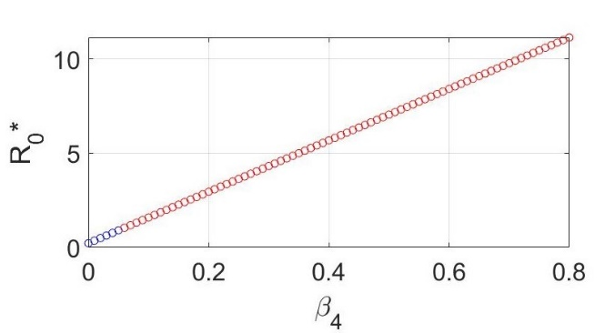 | 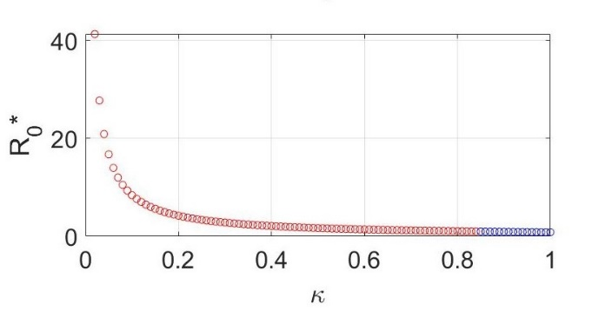
Figure 2. The effect of $β_{4}$ and $κ$ on $R_{0}^{*}$
Next, we observe the dynamics of LSD and choice four different values for $β_{4}$and $κ$. We solve the LSD model (1) by using parameters in Table 1 and the fourth-order Runge-Kutta scheme with the step size $h=0.1$. The values of $β_{4}$ were selected $β_{4} = 0.5,β_{4} = 0.1,β_{4} = 0.05,β_{4} = 0.01$. By selecting these values of $β_{4}$, the corresponding values of $R_{0}^{*}$ are $4.0140, 0.9843, 0.6056$ and 0.3027. The initial values are used to be $N1(0) =(500,25,15,20,10,10,5)$. This simulation is shown in Figure 3. From Figure 3 we know that the more interactions between susceptible cattle and the LSD virus in the environment, it can increase the number of infected cattle subpopulation, infected vectors subpopulation and virus population. However, the fewer interactions between susceptible cattle and the LSD virus in the environment, it can effectively decrease the number of infected cattle subpopulation, infected vectors subpopulation, and virus population
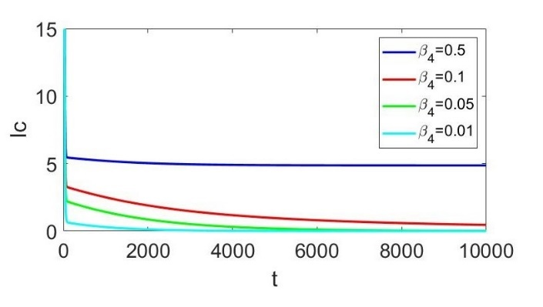 | 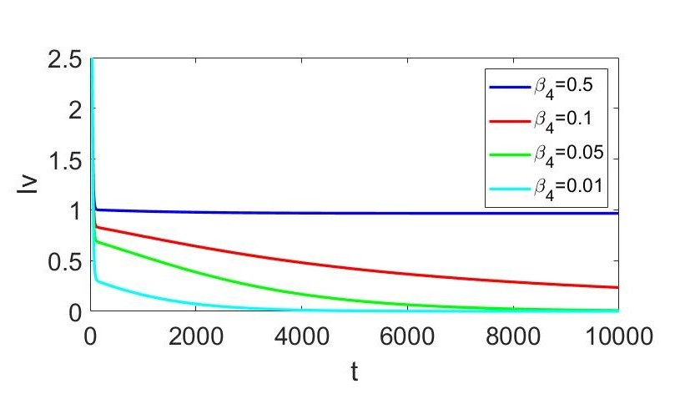
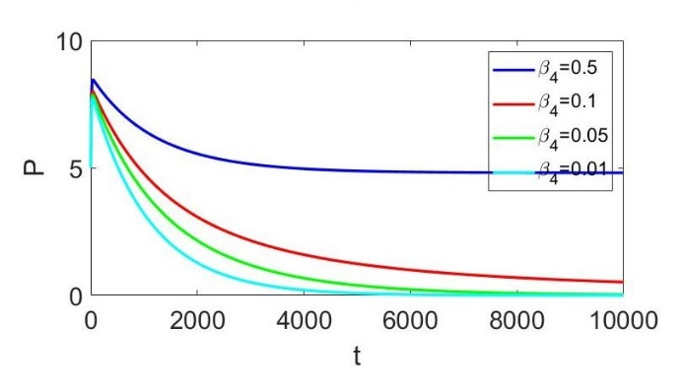
Figure 3. The numerical simulation with several values of $β_{4}$ in $I_{c},I_{v}, P$
Next, we choice the four value for $κ$ there are $κ= 1.2, κ= 0.8,κ= 0.5, κ= 0.15$. By selecting these values of $κ$, the corresponding values of $R_{0}^{*}$ are 0.8526,1.0551,1.6876 and 5.6133. The initial values are used to be $N1(0) = (500,25,15,20,10,10,5)$. This simulation is shown in Figure 4.
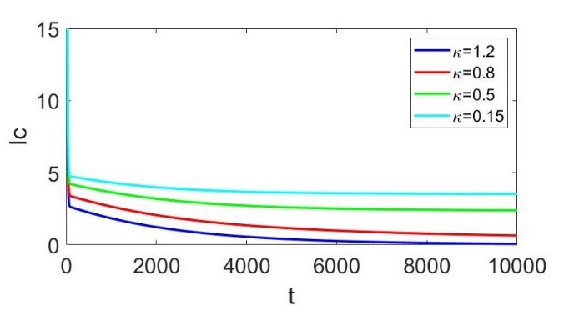 | 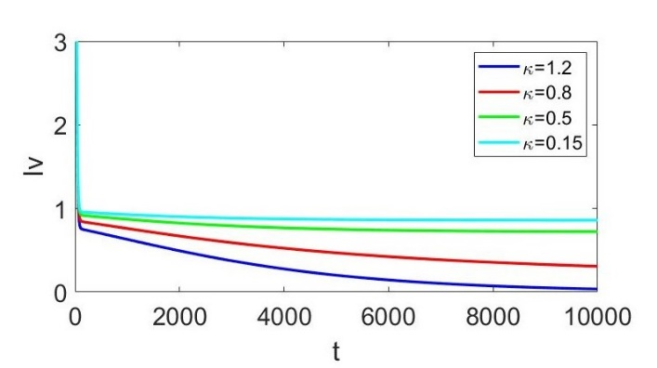
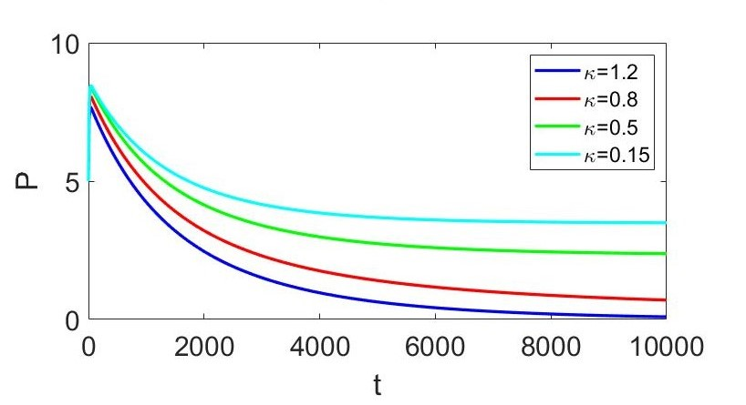
Figure 4. The numerical simulation with several values of $κ$ in $I_{c},I_{v}, P$
Based on the Figure 4 we get information, by increasing vaccination to susceptible cattle, it is effectively to reduce the number of infected cattle subpopulation, infected vectors subpopulation, and virus population. However, by decreasing vaccinations to susceptible cattle, it can increase the number of infected cattle subpopulation, infected vectors subpopulation, and virus population.

Conclusions
In this article, we develop the LSD model which focus on transmission between cattle, infected vectors, and LSDV in the environment. The non-negativity and boundedness of solution of the proposed LSD spread model are proven. The LSD model (1) has two equilibrium points, there are the DFE point $(E^{0})$ and the EE point $(E^{*})$. The DFE point exists and the stability is asymptotically stable for locally and globally if $R_{0}^{*}<1$. The EE exists if it satisfies the criteria and the stability is locally asymptotically if it satisfies the Lienard-Chipart criteria. From the sensitivity analysis, the parameters $β_{4}$ and $κ$ has significant change in the value of $R_{0}^{*}$ . It shows the appropriate strategy to address the LSD outbreak is to increase vaccination for healthy cattle and to reduce the LSD virus in the environment by performing environmental disinfection. The analysis results have been confirmed by our numerical simulations.

Acknowledgments
You may wish to thank those who have supported you and your work.

References

[1] | O. O. Onyejekwe, A. Alemu, B. Ambachew, A. Tigabie. Royle, "Epidemiological Study and Optimal Control for Lumpy Skin Disease (LSD) in Ethiopia,"Advances in Infectious Diseases, vol. 9, pp. 8-24, 2019.
[2] | E.Tuppurainen, K. Dietze, J. Wolff, H. Bergmann, D. Beltran-Alcrudo, A. Fahrion, C. E. Lamien, F. Busch, C. Sauter-Louis, F. J. Conharts, K. De Clercq, B. Hoffmann, S. Knauf, "Review : Vaccines and Vaccination against Lumpy Skin Disease,"Vaccines (Basel). vol.9, 2021.
[3] | A. Sprygin, Ya. Pestova, D. B. Wallace, E. Tuppurainen, A. V. Kononov, " Transmission of lumpy skin disease virus: A short review," Virus Research, pp. 269, 2019.
[4] | I. Shumilova, A. Nesterov, O. Bykovskaya, P. Prutnikov, D. B. Wallace, M. Mokeeva, V. Pronin, A. Kononov, I. Chvala, A. Sprygin, " A Recombinant Vaccine-like Strain of Lumpy Skin Disease Virus Causes Low-Level Infection of Cattle through Virus-Inoculated Feed," Pathogens, vol.11, pp. 920-935, 2022.
[5] | X. Roche, A. Rozstalnyy, D. TagoPacheco, C. Pittiglio,A. Kamata, D. Beltran, K. Bisht, S. Karki, J. Kayamori, F. Larfaoui, E. Raizman, S. Von Dobschuetz, M. S. Dhingra, K. Sumption, "Introduction and spread of lumpy skin disease in South, East and Southeast Asia,"FAO, 2020.
[6] | F. Namazi, A. K. Tafti, " Lumpy skin disease, an emerging transboundary viral disease: A review," Vet. Med. Sci, vol. 7, pp. 888-896, 2021.
[7] | O. D. Falowo, J. A. Owolabi, O. Oludoun, R. Akingbade, "Mathematical Modelling of Lumpy Skin Disease in Dairy Cow," IOP Conf. Series Earth and Env. Sci, 2023.
[8] | W. N. Li, W. Sheng, "Some gronwall type inequalities on time scales," Journal of Mathematical Inequalities, vol. 4, pp.67-76, 2010.
[9] | A. A. M. Daud, "A note on lienard-chipart criteria and its application to epidemic models," Mathematics and Statistics, vol. 9, pp. 41-45, 2021.
[10] | W. F. Alfwzan, M. H. Dasassi, F. M. Allehiany, M. A. Khan, M. Y. Alshahrani, E. M. Tag-eldin,"A novel mathematical study to understand the Lumpy skin disease (LSD) using modified parameterized approach," A Result in Physics, vol. 51, 2023.
[11] | H. Y. Abdulqa, H. Rahman, H. Dyary, H. Othman, "Lumpy Skin Disease," Reproductive Immunology, vol. 4, 2016.
[12] | A. I. Butt, H. Aftab, M. Imran, T. Ismaeel, "Mathematical study of lumpy skin disease with optimal control analysis through vaccination," Alexandria Engineering Journal, vol. 72 , 2023.
[13] | A. Kononov, P. Prutnikov, I. Shumilova, S. Kononova, A. Nesterov, O. Byadovskaya, Y. Pestova, V. Diev, A. Sprygin, "Determination of lumpy skin disease virus in bovine meat and offal products following experimental infection," Transboundary and Emerging Disease, vol. 66, 2019.
[14] | Direktorat Jenderal Peternakan, Lumpy Skin Disease (LSD), Kementerian Peternakan, 2022.
[15] | S. Lee, C. M. Baker, E. Sellens, M. A. Stevenson, S. Roche, R. N. Hall, A. C. Breed, S. M. Firestone, "A systematic review of epidemiological modelling in response to lumpy skin disease outbreaks," Frontiers in Veterinary Science, vol. 11, 2024.
[16] | C. Castillo-Chavez, Z. Feng, W. Huanz, P.V.D. Huanz, .E. Kirschner, On the computation of R0 and its role in global stability, Mathematical Approaches for Emerging and Reemerging Infectious Diseases: An Introduction, Springer-Verlag, vol. 125, 2002.
[17] | S. Moonchai, A. Himakalasa, T. Rojsiraphisal, O. Arjkumpa, P. Panyasomboonying, N. Kuatako, N. Buamithup, V. Punyapornwithaya, "Modelling epidemic growth models for lumpy skin disease cases in Thailand using nationwide outbreak data," Infectious Disease Modelling, vol. 8, pp. 282-293, 2023.

