Spearman Rank Correlation PCA for Mixed Scale Indicator in Structural Equation Modeling
Lisa Asaliontin¹, Eni Sumarminingsih¹, Solimun¹, Mohammad Ohid Ullah²
¹Department of Statistics, Brawijaya University, Indonesia
²Department of Statistics, Shahjalal Univeristy of Science and Technology, Bangladesh
Email: lisaasaliontin@student.ub.ac.id, eni_stat@ub.ac.id, solimun@ub.ac.id, ohid-sta@sust.edu

Abstract
Structural Equation Modeling (SEM) is a statistical modeling technique that integrates relationships between variables and also indicator models simultaneously. In the SEM measurement model, not all latent variables are metric, they can be mixed scales, namely metric and non-metric which have not been widely studied. This study aims to apply the Spearman Rank Correlation Principal Component Analysis (PCA) to handle mixed-scale indicator data in a mixed measurement model (formative and reflective). This method is evaluated on a case study of fertilizer repurchase decisions, resulting in a total determination coefficient of 80%. This shows the flexibility of SEM in handling the complexity of mixed-scale data without sacrificing estimation accuracy. The results showed that the Spearman Rank Correlation PCA was able to store 78.62% of the diversity of data from mixed-scale indicator variables, namely Farmer Demographics (X2). In addition, the results showed that Customer Satisfaction (X1) significantly influenced Repurchase Decisions (Y2) but did not directly affect Customer Engagement (Y1). Farmer Demographics (X2) significantly influences Customer Engagement (Y1) and Repurchase Decisions (Y2), and Customer Engagement has a significant effect on Repurchase Decisions (Y2).

Keywords: Farmer Demographics; Fertilizer Repurchase Decision; Mixed Scale Indicator; Spearman Rank Correlation PCA; Structural Equation Modeling

Introduction
Structural Equation Modeling (SEM) is statistical modeling that involves relationships between variables and also indicator models simultaneously [1]. SEM is an example of dependency analysis that involves the relationship between variables and also the indicator model simultaneously. SEM data analysis provides a comprehensive explanation of the study's variable relationships. For a set of distinct multiple regression equations calculated concurrently, SEM offers the most suitable and effective estimation method [2]. The structural model and the measurement model are its two fundamental parts.
SEM is an analysis that uses latent variables, namely variables that cannot be measured directly (unobservable variables) so that they require indicators as measuring tools. In SEM, a set of linear relationships with multiple dependent variables can be estimated at the same time, and latent variable models can be specified to estimate the relationships between latent constructs and observed indicators [3]. Researchers can look at observations and theoretical ideas at the same time with SEM [4].The relationships between latent variables are described by the structural model. On the other hand, the measurement model explains how latent variables and observed variables (indicators) relate to one another.
There are two main types of measurement models: formative and reflective. Reflective measurement, which is based on factor analysis, requires a common factor because it is an indicator model that reflects variables. However, a common component is not necessary for formative measurement (based on Principal Component Analysis, or PCA); that is, the indicators are not connected with one another [5].
Principal Component Analysis (PCA) is a technique for combining variables from multidimensional data into new variables, expressed as linear combinations of the original variables, while minimizing information loss from the original dataset [6]. At first, data with nonlinear relationships between variables or indicators from mixed-scale latent variables (metric and non-metric) could not be analyzed using Principal Component Analysis, or PCA. In actuality, not all latent variable indicators constitute metric data in its application. Nominal, ordinal, interval, and ratio data can all be separated according to the measuring scale. Nominal and ordinal data scales are qualitative (non-metric), whereas interval and ratio scales are into the quantitative data category (metric) [7]. Therefore, data must be scored in order to be translated into numeric values on a non-metric measurement scale.
In its development, in 2002 a measurement model was introduced on a mixed scale (metric and non-metric). Based on previous research, Yu et al. conducted a study aimed at overcoming the limitations of using Principal Component Analysis using Spearman rank correlation on the correlation matrix [8]. The study's findings show that the use of Spearman rank correlation successfully maintains the nonlinear correlation structure between variables and is computationally more efficient. Research conducted by Watanabe et al. states that the performance of PCA using the Spearman Rank matrix is ​​comparable or sometimes better than the Tau Kendall and Rank Marden matrices [6].
The novelty of this study lies in the application of Spearman Rank Correlation PCA in Structural Equation Modeling (SEM) on a mixed scale indicator model with a mixed measurement model, which until now has not been widely or even never been studied by previous researchers. This study focuses on the innovation of measurement modeling updates, where currently the most developed is measurement modeling with metric measurement scales (interval and ratio), where this measurement scale is less flexible in its use so that this study will involve a measurement model with a mixed measurement scale (metric and non-metric). The Spearman Rank Correlation PCA method will be evaluated in the context of mixed scale data to determine its effectiveness in analyzing latent variables with a formative measurement model.

Methods

Data
This study is a quantitative research that utilizes secondary data collected through questionnaires. The research focuses on farmers as the customers of PT X fertilizer, with a sample size of 250 respondents. The research model is as follows:
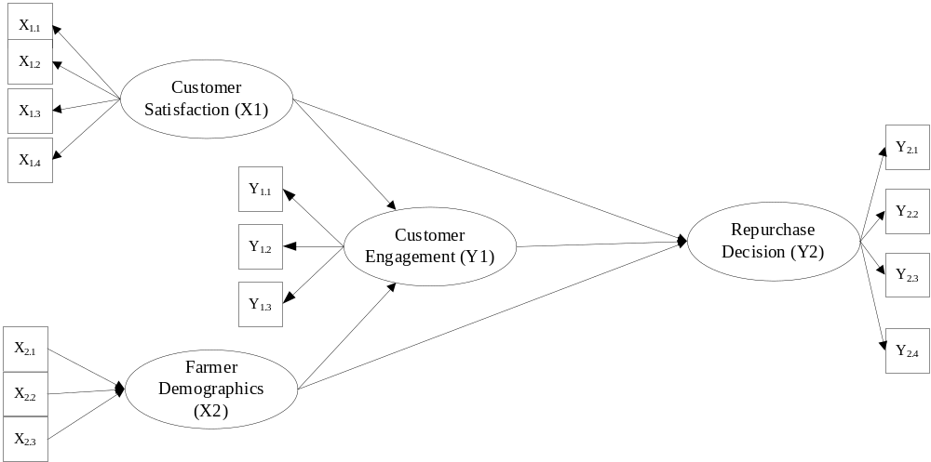
Gambar 1. Research Model
Tables 1 and 2 display the variables and indicators that were employed.
Tabel 1. Research Variables and Indicators
Variables | Measurement Model | Indicator | Scale
Customer satisfaction${(X}_{1})$ | Reflective | General Satisfaction${(X}_{11})$ | Interval
Customer satisfaction${(X}_{1})$ | Reflective | Customer Complaints${(X}_{12})$ | Interval
Customer satisfaction${(X}_{1})$ | Reflective | Satisfaction of Service Received${(X}_{13})$ | Interval
Customer satisfaction${(X}_{1})$ | Reflective | Customer Rating${(X}_{14})$ | Interval
Farmer Demographics${(X}_{2})$ | Formative | Farmer Age${(X}_{21})$ | Ratio
Farmer Demographics${(X}_{2})$ | Formative | Farmer's Last Education${(X}_{22})$ | Ordinal
Farmer Demographics${(X}_{2})$ | Formative | Family Income Level${(X}_{23})$ | Ordinal
Customer Engagement ${(Y}_{1})$ | Reflective | Conscious Attention${(Y}_{1})$ | Interval
Customer Engagement ${(Y}_{1})$ | Reflective | Focused Participation${(Y}_{1})$ | Interval
Customer Engagement ${(Y}_{1})$ | Reflective | Social Connection${(Y}_{1})$ | Interval
Repurchase Decision${(Y}_{2})$ | Formative | Purchase Incentives${(Y}_{21})$ | Interval
Repurchase Decision${(Y}_{2})$ | Formative | Time from Purchase to Goods Received${(Y}_{22})$ | Interval
Repurchase Decision${(Y}_{2})$ | Formative | Seller Response Speed${(Y}_{23})$ | Interval
Repurchase Decision${(Y}_{2})$ | Formative | Transaction System${(Y}_{24})$ | Interval

The Farmer Demographic Variable (X2) is a mixed data scale variable because there are 2 data scales at once in one variable, namely the ratio and ordinal scales which can be detailed in Table 2.
Tabel 1. Research Variables for Principal Component Analysis
Variables |  | Indicator | Observation Data  (Score)
Farmer Demographics${(X}_{2})$ |  | Farmer Age${(X}_{21})$ | Year
 |  | Farmer's Last Education${(X}_{22})$ | No School (1)
 |  | Farmer's Last Education${(X}_{22})$ | Elementary School (2)
 |  | Farmer's Last Education${(X}_{22})$ | Junior High School (3)
 |  | Farmer's Last Education${(X}_{22})$ | High School (4)
 |  | Farmer's Last Education${(X}_{22})$ | Lecture (5)
 |  | Family Income Level${(X}_{23})$ | $<Rp500.000$per month(1)
 |  | Family Income Level${(X}_{23})$ | $Rp500.000-Rp1.000.000$ per month (2)
 |  | Family Income Level${(X}_{23})$ | $Rp1.000.001-Rp3.000.000$ per month (3)
 |  | Family Income Level${(X}_{23})$ | $Rp3.000.001-Rp10.000.000$ per month (4)
 |  | Family Income Level${(X}_{23})$ | $Rp10.000.000-Rp30.000.001$ per month (5)

Spearman Rank Correlation PCA
Principal Component Analysis (PCA) is a statistical method that applies an orthogonal transformation to convert a dataset of potentially correlated variables into a new set of linearly uncorrelated variables [9]. PCA reduces the dimensions of a dataset while preserving as much of its statistical variability as possible [10]. It achieves this by computing the eigenvectors of the covariance matrix derived from the input data. Through this process, PCA performs a linear transformation, converting the high-dimensional input vector into a lower-dimensional representation with uncorrelated components [11]. Spearman rank correlation PCA is a PCA with an input matrix in the form of a Spearman rank correlation matrix. Like PCA in general, Spearman rank correlation PCA is used to acquire data representing latent variables, namely in the form of principal component scores. Spearman rank correlation coefficient using equation (1).
$$r_{sj}=1-\frac{6\sum_{i=1}^{N}{d_{i}^{2}}}{N^{3}-N} (1)$$
The following is the correlation matrix which can be seen in equation (2)
$$R=\left[\begin{matrix}1 & r_{12} & \begin{matrix}⋯ & r_{1m}\end{matrix} \\ r_{21} & 1 & \begin{matrix}⋯ & r_{2m}\end{matrix} \\ \begin{matrix}⋮ \\ r_{m1}\end{matrix} & \begin{matrix}⋮ \\ r_{m2}\end{matrix} & \begin{matrix}\begin{matrix}⋱ \\ ⋯\end{matrix} & \begin{matrix}⋮ \\ 1\end{matrix}\end{matrix}\end{matrix}\right] (2)$$
information:
$$r_{sj}$$ | : | correlation value between indicators in the same variable
$$R$$ | : | sample correlation matrix

Confirmatory Factor Analysis (CFA)
Confirmatory Factor Analysis (CFA) is a statistical method used to assess the measurement of latent variables by modeling their relationships with observed indicators believed to represent them [12]. CFA assesses whether the empirical evidence supports an imagined link between manifest indicators and latent components [13]. Latent variables, are those that are not directly measurable but can be constructed and shaped by other factors that are [2]. Reflective models, also known as confirmatory factor models, use factor analysis to extract latent variable data in the form of factor scores.

Ramsey’s RESET Test
The relationship between independent and dependent variables must be linear, according to the linear regression assumption of linear relationships [14]. Ramsey first proposed the Regression Specification Error verify, or RESET, in 1969 as a way to verify the linearity assumption. The steps to apply RESET are as follows [15]:

Regress $X_{1}$ on $Y_{i}$. The equation of ${\hat{Y}}_{i}$as an endogenous variable in the model is presented in the form of equation (3).
$${\hat{Y}}_{i}={\hat{β}}_{0}+{\hat{β}}_{1}X_{1i} \left(3\right)$$
Calculating the coefficient of determination according to equation (3) as $R_{1}^{2}$ which is presented in the equation (4).
$$R_{1}^{2}=1-\frac{\sum_{i=1}^{n}{{\left(Y_{i}-{\hat{Y}}_{i}\right)}^{2}}}{\sum_{i=1}^{n}{{\left(Y_{i}-\overline{Y}\right)}^{2}}} (4)$$
Regress $X_{1}$ on $Y_{i}$ nd two additional predictor variables ${\hat{Y}}_{i}^{2}$ and ${\hat{Y}}_{i}^{3}$. Furthermore $Y_{i}^{*}$ as the response variable is presented in equation (5).
$$Y_{i}^{*}=β_{0}^{*}+β_{1}^{*}X_{1i}+β_{2}{\hat{Y}}_{i}^{2}+β_{3}{\hat{Y}}_{i}^{3}+ε_{i}^{*} (5)$$
Then, calculate ${\hat{Y}}_{i}^{*}$ as per the model in equation (6).
$${\hat{Y}}_{i}^{*}={\hat{β}}_{0}^{*}+{\hat{β}}_{1}^{*}X_{1i}+{\hat{β}}_{2}{\hat{Y}}_{i}^{2}+{\hat{β}}_{3}{\hat{Y}}_{i}^{3} (6)$$
Calculate the coefficient of determination according to equation (6) as $R_{2}^{2}$ presented in equation (7).
$$R_{2}^{2}=1-\frac{\sum_{i=1}^{n}{{\left(Y_{i}-{\hat{Y}}_{i}^{*}\right)}^{2}}}{\sum_{i=1}^{n}{{\left(Y_{i}-\overline{Y}\right)}^{2}}} (7)$$
Testing the linearity between predictor variables and the response with the following hypothesis.
$$H_{0} : β_{2}=β_{3}=0$$
$$H_{1} : there is at least one β_{j}≠0;j=2,3$$
with test statistics following the F distribution according to equation (8).
$$F_{value}=\frac{(R_{2}^{2}-R_{1}^{2})/m}{(1-R_{2}^{2})/(n-k-1-m)}\sim { F}_{m,n-k-1-m} (8)$$
Information:
n : number of observations
k : the number of initial predictor variables
m : number of additional predictor variables
Drawing conclusions based on the results obtained with the criteria if the test statistic $F_{value}>F_{(α,m,n-k-1-m)}$ or $p-value>α$ then Accept $H_{0}$ means that the relationship between variables is linear.

Analysis Steps
The analysis methods used are PCA Spearman Rank Correlation and CFA in SEM. Data analysis in this study was carried out using the help of R Studio software. The analysis steps are as follows.
- Identifying data based on the nature of the indicators of the latent variables, namely formative for the Farmer Demographics variable (X2) and reflective forCustomer Satisfaction (X1), Customer Engagement (Y1), and Repurchase Decisions (Y2)
- Conducting Spearman Rank Principal Component Analysis on Variable X2 and Confirmatory Factor Analysis on Variable X2Customer Satisfaction (X1), Customer Engagement (Y1), and Repurchase Decisions (Y2)
- Creating a Structural Equation Modeling path diagram.
- Convert path diagrams into systems of equations to form structural and measurement models.
- Checking the linearity assumption of the structural model of SEM analysis with Ramsey's RESET Test
- Estimating parameters using the PLS (Partial Least Square) method
- Conducting hypothesis testing
- Checking validity on structural models and measurement models
- Interpreting the results

Results and Discussion

Spearman Rank Correlation PCA
Variables that have indicators with mixed scales are analyzed using Spearman rank correlation PCA, is used to generate eigenvalues and component weights. Table 3 displays the resultant eigenvalues.
Table 3. Eigenvalues ​ Spearman Rank Correlation PCA
Variables | Dimensions/PC | Eigenvalues | Diversity Proportion | Cumulative Percent Diversity
Farmer Demographics (X₂) | 1 | 2,4004 | 0.7862 | 0.7862
Farmer Demographics (X₂) | 2 | 0.5245 | 0.1718 | 0.9580
Farmer Demographics (X₂) | 3 | 0.1307 | 0.0428 | 1
The first component, also known as PC1, which represents the latent variable under analysis, is the primary component that has the highest cumulative value of percent diversity on Table 3. In the X2 variable, the main component produced is able to store78.62% of the diversity of all indicators, while the remaining 21.38% is not stored (wasted).
From the eigenvalues, the component weights will be obtained. Table 3 shows the results of the component weights of each indicator. The component weights show the relative contribution of each indicator to the formation of each main component. The resulting component weights are presented in Table 4.
Table 4. Weights Spearman Rank Correlation PCA
Variables | Indicator | Component weight
Farmer Demographics ($X_{2}$) | Farmer Age${(X}_{21})$ | 0.6354
Farmer Demographics ($X_{2}$) | Farmer's Last Education${(X}_{22})$ | 0.3482
Farmer Demographics ($X_{2}$) | Family Income Level${(X}_{23})$ | 0.6893
Based on the weight of the main components of Spearman rank correlation, the indicator variable Demographic Farmers ($X_{2}$) which has the greatest weight is the indicator of Farmer Income Level ${(X}_{23}$) which means that the indicator of Farmer Income Level ${(X}_{23}$) is the dominant indicator in shaping the Demographic Farmer Variable ($X_{2}$). Table 4 allows for the creation of a linear combination equation of the primary components, which yields a component score that serves as the Farmer Demographics variable's value ($X_{2}$).
$$X_{2}=0.6354X_{2.1}+0.3482X_{2.2}+0.6893X_{2.3}$$

Confirmatory Factor Analysis
Variables that have indicators with interval scales and are reflective are analyzed using Confirmatory Factor Analysis. Table 5 shows the results of the loading values ​​of each indicator.
Table 5. Confirmatory Factor Analysis Component Loadings
Variables | Indicator | Loading | P-Value
Customer satisfaction${(X}_{1})$ | General Satisfaction${(X}_{11})$ | 0.635 | <0.001
Customer satisfaction${(X}_{1})$ | Customer Complaints${(X}_{12})$ | 0.630 | <0.001
Customer satisfaction${(X}_{1})$ | Satisfaction of Service Received${(X}_{13})$ | 0.674 | <0.001
Customer satisfaction${(X}_{1})$ | Customer Rating${(X}_{14})$ | 0.888 | <0.001
Customer Engagement${(Y}_{1})$ | Conscious Attention${(Y}_{1})$ | 0.553 | <0.001
Customer Engagement${(Y}_{1})$ | Focused Participation${(Y}_{1})$ | 0.721 | <0.001
Customer Engagement${(Y}_{1})$ | Social Connection${(Y}_{1})$ | 0.418 | <0.001
Repurchase Decision${(Y}_{2})$ | Purchase Incentives${(Y}_{21})$ | 0.726 | <0.001
Repurchase Decision${(Y}_{2})$ | Time from Purchase to Goods Received${(Y}_{22})$ | 0.927 | <0.001
Repurchase Decision${(Y}_{2})$ | Seller Response Speed ${(Y}_{23})$ | 0.568 | <0.001
Repurchase Decision${(Y}_{2})$ | Transaction System${(Y}_{24})$ | 0.139 ns | 0.608
It is evident from Table 5 that in the Customer Satisfaction ${(X}_{1}$), and Customer Engagement ${(Y}_{1}$) variables, all indicators have a p-value smaller than 0 05 so that these indicators can reflect the Customer Satisfaction ${(X}_{1}$), Customer Engagement ${(Y}_{1}$) variables. Meanwhile, in the Repurchase Decision Variable (Y2) there is a Transaction System indicator ${(Y}_{24})$ with a p-value> 0.05, which can be concluded that the Transaction System indicator does not reflect the Repurchase Decision variable so that the indicator does not need to be used in the analysis. Indicators that reflect the Repurchase Decision Variable ${(Y}_{2}$) are Item Purchase Incentives ${(Y}_{21})$, Purchase Time until Goods Received ${(Y}_{22})$ and Seller Response Speed ${(Y}_{23})$.
According to the factor loading values, it can be seen that the most dominant indicator in reflecting the variable is the indicator with the highest outer loading value. The indicator that best reflects the Customer Satisfaction variable ${(X}_{1}$) is Customer Assessment${ (X}_{14})$ with a loading of 0.888. In the Customer Engagement variable ${(Y}_{1}$), the most dominant indicator in reflecting the Customer Engagement Variable is Focused Participation ${(Y}_{1}$) with a loading of 0.721. Meanwhile, the indicator of Purchase Time until Goods Received ${(Y}_{22})$is the most dominant indicator in reflecting the Repurchase Decision variable (Y2) with a loading of 0.927.

SEM Model Path Diagram
The path diagram resulting from the design of the SEM Model can be seen in Figure 3.

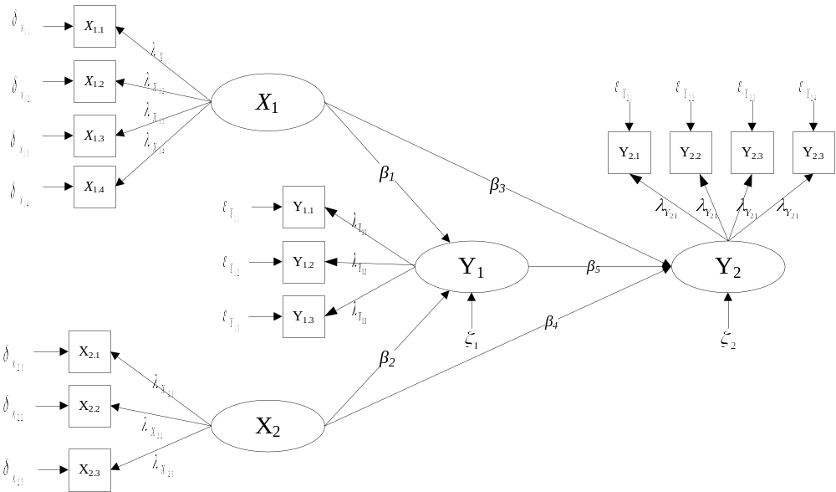
Figure 2. SEM Path Diagram
Information:
$X_{i}$ : exogenous latent variable to-i
$Y_{g}$ : endogenous latent variable to-g
$X_{ij}$ : exogenous variable to-i indicato r to-j
$Y_{gk}$ : endogenous variable to-g indicator to-k
$λ_{xij}$ : coefficient loading exogenous variable to-i indicator to-j
$λ_{ygk}$ : coefficient loading endogenous variable to-g indicator to-k
$β$ : coefficient of influence of latent variables
$δ_{X_{i}}$ : error measurement on exogenous latent variables
$ε_{Y_{g}}$ : error measurement on endogenous latent variables
$ζ_{g}$ : error g-model

Based on the SEM model, an inner model or structural model is formed as follows:
$$Y_{1i}=β_{01}+β_{1}X_{1i}+β_{1}X_{1i}+ζ_{1i} (9)$$
$$Y_{2i}=β_{02}+β_{3}X_{1i}+β_{4}X_{2i}+β_{5}Y_{1i}+ζ_{2i} (10)$$

Which can be described in matrix form as follows:
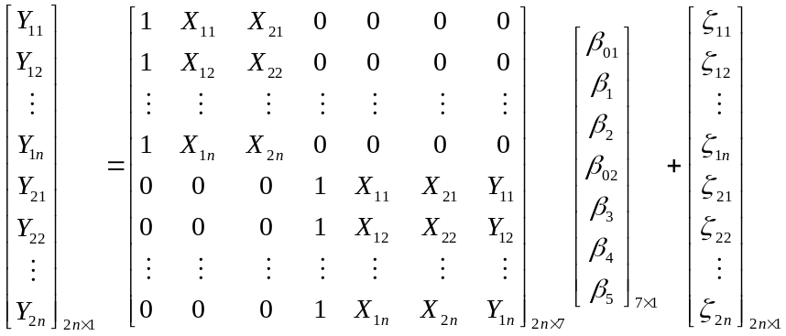
Or it can be written in matrix notation, as in equation (11):
$$Y_{2n×1}=X_{2n×7}β_{7×1}+ζ_{7n×1} (11)$$

Results of Structural Model Linearity Assumption Test
The assumptions in SEM analysis are only related to structural modeling, where the relationship between latent variables in the structural model is linear. Table 6 displays the outcomes of the linearity assumption test using Ramsey's RESET Test.
Table 6. Linearity Test Results
Variables | P-value | Connection
X1 to Y1 | 0.6326 | Linear
X1 to Y2 | 0.9954 | Linear
X2 to Y1 | 0.7224 | Linear
X2 to Y2 | 0.8063 | Linear
Y1 to Y2 | 0.8932 | Linear
Table 6 shows that a p-value > α (5%) is produced by the link between latent variables, so it is decided that H₀ is accepted and it is concluded that all relationships between latent variables in the fertilizer repurchase decision data are linear.

Parameter Estimation and Hypothesis Testing of Structural Models
Hypothesis testing of the structural model using the t-test. The results of the structural model hypothesis testing can be seen in Table 7. and Figure 3. below.
Table 7. Results of Structural Model Hypothesis Testing
Relationship Between Variables | Path Coefficient | p-value | Information
X1 to Y1 | 0.0434 ns | 0.066 | Not Significant
X2 toY1 | 0.2662 | <0.001 | Significant
X1 to Y2 | 0.6879 | <0.001 | Significant
X2 to Y2 | 0.0815 | <0.001 | Significant
Y1 to Y2 | 0.1333 | <0.001 | Significant

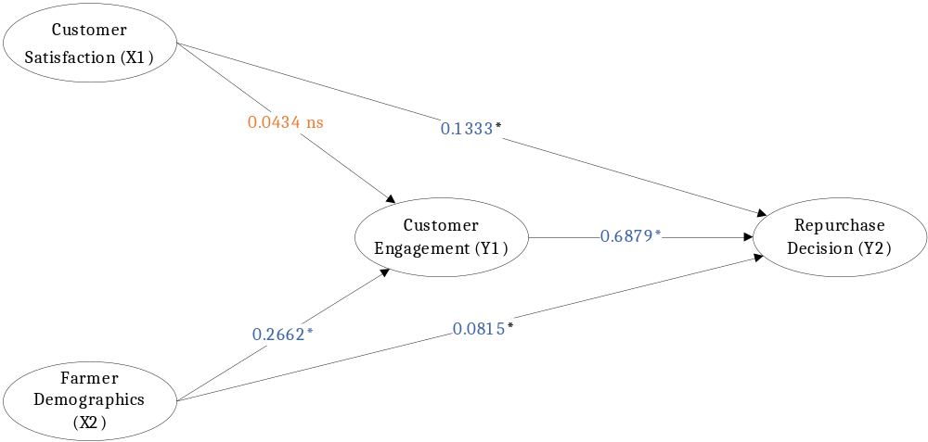
Figure 3. Structural Model Hypothesis Testing
Based on the inner model path coefficients, the function estimate is obtained through:
$$Y_{1i}=β_{01}+β_{1}X_{1i}+β_{1}X_{1i}+ζ_{1i}$$
$$Y_{2i}=β_{02}+β_{3}X_{1i}+β_{4}X_{2i}+β_{5}Y_{1i}+ζ_{2i}$$
By performing standardization, the following equation is produced:
$$Y_{Y1}=β_{1}Z_{X1}+β_{2}Z_{X2}+ζ_{1}$$
$$Y_{Y2}=β_{3}Z_{X1}+β_{4}Z_{X2}+β_{5}Z_{Y1}+ζ_{2}$$
So the estimated function of the Fertilizer Repurchase Decision is:
$$Z_{Y_{1}}={0.0434 Z}_{X_{1}}+{0.2662Z}_{X_{2}}$$
$$Z_{Y_{2}}={0.6879Z}_{X_{1}}{+ 0.0815Z}_{X_{2}}+ {0.1333Z}_{Y1}$$
The association between Customer Satisfaction (X1) and Customer Engagement (Y1) is significant with a coefficient value of 0.1333. This suggests that consumers' (farmers') degree of engagement increases with customer satisfaction. This means that when customers are satisfied, they tend to have a stronger relationship with the products or services they use. The relationship between Customer Satisfaction (X1) and Repurchase Decisions (Y2) is not significant, with a coefficient of 0.0434. This shows that the level of customer satisfaction does not directly influence their decision to make a repurchase. Although satisfaction is an important factor, it does not directly encourage customers to make repurchase decisions. Furthermore, the relationship between Farmer Demographics (X2) and Customer Engagement (Y1) is significant with a coefficient of 0.2662. This shows that the demographic characteristics of farmers play an important role in increasing customer engagement. This indicates that the demographic characteristics of farmers, namely the age of farmers, the last education of farmers, and the level of family income of farmers can be factors that increase customer interest and engagement in fertilizer products. In addition, the relationship between Farmer Demographics (X2) and Repurchase Decisions (Y2) is significant, with a coefficient of 0.0815. This shows that the characteristics or demographics of farmers including age, education level, and family income of farmers have an influence in driving farmers' decisions to make repeat purchases. Furthermore, the relationship between Customer Attachment (Y1) and Repurchase Decisions (Y2) is significant with a coefficient value of 0.6879. This means that the higher the attachment felt by farmers, the higher the likelihood of farmers to make repeat purchases. Customer attachment plays an important role in shaping repurchase decisions, where when customers feel emotionally or functionally attached to a product or service, farmers tend to consider buying it again in the future.

Structural Model Evaluation
The R-Square value or coefficient of determination of each endogenous variable in each model can be used to evaluate the structural model. Table 8 displays the endogenous variables' R-Square values.
Table 8. R-Square Structural Model
Coefficient of Determination$Y_{1}$ | Coefficient of Determination$Y_{2}$ | Total Determination Coefficient
0.322174 | 0.6291078 | 1 – (0.322174)( 0.6291078) = 0.7973$≈0,8$
Based on Table 8, the total determination coefficient value is 0.8, which means that the model can explain 80% of the data diversity, while the remaining 20% ​​is explained by other variables outside the research model.

Conclusions
Based on the results and discussion, it can be concludedSpearman Rank Correlation PCA is able to store 78.62% of data diversity from variables with mixed-scale indicators, namely Farmer Demographics (X2). Structural Equation Modeling is capable of integrating PCA Spearman Rank Correlation and Confirmatory Factor Analysis to handle mixed scale indicators (metric and non-metric) and mixed measurement models (reflective and formative). This shows that Structural Equation Modeling is a flexible analysis in handling the complexity of mixed data without reducing the accuracy of the estimate. In addition, the application of SEM with PCA Spearman Rank Correlation and Confirmatory Factor Analysis in the case study of fertilizer repurchase decisions shows good ability in capturing data variations with a total determination coefficient of 80%. In addition, it is concluded that Customer Satisfaction (X1) affects significantly on Repurchase Decision Engagement (Y2) but does not directly affect Customer Engagement (Y1), while Farmer Demographics (X2) affects significantly on Customer Engagement (Y1) and Repurchase Decisions (Y2), and Customer Engagement affects significantly on Repurchase Decisions (Y2).

Acknowledgments
The authors would thank to departement statistics, brawijaya university for their support and to the editors and reviewers for their feedback and suggestions.

References
[1] A. A. R. Solimun, Fernandes, Nurjannah, “Metode Statistika Multivariat Pemodelan,” 2017.
[2] J. Joseph F. Hair, W. C. Black, B. J. Babin, and R. E. Anderson, Multivariate Data Analysis (Eighth Edition), vol. 19, no. 3. 2019. doi: 10.5117/2006.019.003.007.
[3] E. Ryu, “Model fit evaluation in multilevel structural equation models,” Front. Psychol., vol. 5, no. FEB, pp. 1–9, 2014, doi: 10.3389/fpsyg.2014.00081.
[4] A. S. Albahri et al., “Based on the multi-assessment model: Towards a new context of combining the artificial neural network and structural equation modelling: A review,” Chaos, Solitons and Fractals, vol. 153, p. 111445, 2021, doi: 10.1016/j.chaos.2021.111445.
[5] H. Chen and Y. Wang, “A Penalized Spline Approach to Functional Mixed Effects Model Analysis,” Biometrics, vol. 67, no. 3, pp. 861–870, 2011, doi: 10.1111/j.1541-0420.2010.01524.x.
[6] K. Watanabe, K. Naito, and I. Koch, “Robustness of Principal Component Analysis with Spearman’s Rank Matrix,” J. Stat. Theory Pract., vol. 18, no. 1, pp. 1–29, 2024, doi: 10.1007/s42519-023-00358-z.
[7] Solimun, A. A. R. Fernandes, Nurjannah, E. G. Erwinda, R. Hardianti, and L. H. Y. Arini, METODOLOGI PENELITIAN Variabel Mining berbasis Big Data dalam Pemodelan Sistem untuk mengungkap Research Novelty, no. c. 2023.
[8] H. Yu, F. Khan, and V. Garaniya, “A Sparse PCA for Nonlinear Fault Diagnosis and Robust Feature Discovery of Industrial Processes,” AIChE J., vol. 62, no. 5, pp. 215–228, 2016, doi: 10.1002/aic.
[9] S. Karamizadeh, S. M. Abdullah, A. A. Manaf, M. Zamani, and A. Hooman, “An Overview of Principal Component Analysis,” J. Signal Inf. Process., vol. 04, no. 03, pp. 173–175, 2013, doi: 10.4236/jsip.2013.43b031.
[10] I. T. Jollife and J. Cadima, “Principal component analysis: A review and recent developments,” Philos. Trans. R. Soc. A Math. Phys. Eng. Sci., vol. 374, no. 2065, 2016, doi: 10.1098/rsta.2015.0202.
[11] X. Kong, C. Hu, and Z. Duan, Principal component analysis networks and algorithms. 2017. doi: 10.1007/978-981-10-2915-8.
[12] J. M. Roos and S. Bauldry, Confirmatory Factor Analysis. United States of America: SAGE Publications, 2022.
[13] D. Goretzko, K. Siemund, and P. Sterner, “Evaluating Model Fit of Measurement Models in Confirmatory Factor Analysis,” Educ. Psychol. Meas., vol. 84, no. 1, pp. 123–144, 2024, doi: 10.1177/00131644231163813.
[14] D. Schreiber-Gregory and K. Bader, “Logistic and Linear Regression Assumptions: Violation Recognition and Control,” SESUG Pap. 247, no. May, pp. 1–22, 2018, [Online]. Available: https://www.researchgate.net/publication/341354759
[15] A. A. R. Fernandes, Solimun, Nurjannah, and L. Amaliana, Analisis Regresi Dalam Pendekatan Fleksibel (Ilustrasi dengan Paket Program R). 2021.

