Development of Semiparametric Truncated Spline Logistic Path Analysis on Balinese Farmer Inclusiveness Data
Sasi Wilujeng Sri Rejeki¹, Solimun¹, Nurjannah¹
¹ Department of Statistics, Faculty of Mathematics and Natural Sciences, Universitas Brawijaya
Email: sasiwsr@student.ub.ac.id , solimun@ub.ac.id, nur.jannahfmipa@gmail.com

Abstract
Abstract: This study develops a semiparametric truncated spline logistic path analysis model to investigate the relationship between variables influencing Balinese farmer inclusiveness. The proposed method extends traditional logistic regression by addressing nonlinear relationships through the use of truncated spline functions. The research utilizes data from 176 farmer groups, focusing on price volatility and human resource quality as exogenous variables, while farmer productivity and welfare serve as endogenous variables. The results indicate that optimal knot selection significantly improves the model's accuracy, sensitivity, and specificity, revealing critical threshold points in variable relationships. Findings demonstrate that moderate price volatility enhances productivity and welfare, whereas extreme fluctuations negatively impact these outcomes. Moreover, the quality of human resources shows a substantial direct effect on both productivity and welfare, underscoring the importance of education and skill development in achieving sustainable agricultural success. This model provides policymakers with a robust framework for addressing nonlinear dynamics in farmer inclusivity, contributing to equitable and effective agricultural policies.
Keywords: farmer inclusiveness, human resources, price volatility, semiparametric logistic path, truncated spline

Introduction
Regression analysis is a method used to describe the relationship between endogenous and exogenous variables. Typically, regression analysis is applied to examine data on quantitative (continuous) response variables that follow a normal distribution. Research on regression analysis has evolved in line with the need to understand the relationship between endogenous and exogenous variables. Generally, regression analysis is applied to data involving quantitative response variables with a normal distribution. However, in various fields such as education, social sciences, economics, and health, endogenous variables are often categorical. This necessitates the use of logistic regression models to explain the relationship between categorical response variables and predictor variables, which can be either continuous or categorical [1]. Logistic regression models facilitate the analysis of binary dependent variables with one or more independent variables, but they rely on the assumption of a linear relationship on the logit scale, which may not always capture more complex data patterns [2].
Advancements in regression analysis methods aim to address the limitations of the linearity assumption in logistic regression models by introducing nonparametric models, such as nonparametric logistic regression with a spline approach. The relationship between independent and dependent variables to vary according to data patterns without enforcing a strictly linear relationship [3]. Splines enable models to accommodate nonlinear changes, providing more accurate estimates in situations where the relationship between variables is not predefined. For example, the study by Islamiyati et al. [4]demonstrated that a binary logistic regression model with a single knot spline achieved high accuracy in classifying nutritional status . Similarly, Arifin [5]showed that ordinal logistic regression models with truncated spline estimators effectively captured changes in data behavior across different intervals.
Further research by Hidayat & Achmad [6] highlighted the flexibility of truncated spline estimators in handling complex data through the selection of optimal knots. This knot selection, conducted using the Generalized Cross Validation (GCV) method, significantly improved model performance. The approach is beneficial in addressing patterns of variable relationships that cannot be captured by conventional binary logistic regression models, as explained by Harrell [7]. Although nonparametric logistic regression with truncated splines excels at identifying nonlinear patterns, it is not yet sufficient for analyzing causal relationships involving multiple pathways. This limitation underscores the need for further development of path analysis [8].
Semiparametric truncated spline logistic path analysis emerges as a flexible approach to model complex and nonlinear relationships, especially in cases involving intervening variables. This method can be applied to issues such as farmer inclusivity in Bali, which aims to integrate small-scale farmers into agricultural value chains [9]. Subak, a traditional institution in Bali, plays a critical role in managing water resources for agriculture but faces challenges that hinder the growth of the agricultural sector. Ardana et al. [10]emphasized the importance of community-based policies and stakeholder collaboration to enhance farmer inclusivity while respecting Bali's cultural landscape.
The welfare of farmers integrated within inclusivity initiatives has a direct impact on national food security, as prosperous farmers are better positioned to enhance the quality and productivity of their agricultural activities [11]. High productivity provides opportunities for farmers to increase their income and overall welfare. Barrett et al. [12]stated that higher productivity enables income diversification, further supporting farmer well-being. Thus, policies that support linear improvements in productivity are essential for enhancing farmer welfare. Additionally, Martins-Filho & Torero [13]demonstrated that food price volatility affects productivity, while Oktavia et al. [14]emphasized the positive impact of human resource quality on agricultural productivity. Consequently, semiparametric truncated spline logistic path analysis is expected to capture the relationships between these variables more accurately, facilitating more effective and equitable policymaking for farmers in Bali.

Methods
The data used in this study consists of secondary data and simulation data. The secondary data was obtained from a research grant conducted by Solimun et al. [15]. This data was collected through a questionnaire survey targeting farmers who are members of farmer groups in Bali Province, an operational area of a state-owned fertilizer company. The population includes 477,439 individuals distributed across 12,323 farmer groups. These farmers are group members, landowners, and have at least a senior high school (or equivalent) level of education. The sample size was determined using the Slovin formula as follows.
$$n=\frac{N}{1+N{\left(e\right)}^{2}}$$ | (1)
wich
n : sample size
N : population size
e : tolerable error rate (5-10%)
The population (N) in this study is as many as 12,323 farmer groups from Bali Province who use fertilizer from one of the SOEs. With an error rate of 7.5%, the sample can be calculated as follows.
$n=\frac{12.323}{1+12.323{\left(0,075\right)}^{2}}=175,25≈176$ Farmer Group
Based on these calculations, the sample used for this study was rounded up into 176 farmer groups. Each farmer group is taken as many as one member. Thus, many samples n = 176 farmers.
The variables used in this study are Price Volatility $(X_{1})$ and Quality of Human Resources $(X_{2})$ as exogenous variables in the form of farmers' perceptions assessed with likert-scale indicators. The Farmer Income $\left(Y_{1}\right)$ and Farmer Welfare Status $\left(Y_{2}\right)$ variables are endogenous variables on a binary ordinal scale with categories of 0 (low) and 1 (high). The conceptual model of the research is presented in Figure 1.

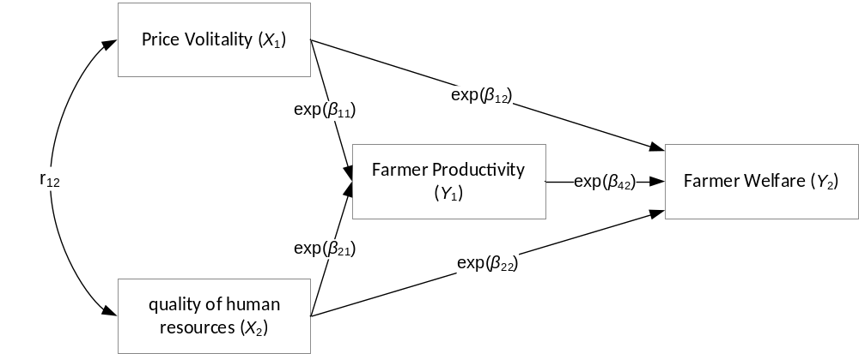
Figure 1. Research Conceptual Model
Based on the conceptual model above, a Semiparametric Truncated Spline Logistics Path Analysis will be developed as follows:
$π_{1i}(X_{1i},{{(X}_{1i}+K_{1})}_{+}, X_{2i } )=\frac{exp⁡(β_{01}+{}_{11}X_{1i}+{}_{21}{{(X}_{1i}+K_{11})}_{+}+{}_{31}X_{2i})}{1+exp⁡(β_{01}+{}_{11}X_{1i}+{}_{21}{{(X}_{1i}+K_{11})}_{+}+{}_{31}X_{2i}))}$ $π_{2i}\left(X_{1i},X_{2i },Y_{1i}\right)=\frac{exp⁡(β_{02}+{}_{12}X_{1i}+{}_{32}X_{2i}+{}_{42}Y_{1i})}{1+exp⁡(β_{02}+{}_{12}X_{1i}+{}_{32}X_{2i}+{}_{42}Y_{1i})}$ | (2)
To facilitate the calculation of parameter estimation, it can be written in the logit model in the equation (3).
$\log\left(\frac{π_{1i}}{1-π_{1i}}\right)=β_{01}+{}_{11}X_{1i}+{}_{21}{{(X}_{1i}+K_{11})}_{+}+{}_{31}X_{2i}$  $\log\left(\frac{π_{2i}}{1-π_{2i}}\right)=β_{02}+{}_{12}X_{1i}+{}_{32}X_{2i}+{}_{42}Y_{1i}$ | (3)
with truncated function:
${{(X}_{1i}+K_{11})}_{+}=\left\{\begin{aligned}{(X}_{1i}+K_{11}) \\ 0\end{aligned}\begin{matrix}; X_{1i}≥K_{11} \\ ; X_{1i}<K_{11}\end{matrix}\right.$
The selection of the best knots leads more to parsimony or simplicity of the model. The optimal knot selection is carried out based on the value of the smallest GCV (Generalized Cross Validation) [16]. GCV for a spline model with K number of knots is defined as the ratio between the Mean Squared Error (MSE) for a model with K knots to the square of the number of diagonal (trace) of the I-A(K) matrix, normalized by the sample size n. Where A(K) is the hat matrix for the model with K knots, I is the identity matrix, and n is the number of observations in the dataset. The GCV formula is as shown in equation (4).
$GCV\left(K\right)=\frac{MSE(K)}{{\left(n^{-1}trace\left(I-A\left(K\right)\right)\right)}^{2}}$ | (4)
Logistics line parameters can be estimated by the Maximum Likelihood Estimation (MLE) method [1]. The MLE method is a technique used to estimate the parameters of a probability distribution based on the observed data. MLE aims to find parameter values that maximize the likelihood function, i.e. a function that states the likelihood that the observed data appears based on certain parameters of the probability model [17]. If$θ$ is the estimated parameter vector and X is the observation data, then the likelihood function $L(θ|X)$ represents the probability of X data given the parameter $θ$. Thus, likelihood $θ$ from the observation data can be expressed in equation (5).
$L\left(θ | X\right)∝P\left(X,θ\right)$ | (5)
The purpose of MLE is to find $\hat{θ}$ which maximizes $L(θ|X).$ In practice, it is easier to use the concept of working with log-likelihood functions, which is the logarithm of the likelihood function as in equation (6).
$l\left(θ | X\right)=\ln{L\left(θ | X\right)}$ | (6)
To achieve value $\hat{θ}$ which maximizes $l(θ|X)$ by finding the first derivative of log-likelihood to and equalizing it to zero as in equation (7).
$$\frac{∂l\left(θ | X\right)}{∂θ}=0$$ | (7)
To ensure the value of $\hat{θ}$ has maximized $l(θ|X)$, can check the second derivative of log-likelihood with the value $\hat{θ}$ negative values [18]. However, in some models it is not possible to estimate the parameters directly, so an iterative method is needed to gradually improve the estimate to get closer to the value $\hat{θ}$ the most convergent. Convergence is achieved when the change in parameter estimation between iterations is very small. The iterative method that is often used is the Newton-Raphson method which refers to the first and second derivatives of the log-likelihood function with iterations $θ^{t+1 }=θ^{t}-{\left(H^{t}\right)}^{-1}q^{t}$, wich $θ$ is a parameter vector where t indicates the t-th iteration, $q^{t}$is the gradient vector of the log-likelihood function at the t-th iteration with equation (8).
$$q^{t}=\frac{∂l\left(θ^{t}\right)}{∂β}$$ | (8)
Wich $l(θ^{t} )$ is the log-likelihood of the parameter $θ$ on the iteration $t.$ While, $H^{t}$ is the Hessian Matrix as the second derivative of the t-th iteration with the element of equation (9).
$$H^{t}=\frac{∂^{2}l\left(θ^{t}\right)}{∂θ ∂θ^{t}}$$ | (9)
When a response variable is a binary variable or a dichotomy in the sense that the response variable consists of two categories, namely "success" $(Y = 1)→P(Y_{i}=1)=π_{i}$ or "failed" $(Y = 0) →P(Y_{i}=0)=1-π_{i}$, then the variable Y follows the Bernoulli distribution. It is stated that binary variables are independent of each other, so the sum of the binary variables will have a binomial spread.
The odds ratio provides a valid measure of effect so that it is able to describe the ratio of the chance of success or not of the response variable affected by the predictor variable [19]. The odds of an event are defined as the probability of a successful outcome divided by the probability of a failure event as calculated by the formula in equation (10).
$Odds\left(β\right)=\frac{π_{i}}{1-π_{i}}$ (10)
wich
$π_{i}$ : probability of success $\left(Y=1\right)$
$1-π_{i}$ : probability of failure $\left(Y=0\right)$
The goodness of the model in the analysis of semiparametric logistic paths can be obtained in a gradual way, namely deviance to test the feasibility of a general linear model that shows a higher number size indicating a worse fit. The Total Determination Coefficient is the total diversity of data that can be explained by the model can be shown by the total determination coefficient using equations (11)[20].
$$R_{total}^{2}=1-P_{e1}^{2}P_{e2}^{2}… P_{eM}^{2}$$ | (11)
The calculation of the residual effect (error) can be done using equation (12).
$$P_{eM}^{2}=1-R_{{MF}_{m}}^{2}$$ | (12)
The calculation of the determination coefficient can be done using equation (13).
$R_{{MF}_{m}}^{2}=1-\frac{l_{m}}{l_{0m}}$ | (13)
wich:
$$R_{Total}^{2}$$ | : | Total determination coefficient
$$P_{em}^{2}$$ | : | Quadratic influence of the remainder of the i-th model (i = 1, 2, …, m)
$$R_{MF_{m}}^{2}$$ | : | The determination coefficient of the i-th model (i = 1, 2, ..., m)
$$l_{m}$$ | : | Loglikelihood full of the i-th model (i = 1, 2, ..., m)
$$l_{0_{m}}$$ | : | Loglikelihood null of the i-th model (i = 1, 2, ..., m)

The total determination coefficient has a value ranging from 0% to 100%. The greater the value of the total determination coefficient close to 100%, the better the model is said to be.

Results and Discussion

Development of Estimation of Functional Parameters of Semiparametric Truncated Spline Logistics Line
The truncated spline semiparametric logistics path model is a development of the classical logistics path model that is used when there is a relationship between exogenous variables and the probability of occurrence of events in endogenous variables that are not linear. This approach allows path analysis on two endogenous variables at once, where one of them is an intervening exogenous variable and is influenced by the same exogenous variable, and there is a relationship between the exogenous variable and the chance in the endogenous variable is non-linear. The following is the translined semiparametric logistics path algorithm in this study.
- Identify the relationship between each exogenous variable with the chance of endogenous variables with a scatter plot curve approach.
- Compiling the matrix of the semiparametric truncated spline logistics path equation, assuming there is a nonparametric relationship between variable X1 to the probability of occurrence in variable Y1, then the path equation can be written as equation (14).
$π_{1i}(X_{1i},{{(X}_{1i}+K_{1})}_{+}, X_{2i } )=\frac{exp⁡(β_{01}+{}_{11}X_{1i}+{}_{21}{{(X}_{1i}+K_{11})}_{+}+{}_{31}X_{2i})}{1+exp⁡(β_{01}+{}_{11}X_{1i}+{}_{21}{{(X}_{1i}+K_{11})}_{+}+{}_{31}X_{2i}))}$  $π_{2i}\left(X_{1i},X_{2i },Y_{1i}\right)=\frac{exp⁡(β_{02}+{}_{12}X_{1i}+{}_{32}X_{2i}+{}_{42}Y_{1i})}{1+exp⁡(β_{02}+{}_{12}X_{1i}+{}_{32}X_{2i}+{}_{42}Y_{1i})}$ | (14)
To facilitate the calculation of parameter estimation, it can be written in the logit model in equation (14).
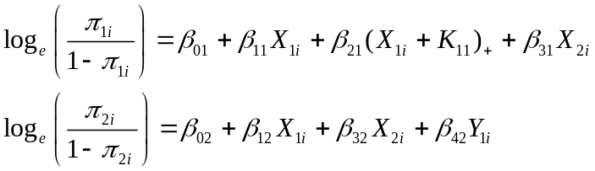 | (15)
with truncated function:
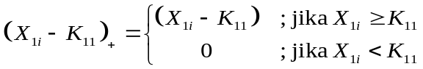
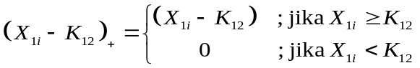
Equation (14) can be written in the form of a matrix as equation (16).
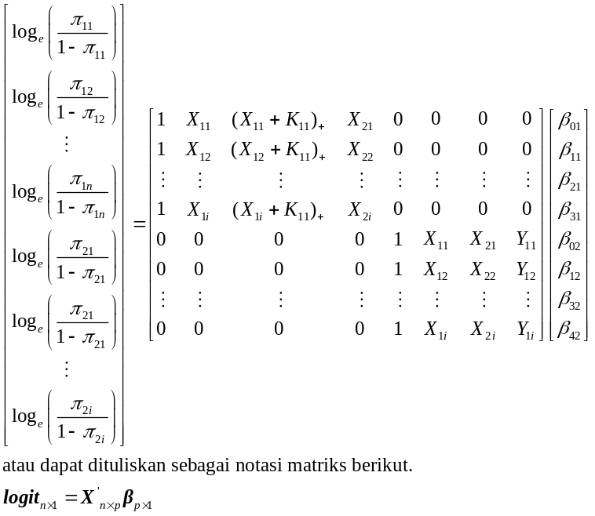 | (16)
- Estimating the parameters of the truncated spline semiparametric logistics path function using the MLE method, with the likelihood function as shown in equation (17).
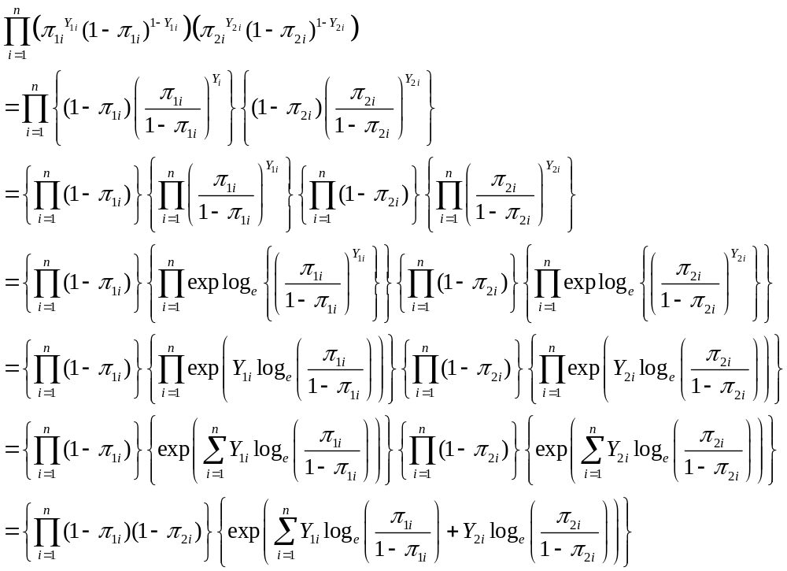  Which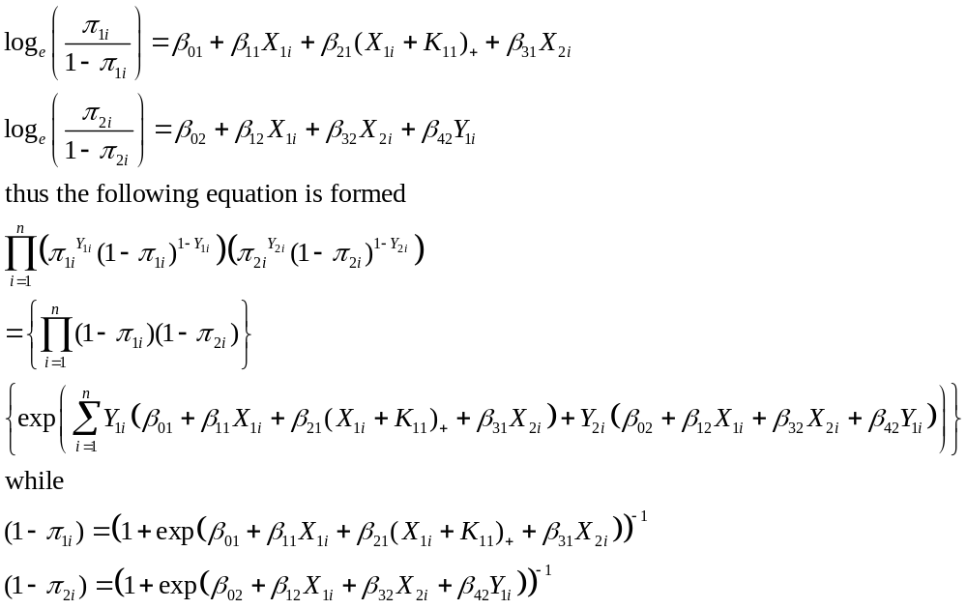  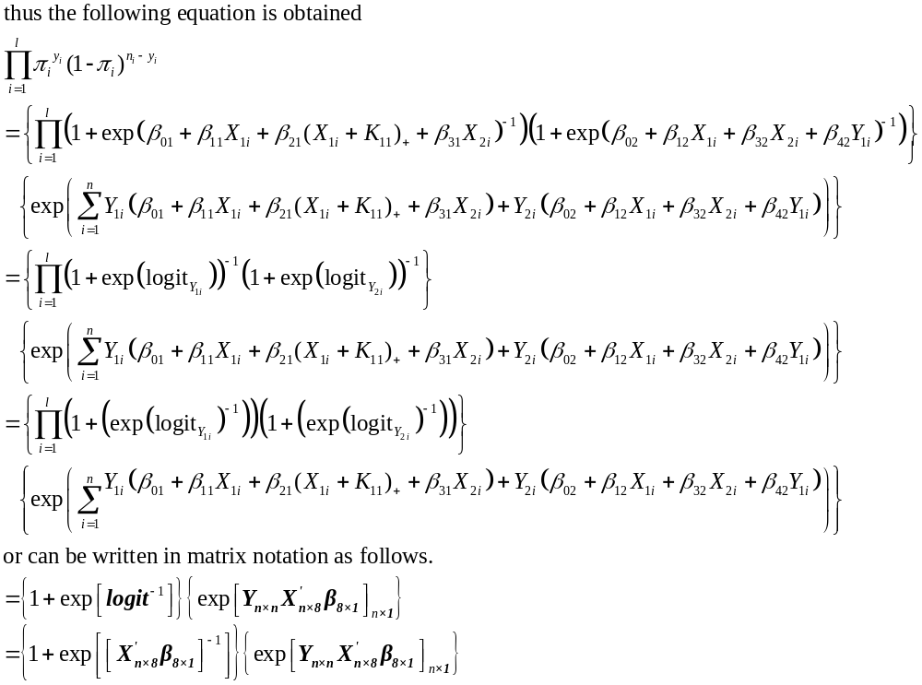  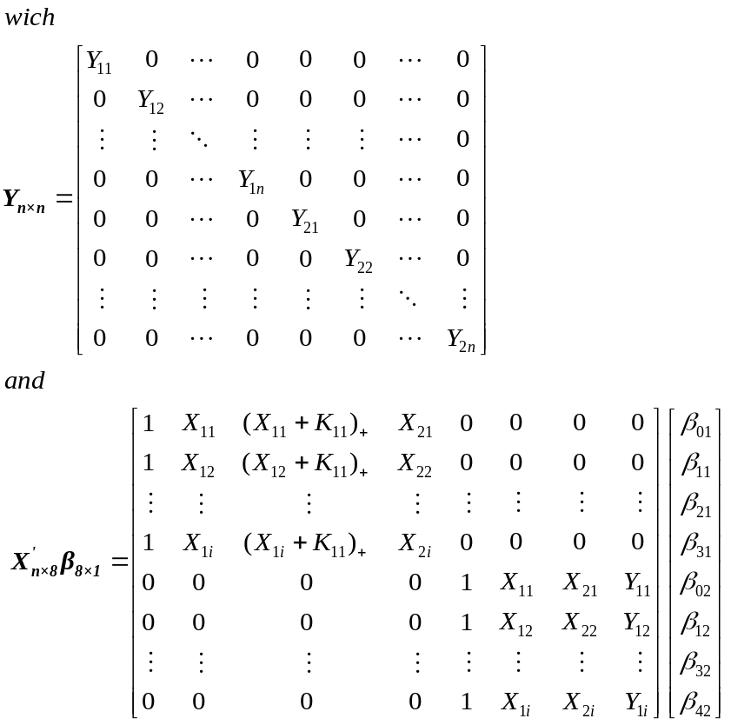 | (17)
To estimate the parameters of the truncated spline nonparametric logistic regression, the next process is to deduce the log-likelihood function to the parameter and equal to zero as in equation (18).
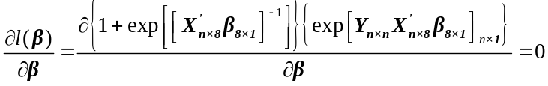 | (18)
To get the beta estimator value, the feeding is done Newton Raphson's algorithm with iterations $β^{t+1 }=β^{t}-{\left(H^{t}\right)}^{-1}q^{t}$, dengan $β^{t}=\left(\begin{matrix}β_{j}^{(t)} \\ β_{p+k}^{(t)}\end{matrix}\right)$ shows the model parameter vector, t shows the t-th iteration, $q^{t}$is a vector that is the first derivative of the likelihood function and $H^{t}$ is a Hessian matrix which is the second derivative of the likelihood function.

Results of Estimation of the Function of Truncated Spline Semiparametric Logistics Lines on Farmer Inclusivity Data
The semiparametric logistics path model can be described as shown in equation (14). The estimation of parameters in the truncated spline semiparametric logistics path function is carried out on the logit model listed in equation (16) with the MLE method that has been described in equations (17) to equations (18).
The selection of optimal knots can be seen through the goodness of fit in each relationship between exogenous variables and the chance of endogenous variables in Table 1.
Table 1. Results of Optimal Knot Selection
Relationships between variables | Knots | Goodness of Fit
Relationships between variables | Knots | GCV | Accuracy | Specificity | Sensitifity | R²_{total}
X1 Y1 | K1 = 2,692 | 0,216 | 64,77% | 60,08% | 79,76% | 68,53%
X2 Y1 | K2 = 3,413 | 0,216 | 73,96% | 73,96% | 73,22% | 73,59%
X1 Y2 | K3 = 2,692 | 0,216 | 74,72% | 73,30% | 76,40% | 74,82%
X2 Y2 | K4 = 2,758 | 0,216 | 55,39% | 53,81% | 58,14% | 55,89%
X1 Y1  X1 Y2 | K1 = 2,692  K3 = 2,692 | 0,229 | 73,58% | 73,22% | 73,96% | 73,59%
X1 Y1  X2 Y2 | K1 = 2,692  K4 = 2,758 | 0,211 | 75,00% | 72,96% | 77,56% | 75,19%
X2 Y1  X1 Y2 | K2 = 3,413  K3 = 2,692 | 0,229 | 73,86% | 74,12% | 73,87% | 73,87%
X2 Y1  X2 Y2 | K2 = 3,413  K4 = 2,758 | 0,215 | 73,86% | 74,12% | 73,87% | 73,87%
X1 Y2  X2 Y2 | K3 = 2,692  K4 = 2,758 | 0,229 | 73,86% | 74,12% | 73,87% | 73,87%
Based on Table 1, it shows that the optimal knot is in a non-linear relationship between variable X1 (Price Volatility) and variable opportunity Y1 (Farmer Productivity) and variable X2 (Human Resource Quality) with variable opportunity Y2 (Farmer Welfare). This is because the goodness of fit value is above 75% with the lowest GCV value of 0.211 which indicates that the existence of an optimal knot as a fault pattern of the relationship between these variables can accurately classify endogenous variables. The following is the result of estimating the functional parameters of the truncated spline semiparametric logistics path with the optimal knots K1 = 2.692 and K4 = 2.758 in equation (18).

$π_{1i}\left(X_{1i},{{(X}_{1i}+K_{11})}_{+}, X_{2i } \right)=\frac{\exp\left(-7,916+2,433 X_{1i}-1,786{{(X}_{1i}+K_{11})}_{+}+0,716X_{2i}\right)}{1+\exp\left(-7,916+2,433 X_{1i}-1,786{{(X}_{1i}+K_{11})}_{+}+0,716X_{2i}\right)}$  $π_{2i}\left(X_{1i},X_{2i },{{(X}_{2i}+K_{42})}_{+},Y_{1i}\right)=\frac{exp⁡(-14,737+1,433X_{1i}+4,339X_{2i}-2,336{{{(X}_{2i}+K_{42})}_{+}-0,010Y}_{1i})}{1+exp⁡(-14,737+1,433X_{1i}+4,339X_{2i}-2,336{{{(X}_{2i}+K_{42})}_{+}-0,010Y}_{1i})}$ | (19)
with truncated function:
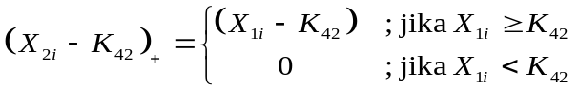

Value Odds Ratio
The magnitude of the influence of the ordinal logistics path analysis can be seen through the odds ratio (OR) value obtained by the equation. The odds ratio values for each path are presented in $π \left(x\right)=exp (β_{X_{i}Y_{i}})$

Table 2. Odds Ratio Calculation Results
Relationship | Coefficient | Odds Ratio
X1 (Price Volatility) Y1 (Farmer Productivity) | $$\exp\left(β_{11}\right)$$  (X1 < K2) | 11,393
X1 (Price Volatility) Y1 (Farmer Productivity) | $$\exp\left(β_{21}\right)$$  (X1 ≥ K2) | 11,561
X2 (Farmer Quality) Y1(Farmer Productivity) | $$\exp\left(β_{31}\right)$$ | 2,046
X1 (Price Volatility) Y2 (Farmer Welfare) | $$\exp\left(β_{12}\right)$$ | 4,191
X2 (Farmer Quality) Y2 (Farmer Welfare) | $$\exp\left(β_{32}\right)$$  (X1 < 2,111) | 76,631
X2 (Farmer Quality) Y2 (Farmer Welfare) | $$\exp\left(β_{42}\right)$$  (X1 ≥ 2,111) | 76,728
Y1 (Farmer Productivity) Y2 (Farmer Welfare) | $$\exp\left(β_{52}\right)$$ | 0,990
X1 Y1 Y2 | $$\exp\left((β_{11}+β_{21})×β_{52}\right)$$  (X1 ≥ 2,111) | 0,962
X1 Y1 Y2 | $$\exp\left(β_{11}×β_{52}\right)$$  (X1 < 2,111) | 0,976
X2 Y1 Y2 | $$\exp\left(β_{31}×β_{52}\right)$$ | 0,993

Based on Table 2, information can be obtained that the odds ratio (OR) value can be interpreted as follows.
- The effect of X1 (Price Volatility) on Y1 (Farmer Productivity) shows an odds ratio value of 11.393. This shows that when price volatility is below the critical point (K1), the probability (odds) of an increase in farmers' productivity increases by 11,393 times. However, when the price volatility is above the knots (K1) point, the odds ratio value is 0.168, which indicates that the possibility of increasing farmers' productivity actually decreases.
A high odds ratio for conditions (X1 < 2.111) suggests that less extreme price volatility can be an incentive for farmers to increase productivity. According to previous research, prices that fluctuate within reasonable limits can motivate farmers to produce more to take advantage of high price opportunities (Hoddinott, 2016). However, when volatility is already very high or uncontrollable (X1 ≥ 2,111), excessive uncertainty can demotivate farmers as they see a greater risk of loss.
- The effect of X2 (Farmer Quality) on Y1 (Farmer Productivity) shows that the odds ratio of 2.046 shows that improving the quality of farmers can increase the likelihood of increasing productivity by 2.046 times. Thus, showing that the quality of farmers, including education, skills, and access to information, has a positive influence on productivity. The theory of human capital states that investment in the quality of human resources can increase production capacity and efficiency. With increased skills and knowledge, farmers can be more efficient in the use of resources, which contributes to increased productivity.
- The effect of X1 (Price Volatility) on Y2 (Farmer Welfare) shows an odds ratio value of 4.191 indicating that price volatility below the K4 critical point increases the likelihood of increasing farmers' welfare by 4.191 times. Meanwhile, in the condition (X1 ≥ 2.114) the odds ratio of 0.097 shows that when price volatility is very high or uncontrollable, the possibility of improving farmers' welfare is actually very low. Thus, the impact of price volatility on farmers' welfare depends on price stability. Low to moderate volatility allows farmers to plan for and take advantage of periods of high prices, which can increase their income and well-being. However, when price volatility is too high, income uncertainty and increased financial risk can threaten farmers' well-being, given that farmers are often in a vulnerable position .
- The influence of X2 (Farmer Quality) on Y2 (Farmer Welfare) shows that the odds ratio of 76.631 shows a very large influence of farmer quality on farmer welfare. Meanwhile, in the condition (X1 ≥ 2.114), the odds ratio of 0.097 shows that at a higher level of farmer quality (above the critical point of 2.114), the influence on farmers' welfare is not significant or decreases. This shows that in the early stages of quality improvement (below 2,114), better qualities (such as education and skills) provide a huge advantage in terms of well-being. Farmers who have management skills and access to information are better able to respond to market changes and manage risks, which can significantly improve their well-being. However, after reaching a certain point (above 2,114), additional quality improvement may not result in significant additional benefits for well-being due to market limitations or other external factors.
- The effect of Y1 (Farmer Productivity) on Y2 (Farmer Welfare) shows an odds ratio of 0.990 indicating that farmer productivity does not have a significant influence on farmers' welfare. Increased productivity is not always directly proportional to increased welfare, especially if farmers face unstable prices or high production costs. Although productivity increases, if the selling price of crops is low or the cost of production is high, the increase in productivity may not have a major impact on the welfare of farmers. Income distribution factors in the supply chain can also limit the influence of productivity on farmers' welfare.
Influence of Indirect Path (Variable Interaction), when X1 Y1 Y2 with Odds Ratios 0.962 and 0.976**: The odds ratio shows that price volatility affecting farmers' productivity (Y1) does not have a significant impact on farmers' welfare (Y2). While on X2 → Y1 → Y2 with an Odds Ratio of 0.993**: This also shows an insignificant influence. The indirect path shows that the influence of price volatility and farmer quality on farmers' welfare is not significantly mediated by productivity. This is in accordance with the theory that farmers' welfare is affected by direct external factors, such as market prices and the cost of living, compared to productivity alone.

Conclusions
Hypothesis testing on the function of the semiparametric logistic pathway shows a significant difference in the effectiveness of the model between linear and non-linear relationships on certain variables. The use of truncated splines in hypothesis testing allows for the identification of knot points where the relationships between variables change significantly, providing deeper insights into the influence of independent variables on dependent variables. These results support the application of the Parameter Linear Function Hypothesis approach, especially in cases where variable relationships are not purely linear and require a non-linear approach at certain critical points.
This model shows quite good validity in classifying data with consistent accuracy across various scenarios, especially at smaller data proportions. Goodness of Fit shows that the truncated spline semiparametric logistics path model is reliable, especially when accuracy, sensitivity, specificity, and R₂total support each other. However, model performance tends to decline as the proportion of data increases, suggesting that the model may be more valid or optimal on smaller proportions of data.

REFERENCES
[1] Agresti, “Categorical Data Analysis.”, John Wiley & Sons, 2012.
[2] J. Friedman, T. Hastie, and R. Tibshirani, “The Elements of Statistical Learning Preface to the Second Edition,” 2008.
[3] W. Simon, Generalized Additive Models: An Introduction with R, Second Edition. New York: Chapman and Hall/CRC, 2017.
[4] A. Islamiyati, Anisa, M. Zakir, U. Sari, and D. S. Salam, “THE USE OF THE BINARY SPLINE LOGISTIC REGRESSION MODEL ON THE NUTRITIONAL STATUS DATA OF CHILDREN,” Communications in Mathematical Biology and Neuroscience, vol. 2023, 2023, doi: 10.28919/cmbn/7935.
[5] S. Arifin, “PEMODELAN REGRESI LOGISTIK ORDINAL DENGAN ESTIMATOR SPLINE TRUNCATED.”, Universitas Hasanuddin, 2003.
[6] M. F. Hidayat, R. F. Adji Achmad, and Solimun, “Estimation of Truncated Spline Function in Non-parametric Path Analysis Based on Weighted Least Square (WLS),” in IOP Conference Series: Materials Science and Engineering, Institute of Physics Publishing, Jul. 2019. doi: 10.1088/1757-899X/546/5/052027.
[7] F. E. Harrell, “Regression Modeling Strategies With Applications to Linear Models, Logistic and Ordinal Regression, and Survival Analysis Second Edition Springer Series in Statistics.” [Online]. Available: http://www.springer.com/series/692
[8] “Structural Equations with Latent Variables.”
[9] V. B, L. M, and M. J, “Business models that are inclusive of small farmers.,” Agro-industries for development, pp. 186–222, 2009.
[10] P. Doddy, H. Ardana, D. Oka Suparwata, A. Sudrajat, S. Chatun, and I. Harsono, “The Role of Bali’s Traditional Subak Farming System in the Preservation of Natural and Cultural Resources Article Info ABSTRACT,” 2024.
[11] F. Shenggen, B. Joanna, K. Michiel, and H. Alex, From subsistence to profit: Transforming smallholder farms. International Food Policy Research Institute, 2013.
[12] C. B. Barrett, T. Reardon, and P. Webb, “Nonfarm income diversification and household livelihood strategies in rural Africa: concepts, dynamics, and policy implications,” Food Policy, vol. 26, no. 4, pp. 315–331, Aug. 2001, doi: 10.1016/S0306-9192(01)00014-8.
[13] C. Martins-Filho and M. Torero, “ Relative prices of food and the volatility of agricultural commodities: Evidence for a panel of developing economies,” Food Price Volatility and Its Implications for Food Security and Policy, 2016.
[14] A. Oktavia, ; Zulfanetti, and ; Yulmardi, “Analisis produktivitas tenaga kerja sektor pertanian di Sumatera,” 2017.
[15] Solimun, F. Adji, and L. Dwi, “Pengembangan Pemodelan Analisis Jalur Semiparametrik Smoothing Spline Dengan Pendekatan Sains Data: Variable And Relationship Mining Pada Inklusivitas Petani,” 2023.
[16] C. I. Nyoman Budiantara, Ms. Bambang Widjanarko Otok, and Ms. Suhartono, “SPLINE ESTIMATOR IN BIRESPON NONPARAMETRIC REGRESSION FOR LONGITUDINAL DATA (CASE STUDY PATIENT WITH PULMONARY TUBERCULOSIS IN MALANG) DOCTORAL PROGRAM STATISTICS DEPARTMENT FACULTY OF MATHEMATICS AND NATURAL SCIENCES INSTITUT TEKNOLOGI SEPULUH NOPEMBER SURABAYA 2016.”
[17] C. R. Rao, “LINEAR STATISTICAL INFERENCE AND ITS APPLICATION,” John Wiley and Sons, 1965.
[18] E. L. Lehmann and G. C. Springer, “Theory of Point Estimation, Second Edition.”
[19] C. O. Schmidt and T. Kohlmann, “When to use the odds ratio or the relative risk?,” Int J Public Health, vol. 53, no. 3, pp. 165–167, Jun. 2008, doi: 10.1007/s00038-008-7068-3.
[20] Solimun, Structural Equation Modelling (SEM) Lisrel dan Amos. Malang: Fakultas MIPA Universitas Brawijaya, 2002.

