Obesity Prediction Using SMOTE-NC and Ensemble Learning Approaches
Tiara Azahra Wika Putri^{1*}, Umu Sa’adah¹, Ummu Habibah¹
¹Department of Mathematics, Faculty of Science, University of Brawijaya
*Corresponding Autor: tiaraazahra@student.ub.ac.id

Abstract
This research is the effect of using SMOTE-NC on the XGBoost algorithm in predicting obesity. The main purpose of this research is to determine the effect of implementing SMOTE-NC and also the features that are most influential in the prediction process. By using the SMOTE-NC approach with XGBoost it is hoped that it can increase quality performance in predicting obesity, data is collected from University of California, Irvine Machine Learning for Obesity analysis. The prediction results reveal that the application of SMOTE-NC can improve the accuracy of obesity prediction using XGBoost. Output of this research that the highest accuracy in this study was able to reach 98.30%. Further analysis, this research reviews several influential features in the prediction process, namely Weight, Height and Age. Based on these results, it is hoped that they can contribute to further research. Overall, this research underlines the importance of maintaining health to avoid obesity by keeping body weight within normal limits.
Keywords: Obesity; Ensemble Learning; SMOTE-NC; XGBoost.

Introduction
Obesity is identified as a significant public health challenge experiencing continuous improvement. Obesity sufferers are predicted to increase to reach 1 billion sufferers by 2030 (the world obesity atlas) [1]. Facts from the World Health Organization (WHO) state that around 67% of the population of the American continent is obese [2]. The number of obese people worldwide has increased since 1980 [3]. Obesity sufferers in Indonesia in 2017 reached 1 in 4 adults [4]. In 2024, as many as 6.53% of the adult male population in Indonesia were obese and ranked 168 out of 200 countries registered with the highest male obesity in the world [5]. In addition to men, obesity is also experienced by the adult female population in Indonesia. As many as 16.58% of adult women are obese with a ranking of 150 out of 200 countries with the highest obesity rates in the world [5]. The impact of obesity not only has a major impact on sufferers but also on society at large. Obesity sufferers can cause several losses in the health sector to the economy [6]. Several complications in obesity sufferers can reduce the quality of life of sufferers and can also shorten the life expectancy of sufferers [6]. In addition, as sufferers will be very susceptible to mental health disorders. This is because of the many negative stigmas from society, discrimination, and decreased self-confidence [6]. Obesity also causes a significant economic burden [6]. Sufferers will experience several complications of the disease that require quite high treatment costs [7].
The ability to predict and classify the level of obesity in each individual needs to be done early. This step can enable the implementation of improvements in several factors that trigger obesity. Innovations in technology and data analysis such as Machine Learning methods are relevant. The ability to analyze large amounts of data and complex patterns can decide on more precise and targeted prevention [8]. Several previous studies have been conducted using the Machine Learning approach. Research conducted in 2021 used several algorithms from the Machine Learning approach, namely K-NN (K-Nearest Neighbors), SVM (Support Vector Machine), LR (Logistic Regression), NB (Naïve Bayes), DT (Decision Tree), AdaBoost, RF (Random Forest), MLP (Multi Layer Preceptron), and Gradient Boosting [9]. Based on the results of this study, it was obtained that the best accuracy results using the obesity dataset in the case of binary classification were carried out by the LR algorithm. Comparison of Machine Learning algorithms in the case of classification using the obesity dataset, with the additional XGBoost algorithm in other studies conducted in the same year [10]. The results of the study showed that the best algorithm was performed by XGBoost with a difference of 1.33% better than LR. The study used XGBoost in the case of feature selection. In the following 2 years, the XGBoost algorithm was applied to predict obesity using the Chilean adolescent population dataset in the classification case [11]. The results of the study obtained a ROC (Receiver Operating Characteristic) curve value of 87.5%. Based on these results, it can show the effectiveness of using XGBoost in predicting obesity. In addition, efforts to improve the prediction process are carried out by using data balancing techniques at the preprocessing stage. In this technique, data with minority classes is synthesized until the amount of data from the majority class is reached [12]. This study uses the SMOTE-NC technique which was first proposed in 2002 [12]. The application of this technique has been carried out in 2023 in the Ensemble Learning technique, namely CatBoost with an increase in prediction results of 7% after SMOTE-NC was applied at the stage before prediction [13].
One of the effective Machine Learning (ML) approaches in predicting obesity is using the Ensemble Learning (EL) method, such as extreme gradient boosting (XGBoost). The XGBoost method works on the development of Gradient Boosting to improve the efficiency of the computational process and prediction performance [14]. The XGBoost algorithm is equipped with features such as L1 and L2 regularization to prevent overfitting and can speed up the prediction process [14]. XGBoost's performance is considered better in producing accurate predictions in a shorter time than gradient boosting [15]. The algorithm can be combined with the Synthetic Minority Oversampling Technique for Nominal and Continuous (SMOTE-NC) technique to strengthen the model. This technique is considered to be able to help in the preprocessing stage to balance unbalanced datasets [12]. In this study, an approach was carried out using the SMOTE-NC and EL resampling techniques with the aim that obesity prediction can be carried out as optimally as possible. The results of the study can be used as support in taking more effective preventive measures. The hope is that this study using the EL method can provide a more effective solution to the challenge of obesity and also global efforts to overcome this public health problem.

Materials and Methods

Preprocessing Data
Data preprocessing is the initial step before performing data prediction analysis using ensemble learning techniques [16]. This aims to help prepare data in the prediction process [16]. The initial step in data preprocessing is to import data from the repository [17]. This study uses a dataset related to obesity that contains some information on the variables used. The obesity dataset has a response variable in the form of the level of obesity of each individual, such as NW (Normal Weight), OT_I (Obesity Type I), OT_II (Obesity Type II), OT_III (Obesity Type III), OW (Overweight), UW (UnderWeight) [18]. This stage is carried out using several steps, namely data identification, changing data types, balancing data on the Y variable. Data identification includes checking the data type, missing values ​​and the number of data for each class on the Y variable [19]. Data with a categorical type is changed to data with a numeric type to equalize the data type. The amount of unbalanced data on the Y variable is balanced using the resampling technique. This stage aims to improve data quality in helping the prediction process to be more accurate and improve model performance.

SMOTE-NC
Data balance in obesity datasets can affect model performance, especially in minority classes [12]. The SMOTE-NC technique is a resampling technique using the oversampling method and can work on mixed data types, namely nominal and continuous [12]. The oversampling method works by synthesizing data samples in the minority data class until the amount of data in the minority class is the same as the amount of data in the majority class [12]. The initial step in implementing the SMOTE-NC technique is to define data samples that are included in the minority class. Suppose there are m data samples. The data samples have $X=\left[x_{1}, x_{2},…, x_{m}\right]$ and $Y=\left[y_{1}, y_{2},…, y_{m}\right]$. The process of forming data synthesis $x_{i}^{'}$requires searching for the nearest neighbor $z_{ij}$ which runs as far as $r$ as shown in Equation (1) and Equation (2). This process can be run on continuous data types, in a different way when using nominal or categorical data [20]. The formation of data synthesis is based on searching for the majority value and the intensity of the appearance of the data [20]. Then the data is used as an observation in adding minority class data. After the data on the Y variable is balanced, the prediction process can be continued using the ensemble learning method, namely XGBoost.
$z_{ij}=\sqrt{{\left(x_{1}-y_{1}\right)}^{2}+{\left(x_{2}-y_{2}\right)}^{2}+⋯+\left(x_{m}-y_{m}\right)}$, | (1)
$x_{i}^{'}=x_{i}+r×\left(z_{ij}-x_{i}\right)$. | (2)

Ensemble Learning
EL technique is part of ML by combining several models to improve the accuracy and stability of predictions [21]. Prediction using EL technique by fixing the weaknesses of individual models and obtaining better results [21]. There are several types of EL, namely Bootstrap Aggregating (Bagging), Boosting, and Stacking [21]. This study uses the XGBoost Boosting technique. The Boosting model works by fixing errors made by the previous model [21].

XGBoost
XGBoost is an ML algorithm designed to be an EL technique by boosting [22]. This algorithm prioritizes speed and better performance in the prediction model, and is an implementation of the gradient boosting algorithm [22]. The prediction process uses a block system which is used to store data to make the prediction process more efficient [22]. This is because the tree model in XGBoost is designed to improve the shortcomings of the previous tree [22]. Mathematically, the XGBoost algorithm can be described by assuming the dataset $D = \left\{x_{i},y_{i}\right\}$ with $i∈1,…,K$ [15]. The value of $K$ is the number of trees. The predicted results $\hat{y}$ can be calculated using Equation (1). In this equation, it is calculated based on the function f for each $k^{th}$ tree [15].
$${\hat{y}}_{i}=φ\left(x_{i}\right)=\sum_{k=1}^{K}{f_{k}(x_{i})}.$$

The initial step in predicting on obesity dataset is done by determining the initial prediction value using the log-odds value for the classification case [23]. The log-odd function is shown in Equation (2) [23]. The log-odds value is the ratio of the occurrence of an event to the non-occurrence of the event [23]. This is certainly different from probability, which is the value in the form of a ratio of the occurrence of an event to all events or the total number [23].
$$odds=\frac{event occur}{even did not occur}.$$ | (2)
In the XGBoost algorithm, the objective function $L$ is applied to improve the prediction results [15]. The loss function $l$ and penalty function $Ω$ shown in Equation (3) are two important parts in calculating the objective function [15]. Measuring how good a model is by calculating the error between the actual and predicted values ​​is what the loss function is used for[15]. The prediction is better if the value of the loss function is smaller. The penalty function $Ω$ is used to prevent the model from becoming too complex. This is shown in Equation (4). The parameter $γT$ is a penalty for the leaf, where T is the number of leaves and the parameter $γ$ regulates the amount of penalty for each leaf [15]. The smaller the value of the parameter $γ$ makes the tree simpler and makes the tree more flexible. This is used to limit the size of the tree to avoid the formation of too many leaves. $ω_{j}$ is the weight value on leaf $j$, the parameter $λ$is used to regulate the penalty from L2 regularization on $ω_{j}$ [15]. Too large a weight value can cause instability in the model and the use of the penalty function is to encourage the weight to remain small and help in the distribution of contributions between leaves. The larger the value of $λ$ and the smaller the value of $ω_{j}$, the better and more conservative the model becomes [15].
$$L=\sum_{i=1}^{n}{l\left(y_{i},{\hat{y}}_{i}\right)}+\sum_{k=1}^{K}{Ω\left(f_{k}\right)},$$ | (3)
$$Ω\left(f\right)=γT+\frac{1}{2}λ\sum_{j=1}^{T}{ω_{j}^{2}}.$$ | (4)
Gradient and Hessian are used to calculate the weight of the leaf. Calculations can be obtained sequentially with radians being the first derivative and Hessian being the second derivative of the loss function [15]. The Gradient equation $g_{i}$ and Hessian $h_{i}$ are obtained using Equation (5) and Equation (6) [15]. The $g_{i}$ function is used to determine the model update by minimizing the loss function [15]. In contrast to the $h_{i}$ function as the second derivative of the loss function is used to measure the rate of change of Gradient and provide information about the change in the speed of the loss function to the prediction [15]. Hessian is used to help determine the optimal value in the model update. This can help the model maintain stability in the training process and can build an optimal tree in each iteration. In Equation (7) is used to calculate the weight of the leaf using $g_{i}$ and $h_{i}$ [15]. Then the function is substituted into the loss function and obtained in Equation (8) [15].

$g_{i}$ $=∂_{{\hat{y}}_{i}^{\left(t-1\right)}}l\left(y_{i}, {\hat{y}}_{i}^{\left(t-1\right)}\right),$ | (5)
$h_{i}$ $=∂_{{\hat{y}}_{i}^{\left(t-1\right)}}^{2}l\left(y_{i}, {\hat{y}}_{i}^{\left(t-1\right)}\right),$ | (6)
$$ω_{j}=-\frac{\sum_{i∈I_{j}}{g_{i}}}{\sum_{i∈I_{j}}{h_{i}}+λ},$$ | (7)
$$L=-\frac{1}{2}\sum_{j=1}^{T}{\frac{{\left(\sum_{i∈I_{j}}{g_{i}}\right)}^{2}}{\sum_{i∈I_{j}}{h_{i}}+λ}}+γT.$$ | (8)

Evaluation
The evaluation process uses the confusion matrix which then obtains the percentage of model accuracy. The confusion matrix has 4 important components, namely TP (True Positive), FP (False Positive), TN (True Negative), and FN (False Negative) [24]. The TP and TN components produce correct predictions in the positive and negative classes [24]. The opposite applies to FP and FN predicting incorrectly in both classes, namely positive and negative [24]. The confusion matrix can be used to calculate accuracy, prediction quality (precision), prediction accuracy (recall), and harmony between prediction quality and accuracy (f1-score). Accuracy is used to calculate the overall correct percentage using Equation (9) [24]. Precision is used to predict the proportion of the quality of the correct positive class and recall is used to measure the proportion of positive class data detected by the model and shows the sensitivity of the model in recognizing positive class data. This is shown in Equation (10) and Equation (11) [24]. The harmony of precision and recall can be calculated using the f1-score shown in Equation (12) [24].
$$Accuracy=\frac{TP+TN}{TP+FP+TN+FN}$$ | (9)
$$Precision=\frac{TP}{TP+FP}$$ | (10)
$$Recall=\frac{TP}{TP+FN}$$ | (11)
$$F1-score=2∙\frac{precision∙recall}{precision+recall}$$ | (12)

Results and Discussion
Explanation and presentation of the results are carried out in this section in the form of analysis. The aim of this research is to obtain analysis results regarding the performance of the XGBoost and SMOTE-NC models in predicting obesity data sets. The presentation of the results of this research is shown in tables and graphs with the aim of facilitating understanding. The evaluation results include several classification metrics such as accuracy, precision, recall, and f1-score. These metrics describe the performance of the model and the efficiency of the training process that has been carried out. This research process was carried out as many as 25 iterations and 2 treatments on each algorithm in order to avoid bias in making decisions on model performance. The treatment was carried out by comparing the use of SMOTE-NC and not using SMOTE-NC in the preprocessing stage in obesity prediction. This study uses a dataset taken from the UCI Machine Learning platform. This dataset was taken because of its relevance to the research topic, consisting of 17 columns and 2111 rows in the form of nominal and continuous data. The data consists of 16 attribute columns (variable X) and 1 response column (variable Y). Before the classification analysis process is carried out, the obesity dataset goes through a preprocessing stage. This stage includes data identification, equalizing data types by changing data with categorical characters to nominal, balancing data using the SMOTE-NC technique. After this stage is finished, the data is confirmed to be ready for further processing in the model classification analysis.

Preprocessing Data
The preprocessing stage is an important part of every research. This is because at this stage the data undergoes processing and maturation so that it is ready to be used for the analysis process using a certain algorithm. In the first stage, the dataset is identified to obtain information about the characteristics and structure of the data. The identification process includes examining the data type, the number of missing values, and also the number of samples in each class of variable Y data. The identification results for the data type are 9 data with the object data type and the rest are of the int64 type. All columns in the obesity dataset have no missing values. Then, the data with the object type is changed to int64 to match the data type. The results of the data identification process are shown in Table 1. Changes were made to all variables with the previous object data type. Examples of changes to the Y variable or the Nobeyesdad variable are presented in Table 2.
Table 1 Indentification Types of Data and Missing Value
No | Name of Variable | Types of Data | Missing Value
1 | Gender | Object | 0
2 | Age | int64 | 0
3 | Height | int64 | 0
4 | Weight | int64 | 0
5 | family_history_with_overweight | Object | 0
6 | FAVC | Object | 0
7 | FCVC | int64 | 0
8 | NCP | int64 | 0
9 | CAEC | Object | 0
10 | SMOKE | Object | 0
11 | CH2O | int64 | 0
12 | SCC | Object | 0
13 | FAF | int64 | 0
14 | TUE | int64 | 0
15 | CALC | Object | 0
16 | MTRANS | Object | 0
17 | NObeyesdad | Object | 0

Table 2 Changing for Types of Data on Y Variable
No | Variable | Types of Data
No | Variable | Before | After
1. | NObeyesdad | NW | 0
2. | NObeyesdad | OT_I | 1
3. | NObeyesdad | OT_II | 2
4. | NObeyesdad | OT_III | 3
5. | NObeyesdad | OW | 4
6. | NObeyesdad | UW | 5

Following are the results of the data identification process to determine the number of data samples for each class in variable Y, then a resampling technique is carried out to balance the number of data samples. This is summarized in Table 3. The results of the study show a significant change in the number of minority class samples compared to the number of samples in the majority class. The class with the largest samples in variable Y is the overweight class with 580 sample data. In the other classes, it is the minority class which is then resampled to 580 sample data in each class. The application of SMOTE-NC can perform data synthesis on data with mixed types such as in the obesity dataset, namely nominal and continuous. Data on the X variable will be synthesized based on the Y variable data. For example, in the Y variable the fifth data is included in the minority class and data synthesis will be carried out, then in the X variable the fifth data will also occur data synthesis. This process will occur until the minority class has reached the target number to balance with largest number of classes.
Table 3 Number of Data Samples in Respon Variable
No | Class | Number of Samples
No | Class | Before SMOTE-NC | After SMOTE-NC
1. | NW | 287 | 580
2. | OT_I | 351 | 580
3. | OT_II | 324 | 580
4. | OT_III | 297 | 580
5. | OW | 580 | 580
6. | UW | 272 | 580

Ensemble Learning Method and Evaluation
After the obesity dataset has undergone data preprocessing and the data is balanced, the prediction process can be carried out using the ML algorithm, namely XGBoost. The initial prediction process is carried out by adding feature importance techniques to both treatments, namely with and without SMOTE-NC at the preprocessing stage. The feature selection stage obtained the results that there were 3 top features that had the most influence on the process. These features were then used as a reference for comparison between using all features or only using the 3 features. The results of obtaining the order of features starting from the most influential are shown in Fig. 1. The figure shows that in both treatments there are 3 variables that have the most influence. These variables are Weight, Height, and Age. Other observations show the results in Figure 1(a) that the Height feature is the most influential feature when using data without going through the data balancing process using the SMOTE-NC method. The results are different in the treatment using the SMOTE-NC method first at the preprocessing stage. Figure 1(b) shows that the most influential feature in the obesity prediction process is Body Weight and the second and third place respectively are Height and Age. The feature selection process is used to find the efficiency of the process.
Evaluation uses several methods to calculate model performance from various contexts. The high accuracy results in both treatments indicate their ability to classify data correctly. The best prediction results for XGBoost without using SMOTE-NC show that the performance is much lower than using SMOTE-NC. The results are shown in Table 4. The average accuracy of XGBoost performance without using SMOTE-NC has a lower difference of 19.78% in accuracy. If observed more deeply, the fastest processing time is done by the XGBoost algorithm without using SMOTE-NC. This does not have a significant impact if processing time is not the biggest consideration in the study. This study also considers the use of feature selection, namely feature importance. This is used to determine the variables or features that have the most influence on the obesity prediction process. Based on Fig. 1, it is known that the order of the three highest features is the most influential in the obesity prediction process. Fig. 1(a) shows a picture of the level of feature importance results for the treatment without SMOTE-NC. The figure shows that the feature with the highest influence is obtained by Height and then followed by Weight and Age. In addition, in Fig. 1(b) it is known that the Weight variable has the greatest influence in the prediction process and then followed by Height and Weight. There are 3 types of combination features with the same high level of influence in the obesity prediction process. The performance results of the EL model in the case of multiclass classification and balanced data using SMOTE-NC are shown in Table 4. The evaluation of the XGBoost algorithm shows an average accuracy of 25 iterations of 98.30%, and the precision and recall evaluation metrics are 98.32%, 98.02%, respectively. In addition, the average evaluation results for the f1-score of 97.30% are good values ​​in terms of the harmonization of precision and recall. The algorithm has a standard deviation of accuracy of 0.004%. This indicates variation in model performance. The model shows stable performance in the prediction process, as can be seen from the confidence interval in the range of 97.8% and 98.2%.
Further analysis was carried out based on obtaining information regarding the magnitude of the influence of variables on the obesity prediction process, the results of the prediction process using the three features can be seen. The results after reducing the feature variables other than Height, Weight and Age are shown in Table 5. Based on the results in Table 4, it is known that the performance of the results in the treatment without SMOTE-NC decreased, with an average accuracy of around 70.81% and followed by other metrics. The table shows that when using SMOTE-NC, the results increased to reach an average accuracy of around 98.03%. There is an advantage after feature selection, namely in more computing time than before. Although after the feature selection process, there was a decrease in accuracy, especially in the treatment without the SMOTE-NC technique, this did not have a significant impact on the treatment using the SMOTE-NC technique. The decrease in accuracy can be caused because not all variables are used in the prediction process, but the decrease is still in good accuracy for the treatment using the SMOTE-NC method, which is 98.03%.
Table 4. Comparation of Mean and STD Result for XGBoost
No | Method | Algorithm | Acc (%) | Pre (%) | Rcl (%) | F1S (%) | T (s)
1. | Without SMOTE-NC | Mean | 0,7854 | 0,7840 | 0,7823 | 0,7809 | 3,169
1. | Without SMOTE-NC | STD | 0,0234 | 0,0249 | 0,0212 | 0,0236 | 0,3394
2. | With SMOTE-NC | Mean | 0,9830 | 0,9832 | 0,9802 | 0,9730 | 3,468
2. | With SMOTE-NC | STD | 0,004899 | 0,004787 | 0,004892 | 0,004898 | 0,3374

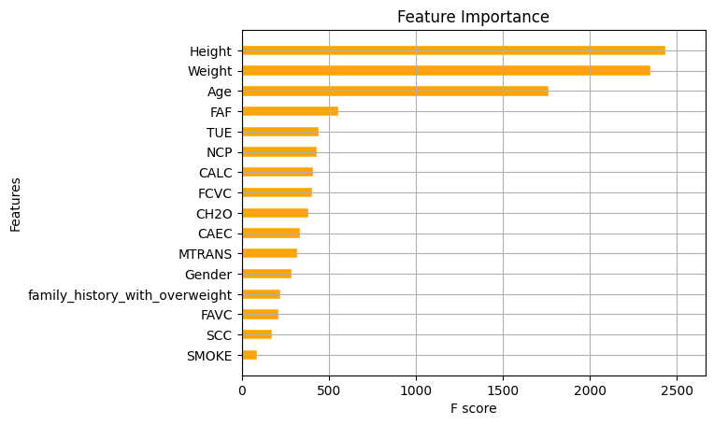
(a)

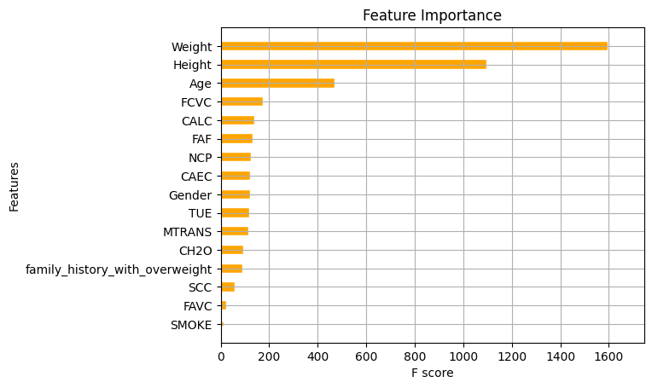
(b)
Fig. 1 Feature importance for XGBoost model (a) without SMOTE-NC (b) with SMOTE-NC

The overall results of the treatment with and without using SMOTE-NC showed the best results when the SMOTE-NC method was applied. This also happened after the feature selection process was carried out with the evaluation results after reducing several variables except for the Weight, Height and Age variables. These results also show that the best accuracy is found in the use of the SMOTE-NC technique in the obesity prediction process. This treatment is considered better when compared to not using this technique. Fig. 2 shows the difference in the range of treatment using the SMOTE-NC technique. These results show two ranges, namely when all X variables are used to predict obesity and vice versa when only the top 3 variables are used. This range uses a 90% confidence level. The best accuracy range results are shown by the prediction condition using all features in the X variable. The upper and lower limits of the range are 98.22% and 97.85%, respectively. Based on these results, it was obtained that the best results for all treatments and conditions for obesity prediction were the application of the SMOTE-NC technique to the EL XGBoost method for obesity prediction using all features in the X variable.

Table 5. Result after Feature Selection with Variabel Weight, Height, Age
No | Method | Algorithm | Acc (%) | Pre (%) | Rcl(%) | F1S (%) | T (s)
1. | Without SMOTE-NC | Mean | 0,7081 | 0,6982 | 0,6982 | 0,6976 | 2,990
1. | Without SMOTE-NC | STD | 0,0234 | 0,0249 | 0,0212 | 0,0236 | 0,8034
2. | With SMOTE-NC | Mean | 0,9803 | 0,9804 | 0,9790 | 0,9803 | 3,256
2. | With SMOTE-NC | STD | 0,005472 | 0,005423 | 0,005041 | 0,004898 | 0,4630

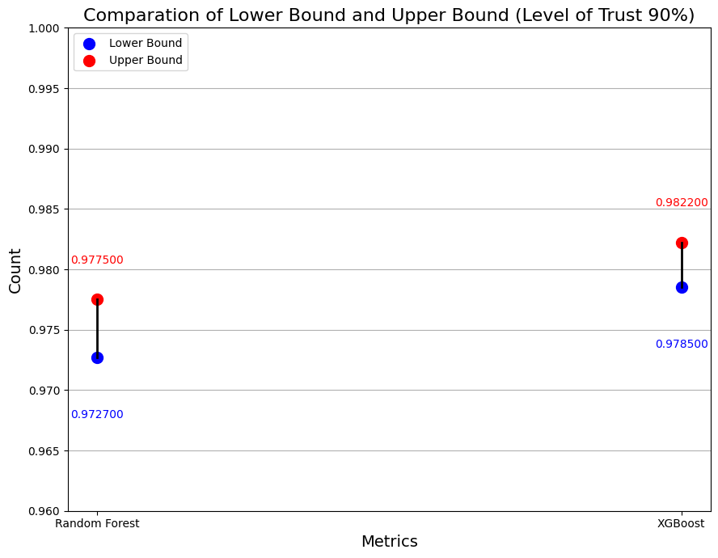
Fig. 2 Results of Confidence Interval for EL with SMOTE-NC

Conclusions
Based on the results and discussion chapter, it is obtained that both ML algorithms can work well in the obesity prediction classification process, especially on datasets that have passed the data balancing stage using the SMOTE-NC method. The results of the evaluation metrics on the XGBoost algorithm using SMOTE-NC are the best results. The average results of the evaluation metrics on the XGBoost treatment with SMOTE-NC are around 98.22% accuracy, 98.32% precision, 98.02% recall, and 97.30% f1-score. The prediction process using all X variables in the XGBoost technique with SMOTE-NC is 0.2 seconds faster than after applying feature selection and only using 3 X variables. At the level of model stability in predicting obesity, a lower standard deviation is obtained in the XGBoost model with SMOTE-NC. The overall results show that XGBoost supported by SMOTE-NC and using all X variables is the best choice in the case of obesity dataset classification. This can be seen from various aspects such as accuracy, speed, and stability. In addition, the use of the SMOTE-NC technique also has a significant effect on the classification performance of the model. The application of SMOTE-NC can improve the performance of the model in the case of obesity classification.

Acknowledgments
I express my deepest gratitude to all departments who have provided assistance until this research was completed. Firstly, a big thank you to my supervisors, Umu Sa'adah and Umu Habibah for their invaluable direction, support and encouragement in the process of working on this project. Their assistance in the form of insight was crucial in shaping this research and helping overcome the difficulties encountered. In addition, I would like to thank the Master of Mathematics Study Program, Faculty of Mathematics and Natural Sciences, Brawijaya University, which has provided the necessary resources and facilities so that this research can be carried out. Thank you for your contribution and support.

References
[1] | WOF, World Obesity Atlas 2022, London: World Obesity Federation 2022, 2022.
[2] | WHO, “Obesity and Overweight,” 2024. [Online]. Available: https://www.who.int/news-room/fact-sheets/detail/obesity-and-overweight.
[3] | E. Laurence, “Obesity Statistics And Facts In 2024,” 2024. [Online]. Available: https://www.forbes.com/health/weight-loss/obesity-statistics/.
[4] | Kemenkes, “1 Dari 4 Penduduk Indonesia Mengalami Obesitas,” Kementrian Kesehatan Indonesia, 2018.
[5] | E. R. Puspapertiwi dan A. N. Dzulfaroh, “List of Countries with the Highest Obesity Rates in the World 2024, Is Indonesia Included?,” Kompas.com, 2024.
[6] | J. Cawley, “An economy of scales: A selective review of obesity’s economic causes, consequences, and solutions,” Journal of Health Economics, no. Elsevier B.V, pp. 244-268, 2015.
[7] | R. Peters, N. Ee, J. Peters, N. Beckett, A. Booth, K. Rockwood dan K. J. Anstey, “Common risk factors for major noncommunicable disease, a systematic overview of reviews and commentary: the implied potential for targeted risk reduction,” Therapeutic Advances in Chronic Disease, vol. 10, pp. 1-14, 2019.
[8] | N. L. Rane, M. Paramesha, S. P. Choudhary dan J. Rane, “Machine Learning and Deep Learning for Big Data Analytics: A Review of Methods and Applications,” Partners Universal International Innovation Journal (PUIIJ), vol. 03, no. 02, p. 172, 2024.
[9] | F. Fredwosy, K. S. A. Rahi, M. I. Jabiullah dan M. T. Habib, “A Machine Learning Approach for Obesity Risk Prediction,” Current Research in Behavioral Sciences, pp. 1-9, 2021.
[10] | X. Pang, C. B. Forrest, F. Le-Scherban dan A. J. Masino, “Prediction of early childhood obesity with machine learning and electronic health record data,” International Journal of Medical Informatics, pp. 1-8, 2021.
[11] | M. Calderon-Diaz, L. J. Seret-Castillo, E. A. Vallejos-Cuevas, A. Espinoza, R. Salas dan M. A. Macias-Jimenez, “Detection of Variables for The Diagnosis of Overweight and Obesitty in Young Chileans Using Machine Learning Techniques,” dalam The 1th International Workshop on Human-Centric Innovation and Computational Intelligence (IWHICI 2023), 2023.
[12] | N. V. Chawla, K. W. Bowyer, L. O. Hall dan W. P. Kegelmeyer, “SMOTE: Synthetic Minority Over-sampling Technique,” Journal of Artiﬁcial Intelligence Research, vol. 16, pp. 321-357, 2002.
[13] | D. L. Zou, X. Fang, L. Xu dan L. L. Wu, “Study on the relationship of design parameters and damage modes for RC slabs subjected to large-scale hard missile impacts base on task-driven approach,” Structures , vol. 58, pp. 1-17, 2023.
[14] | S. Chalichalamala, N. Govindan dan R. Kasarapu, “An extreme gradient boost based classification and regression tree for network intrusion detection in IoT,” Bulletin of Electrical Engineering and Informatics, vol. 3, no. 13, pp. 1741-1751, 2024.
[15] | T. Chen dan C. Guestrin, “XGBoost: A Scalable Tree Boosting System,” dalam KDD '16, San Francisco, 2016.
[16] | S. B. Kotsiantis, D. Kanellopoulos dan P. E. Pintelas, “Data Preprocessing for Supervised Leaning,” INTERNATIONAL JOURNAL OF COMPUTER SCIENCE, vol. 1, no. 1, pp. 111-117, 2006.
[17] | Suraya, M. Sholeh dan U. Lestari, “Evaluation of Data Clustering Accuracy usingK-Means Algorithm,” International Journal of Multidisciplinary Approach Research and Science, vol. 01, no. 02, pp. 385-396, 2024.
[18] | F. M. Palechor dan A. d. l. H. Manotas, “Dataset for estimation of obesity levels based on eating habits and physical condition in individuals from Colombia, Peru and Mexico,” Data in brief, vol. 25, pp. 1-5, 2019.
[19] | S. A. Alasadi dan W. S. Bhaya, “Review of Data Preprocessing Techniques in Data Mining,” Journal of Engineering and Applied Sciences, vol. 16, no. 12, pp. 4102-4107, 2017.
[20] | D. T. Utari, “INTEGRATION OF SVM AND SMOTE-NC FOR CLASSIFICATION OF HEART FAILURE PATIENTS,” BAREKENG: Journal of Mathematics and Its Applications, vol. 4, no. 17, pp. 2263-2272, 2023.
[21] | Z. H. Zhou, Ensemble Method Foundations and Algorithm, Boca Raton: Taylor and Francis Group, CRC press, 2012.
[22] | A. F. L. Ptr, M. M. Siregar dan I. Daniel, “Analysis of Gradient Boosting, XGBoost, and CatBooston Mobile Phone Classification,” Journal of Computer Networks, Architecture and High Performance Computing, vol. 2, no. 6, pp. 661-670, 2024.
[23] | D. Hu, C. Wang dan A. M. O’Connor, “A method of back-calculating the log odds ratio and standard error of the log odds ratio from the reported group-level risk of disease,” Plos One, pp. 1-8, 2020.
[24] | Ž. Đ. Vujović, “Classification Model Evaluation Metrics,” (IJACSA) International Journal of Advanced Computer Science and Applications, vol. 6, no. 12, pp. 1-8, 2021.

