DEEP LEARNING-BASED ISLAMIC RELIGIOUS EDUCATION TO FOSTER RELIGIOUS VALUES AMONG GENERATION Z

Della Putri Aprillianti ¹ *, Agus Fakhruddin ², Mokh. Iman Firmansyah ³
^{1,2,3} Universitas Pendidikan Indonesia, Bandung, Indonesia

Abstract
Generation Z is a dominant demographic group in Indonesia with unique characteristics as a generation highly exposed to globalization and digital technology. The phenomenon of moral degradation experienced by this generation is characterized by a weakening of social ethical values, increasing individualism, and negative behaviors such as bullying and a lack of respect for social norms. Islamic Religious Education (PAI) plays a crucial role as a bulwark in the formation of the religious and moral character of Generation Z. This article examines Islamic Religious Education (PAI) learning, including PAI teachers' strategies in fostering students' religious awareness through an adaptive and contextual in-depth learning approach. This study used a mixed method with a Concurrent Embedded design, namely a combination of quantitative and qualitative approaches through observation, questionnaires, teacher interviews, and analysis of PAI curriculum documents in a high school in Bandung City. The results show that the PAI learning strategy based on in-depth learning improves deep religious understanding, learning motivation, and internalization of positive religious values. This growing religious awareness contributes to strengthening students' moral character, discipline, sense of responsibility, and tolerance. Major obstacles, such as the negative influence of social media and low interest in learning, can be overcome with innovative methods and collaborative support from teachers, parents, and the community. These findings indicate that developing Islamic Religious Education (PAI) learning strategies that adapt to the psychosocial and cultural needs of Generation Z is crucial in addressing moral decline and preparing the nation's next generation with strong and religious characters.
Keywords: | Deep Learning, Generation Z, Islamic Religious Education, Religious values

* Correspondence Address : | della.p.aprillianti@upi.edu

Article History | Accepted | Revised | Accepted | Published
Article History | 2026-01-15 | 2026-02-24 | 2026-02-26 | 2026-03-15

Amidst the rapid flow of globalization and digital media, Generation Z is currently one of the most dominant generations in terms of demographics and social influence. Based on data from the Indonesian Central Statistics Agency (BPS) in 2025, the population of Indonesia reached around 284.44 million people with a relatively balanced ratio of men and women, namely around 143.55 million men, and 140.89 million women. Of the total population of Indonesia, the majority are in the age range of 13-28 years (B P S 2025, 2021). Generation Z is the generation born between 1997-2012, and is currently around 13-28 years old (Maulida & Makrufi, 2025). This data is in accordance with the prediction of a demographic bonus for Indonesia around 2020-2040, so it cannot be denied that this generation has a major role in determining the future of the Indonesian nation.
In contrast to the expectation that the younger generation will be the catalyst for change towards a golden Indonesia in 2045, Generation Z, the dominant generation, has experienced a shift compared to previous generations. This generation tends to understand ethics as a form of respect for individual freedom, but often pays less attention to norms of politeness, respect for authority, and social responsibility. The concept of ethics in Generation Z is more influenced by cultural globalization, the development of digital technology, and shifts in family and educational values. Furthermore, there are indications of weakening manners in social relationships such as respect for teachers, parents, and others (Auliya Sholikhatun, Robingun Suyud El Syam, 2025). This phenomenon is also called moral degradation or decadence among Generation Z, caused by technological developments and the globalization of values, resulting in decreased empathy, increased individualism, weak communication ethics, and verbal and physical violence (Rahmawati & Kusrina, 2025).
This is an ironic phenomenon, because education should be able to lead humans to noble morals, making them moral and able to apply positive values in their daily lives. This is in accordance with the objectives of National Education as stated in Law Number 20 of 2003 concerning the National Education System (UU Sisdiknas), namely to develop the potential of students to become people who are faithful, pious, have noble morals, are healthy, knowledgeable, capable, creative, independent, and become democratic and responsible citizens, in order to educate the life of the nation and shape the character and civilization of a superior nation (Rukiyati, 2020).
Islamic Religious Education is a core subject in public schools from elementary school to university which is established based on the legal basis, namely in TAP MPRS number XXVII/MPRS/1966 chapter I Article I. In line with the objectives of national education, Islamic Religious Education also aims to develop students into Muslim people who believe and fear Allah SWT, have noble morals, and are able to practice Islamic teachings in everyday life (Firmansyah, 2019).
Therefore, Islamic Religious Education is very necessary and can be a solution in overcoming the existing phenomenon of moral degradation, because it essentially teaches religious values such as honesty, responsibility, and obedience to Allah SWT. Islamic Religious Education learning which includes several aspects of material and competency domains has been proven to contribute to building students' character strengths which include: First, attitudes of love, faith, obedience, and gratitude. Second, literate characters towards aspects of Islamic Religious Education material (al-Quran, Hadith, Aqidah, Worship, Morals, and Tarikh). Third, attitudes and behaviors of academic skills, helping others, caring about cleanliness and being pro-environment, sincere and patient, generous, trustworthy and never giving up, communicative, polite, and respectful (Firmansyah et al., n.d.). In addition, the majority of Indonesia's population is Muslim and religion is the last bastion to save the generation from various deviations from religious norms, social norms and ethical politeness (Sofyana et al., 2023). Religion has a major influence on a person's attitudes and behavior because religion can reflect their beliefs and personality construction. Religion also increases a person's religious awareness and encourages them to do good and care for others, which is important for social life (Azhari & Soleh, 2024).
However, Islamic Religious Education (PAI) learning has not fully instilled religious values in students. Various challenges exist in Islamic Religious Education (PAI) learning, such as low student interest in learning, difficulty understanding material that is less relevant to daily life, and difficulty in cultivating religious values in students. This is influenced by PAI learning, which is still verbalistic and lacks context, is memorization-oriented, and is merely conveyed (Azima et al., 2023; Azis & Tamimi, 2025; Hoeruman et al., 2025).
Based on this, it is necessary to transform Islamic Religious Education learning that can create a contextual, interesting, and relevant learning process to the needs of students so that Islamic Religious Education learning is not just a matter of delivery, but also a process of awareness and formation of religious character (Hoeruman et al., 2025).
A previous study entitled "Transformation of Islamic Religious Education Learning in the Era of Independent Learning: The Deep Learning Approach " by Khafid Usman and Makhful Darojat in 2025 showed that there had been a transformation in Islamic Religious Education learning from a conventional model to a more reflective and contextual learning model. This is reflected in the Deep Learning approach, which has been proven to have a positive effect on improving students' conceptual understanding and their active participation in the learning process. This approach refers to three main principles: mindful, meaningful, and joyful learning (Usman, 2025).
This is supported by other studies showing that the integration of deep learning in Islamic Religious Education, which is based on mindful learning, meaningful learning, and joyful learning, or understanding, applying and reflecting, has proven effective and successful in increasing students' deep understanding, creativity, and critical thinking skills. In addition, this approach also contributes to the formation of religious character and strengthening values through innovative projects, making it relevant to facing global challenges (Aliyah et al., 2025; Azima et al., 2023; Hasanuddin et al., 2025; Muhajjalina, 2025) . This shows that deep learning and metacognitive competencies can have a positive impact on students' character education.
Research conducted by Siti Salma Shobibah et al. shows that Mutiara Bunda High School has successfully integrated the concept of meaningful learning into the curriculum. This implementation includes inductive and deductive approaches, which help students connect new information with existing knowledge. This strengthens the research being conducted because the Deep Learning approach also utilizes the concept of meaningful learning. This approach is considered both inductive and deductive, helping students connect new information with existing knowledge. Furthermore, the spiritual and moral values ​​taught in Islamic Religious Education and Character Education are applied in students' daily lives, creating a conducive learning environment oriented toward character development (Shobihah Siti Salma et al., 2024). Although the deep learning approach has been piloted, in general, empirical studies on its application in Islamic Religious Education for Generation Z are still very limited.
Related to this, previous research also recommends further research on technology integration, exploration/development of learning methods and models appropriate to the Deep Learning approach, and training for teachers in the Deep Learning approach. This technology integration aligns with the characteristics of Generation Z as digital natives. Based on this recommendation, the researchers were interested in comprehensively exploring how the implementation of the Deep Learning Approach can instill religious values ​​in Generation Z as students of Islamic Religious Education at SMAN 2 Bandung, Bandung City, West Java. This research was conducted using a mixed research method with a Concurrent Embedded design, which combines quantitative and qualitative approaches simultaneously. The quantitative approach was used as the main method to measure the effectiveness of Islamic Religious Education learning based on the deep learning approach in instilling religious values ​​through the collection of numerical data from questionnaires to Generation Z students.
Meanwhile, the qualitative approach acts as a complementary method to support and enrich the data by collecting in-depth information through interviews, observations, and distributing questionnaires to students (Generation Z) who explore experiences related to the implementation of Islamic Religious Education learning. The combination of these two types of data is expected to produce a comprehensive understanding of the impact and mechanism of Islamic Religious Education learning with the Deep Learning approach , as well as provide a more valid and reliable picture of the instillation of religious values in Generation Z. Quantitative data analysis was carried out using descriptive and inferential statistical techniques, while qualitative data was analyzed descriptively and using coding techniques and word frequency analysis using the Nvivo12 application to find the contribution of words as a pattern of findings. With a mixed method, the study aims to obtain holistic and in-depth results, while being able to validate the findings of each approach in a complementary manner. The results of the analysis will be used to draw conclusions regarding Islamic Religious Education learning based on the Deep Learning approach to instill religious values in Generation Z which is linked to the theory found based on a literature study of sources including scientific articles accredited by Sinta or Scopus.
This research focuses on students as Generation Z. As previously stated, Generation Z is the dominant generation in the demographic bonus. Karl Mannheim, who introduced generational theory in his book "The Problem of Generations," stated that every human being influences each other and tends to develop similar characters. This is because humans face and go through the same socio-historical experiences. Based on this theory, generational qualifications are needed to measure the effectiveness of learning approaches or methods that are appropriate to the specific characteristics that characterize each generation of students.
The characteristics of generation Z are: 1. Digital Natives means that generation Z has grown and developed as a generation that is familiar with the digital world; 2. Multitasking means that generation Z is easier to switch between various tasks and activities simultaneously, especially in the use of technology; 3. Aware of social and humanitarian life means that Gen Z likes things related to social and environmental life; 4. Creative and Independent and the Fifth is an open approach to Diversity (Rahmawati & Kusrina, 2025). In this case, it can be analyzed that the Deep Learning Approach is very suitable to be applied to generation Z or even alpha, especially if it aims to instill religious values and is integrated with 21st century competencies, such as: thinking skills (creativity, critical thinking), work skills (communication, collaboration), skills using tools (literacy, ICT) and life skills (citizenship, personal responsibility).
Furthermore, the Deep Learning approach is interesting to continue research because it was pioneered by the Minister of Primary and Secondary Education, Prof. Abdul Mu'ti, as part of the national curriculum in Indonesia. Initially, this approach was considered foreign and questionable. However, the Deep Learning Approach is not new; the term has been around since 1976, coined by Marton and Saljo. The deep learning approach is believed to have the potential to improve learning effectiveness, focusing on in-depth understanding, critical thinking, internalizing meaningful knowledge, and engaging learning (Khotimah & Abdan, 2025).
Ultimately, this research is expected to make a significant contribution to the discourse on Islamic Religious Education and its role in character development amidst the challenges of contemporary society. By synthesizing insights from existing literature and empirical data, this study aims to provide actionable recommendations for curriculum developers and educators. The goal is to ensure that Islamic Religious Education remains relevant and impactful for Generation Z as they navigate the complexities of moral decision-making in an increasingly digital world.

This study uses a mixed method with a Concurrent Embedded design, which is a combination of quantitative and qualitative approaches carried out simultaneously in one research stage. In this design, the quantitative approach acts as the main method (primary method), while the qualitative approach functions as a supporting method (embedded method) that aims to enrich, explain, and validate quantitative findings. The quantitative approach is used to measure the level of effectiveness of Islamic Religious Education (PAI) learning based on a deep learning approach in instilling religious values in Generation Z students. Meanwhile, the qualitative approach is used to explore in depth the mechanisms of learning implementation, student learning experiences, and the perspectives of educators and curriculum managers.
This study was non-experimental, meaning the researchers did not manipulate the treatment but instead observed and evaluated learning practices that were occurring naturally in the school environment. The study design used a within-subjects approach, as measurements were conducted on the same group of students without comparisons between treatment groups.
Participants and Subject Characteristics
The research subjects consisted of Senior High School (SMA) students who were included in the Generation Z category. Students were selected based on inclusion criteria, namely: (1) registered as active students, (2) regularly taking Islamic Religious Education (PAI) subjects, and (3) having experienced Islamic Religious Education (PAI) learning with a deep learning approach. In addition to students, qualitative informants included Islamic Religious Education teachers and the Vice Principal for Curriculum. These informants were selected purposively based on their direct involvement in the planning and implementation of Islamic Religious Education (PAI) learning. Exclusion criteria included students who did not fully participate in the learning process or did not fill out the research instrument completely.
Sampling Techniques
The quantitative approach employed a non-probability sampling technique with a purposive sampling method, tailored to the research objectives and subject characteristics. All students who met the inclusion criteria were given an equal opportunity to participate in the questionnaire. The sample size was limited to two classes with 68 students as respondents. Therefore, a qualitative approach was also conducted to identify informants deemed to have relevant and in-depth information regarding the implementation of in-depth learning-based Islamic Religious Education (PAI) learning, namely through interviews with PAI teachers and the vice principal for curriculum.
Research Procedure
This research was conducted through several stages. Initially, the researcher coordinated with the school to obtain research permits and determine a data collection schedule. Next, quantitative data was collected by distributing questionnaires to students to obtain numerical data related to the effectiveness of learning and the internalization of religious values. Concurrently, qualitative data was collected through semi-structured interviews with Islamic Religious Education (PAI) teachers and the Vice Principal for Curriculum, each lasting a maximum of one hour across two sessions, direct observation of classroom learning processes, and distribution of open-ended questionnaires to students to explore their learning experiences. Data integration occurred during the analysis and interpretation stage, where qualitative findings were used to clarify, deepen, and confirm the quantitative results.
Measurement Instruments and Techniques
The quantitative instrument consisted of a closed-ended questionnaire with a Likert scale designed to measure students' perceptions of the effectiveness of Islamic Religious Education (PAI) teaching based on in-depth learning and the instillation of religious values. The qualitative instrument included an interview guide, learning observation sheets, and an open-ended questionnaire designed to explore the experiences, meanings, and reflections of the research subjects. The instruments used were based on established concepts and indicators in Islamic Religious Education (PAI) studies and in-depth learning approaches, with contextual adjustments to reflect the characteristics of Generation Z.
Data Analysis Techniques
The quantitative data were analyzed using descriptive statistics to illustrate data trends and inferential statistics to test relevant relationships or differences in accordance with the research objectives. The qualitative data were analyzed using open, axial, and selective coding techniques, which were then developed into thematic analysis to identify key patterns, categories, and themes. The results of the quantitative and qualitative analyses were combined through a process of method triangulation to enhance the validity and reliability of the research findings.
Data Validity and Validity
The validity of the quantitative data was maintained through Cronbach's alpha testing of the quantitative instruments, while the validity of the qualitative data was strengthened through triangulation of sources and techniques, as well as member checking with key informants. Using a mixed-methods approach, this study is expected to produce holistic and comprehensive findings that can provide an in-depth explanation of the impact and mechanisms of in-depth learning-based Islamic Religious Education (PAI) in instilling religious values ​​in Generation Z.

Based on the research that has been conducted, the following results were obtained:
Table 1. Results of Observations of Islamic Education Learning Using the Deep Learning Approach
NO | Observed Aspects | Observation Indicators | Observation Scale  1-5 | Information
1 | Islamic Education Learning Planning | The material is structured by integrating deep learning (deep understanding, reflection, application) | 5 | The teacher has prepared materials that involve analytical and reflective activities.
2 | Learning methods | Implementation strategies that stimulate critical and creative thinking | 5 | The method in learning has invited students to actively discuss and explore
3 | Use of Media and Learning Resources | Learning media according to the needs of generation Z (digital, interactive) | 5 | The media used is appropriate to support deep learning and instilling religious values.
4 | Student Engagement | Students show active participation during learning | 5 | Students are actively involved in discussions, Q&A, and reflective assignments.
5 | Giving Reflective Assignments | The teacher gives assignments that invite students to think about religious values. | 5 | Assignments in the form of journals, essays, or in-depth presentations on religious values
6 | Fostering Religious Attitudes and Character | There is an interaction that instills an attitude of tolerance, honesty, and responsibility. | 5 | There is dialogue and teacher input regarding student attitudes
7 | Learning Evaluation | Evaluation is not only cognitive aspects but also affective and psychomotor aspects related to religious values. | 4 | Evaluation includes understanding religious values and attitudes, not simply memorizing material. However, the affective domain is assessed based solely on students' attitudes in class and their attendance at religious practices at school.
8 | Learning Environment Conditions | A conducive learning environment that supports religious values | 5 | The physical and social environment has supported learning and instilling religious values.
9 | Student Responses to Learning | Students show positive attitudes towards deep learning- based Islamic Education learning | 5 | The results of the observations show positive student expressions and comments in the learning process.
Observation indicators in this study was conducted using a Likert scale of 1–5 to provide an objective picture of the level of implementation of deep learning-based Islamic Religious Education (PAI) learning. A score of 1 (very low) indicates that the indicator is not visible at all in the learning process, while a score of 2 (low) indicates that the indicator is starting to appear but is not yet consistent and is still sporadic. A score of 3 (moderate) is given if the indicator has been implemented situationally, but not comprehensively and has not had a significant impact on student engagement and understanding. A score of 4 (high) indicates that the deep learning indicator is implemented consistently, with active student involvement and the emergence of reflection and interpretation of religious values. A score of 5 (very high) describes optimal implementation, where the deep learning strategy is not only apparent in the planning and learning methods, but also internalized in students' attitudes, participation, and reflective responses.
The Islamic Religious Education Learning with the Deep Learning approach is carried out through the following stages in one of the materials, namely about Sharia Insurance: 1. Class Conditioning; 2. Praying Together; 3. Asking for news; 4. Student Attendance; 5. Check Concentration (the teacher ensures students are aware/focused in learning); 6. The teacher reminds the class agreement; 7. Directing for the learning agenda (Group Presentation); 8. Preparing media (projector and screen, PPT); 9. Starting Learning and group presentation; 10. Group 1 Presentation on Sharia Insurance; 11. Questions and Answers (How is it applied in everyday life? What institutions implement Sharia insurance?); 12. The teacher corrects and adds answers; 13. Group 2 Presentation on Sharia insurance; 14. Questions and Answers (What is called ta'awun (mutual assistance); why is this Sharia insurance called halal? What is the basis for the halal-haram elements of Sharia insurance? why is zakat obligatory in Sharia insurance?); 15. The teacher corrects and adds to the answers; 16. The teacher asks for reflection assignments; 17. The teacher provides conclusions and closing.
From these stages, it can be seen that the Deep Learning approach emphasizes students' awareness or focus before delivering the material. This is a form of mindful learning, as well as joyful learning, demonstrated by fun concentration check activities. One example used by Islamic Religious Education teachers in this stage is a fast counting game where, for multiples of three, the numbers are replaced with clapping. This activity effectively creates a fun learning atmosphere and makes students more concentrated. Next, learning activities are carried out interactively with students as presenters who present the material based on the Islamic Religious Education teacher's guidance. Learning continues with questions and answers or discussions. This is a method that is in accordance with the Deep Learning approach because students must think critically to discuss and understand the material in depth. Furthermore, at the end of the learning process, it is marked by reflection, namely the teacher assigns self-reflection tasks related to Islamic Religious Education material and the practice of students' religious values in everyday life. This activity is a form of meaningful learning in the Deep Learning approach.
In addition to direct observation, researchers also distributed questionnaires to determine students' responses to Islamic Religious Education (PAI) learning at SMAN 2 Bandung. Based on quantitative analysis using SPSS, the following results were obtained:
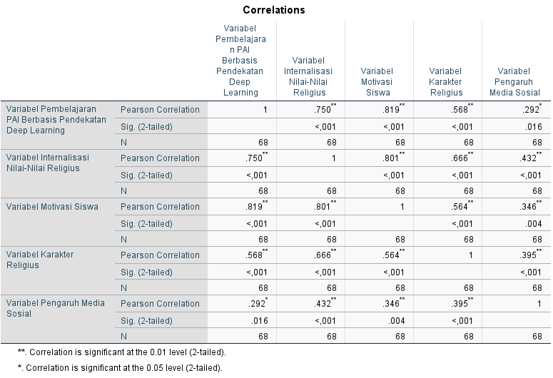
Figure 1. Correlation Table between Research Variables

Based on Figure 1. Correlation Table between Research Variables, the results of the Pearson correlation analysis with a total of 68 respondents, it can be determined that the r table value is 0.2352. Based on the analysis, it was found that all research variables have a significant relationship with each other. The main variable (X1), namely PAI Learning based on the Deep Learning Approach shows a strong and significant relationship with the internalization of religious values variable (Y1) (r = 0.750, p < 0.01). Then the internalization of religious values variable also has the strongest relationship with religious character compared to the student motivation variable and the social media influence variable, which is (r = 0.666, p < 0.01). The social media influence variable has a weak relationship with all variables, including the internalization of religious values. Meanwhile, PAI Learning based on the Deep Learning Approach has a perfect correlation with student motivation (r = 0.819, p < 0.01). And student motivation has a very strong relationship with the internalization of religious values variable (r = 801, p < 0.01). So overall, these results show that Islamic Education Learning based on the Deep Learning Approach contributes greatly to increasing student motivation and internalizing religious values in Generation Z, so that it can form a religious character in students.
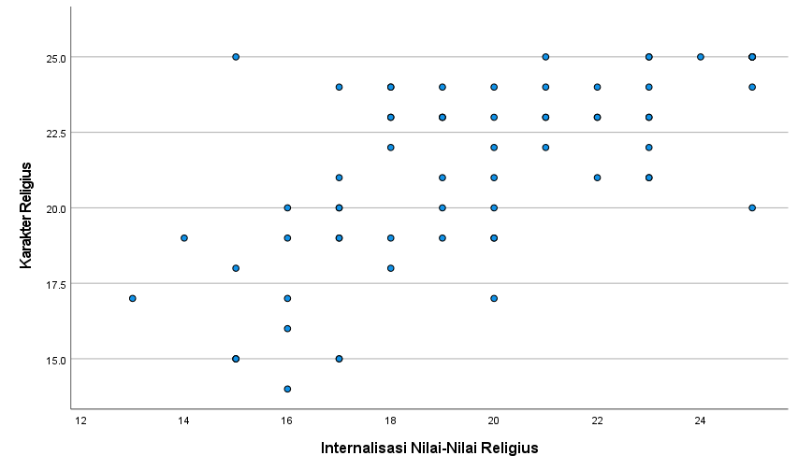
Figure 2. Correlation between variables PAI Learning and Internalization of Islamic Values

In Figure 2, we can see that the relationship between the main variables PAI Learning and Internalization of Islamic Values has a positive value, because it shows a line stretching from the bottom left to the top right using a Scatterplot. This aligns with the constructivist theory of learning, which emphasizes the importance of internalizing values in building religious character, as demonstrated by the Deep Learning approach, which supports a deeper understanding and appreciation of religious values. Learning with a Deep Learning approach will increase students' motivation to learn, thereby enhancing the effectiveness of internalizing religious values. Continuous internalization of values will form recurring habits and become ingrained in students' character. Therefore, in the context of Islamic Religious Education (PAI) learning, this approach strongly supports the implementation of education that focuses not only on the cognitive domain or IQ, but also on the affective and psychomotor domains, as well as developing students' EQ and SQ potential.
PAI learning based on the Deep Learning approach has proven effective in instilling religious values in generation Z. According to the results of observations and interviews, learning with this approach uses learning methods and strategies that are appropriate to the characteristics of generation Z. Learning enables students to explore and utilize technology and the digital world in learning, learning also inserts examples or cases of social and environmental life in real contexts, and facilitates students to develop creativity and independence and encourages 21st century competencies, such as: thinking skills (creativity, critical thinking), work skills (communication, collaboration), skills in using tools (literacy, ICT) and life skills (citizenship, personal responsibility).
In addition, the effectiveness of internalization or instilling religious values in Generation Z in Islamic Religious Education learning is further strengthened by the results of further research using a qualitative approach with a word frequency analysis method with data collection in the form of interviews with the vice principal of the curriculum of SMAN 2 Bandung and three Islamic Religious Education teachers regarding Islamic Religious Education Learning based on the Deep Learning approach . So that after being processed using the Nvivo12 application, the following word cloud results were obtained:
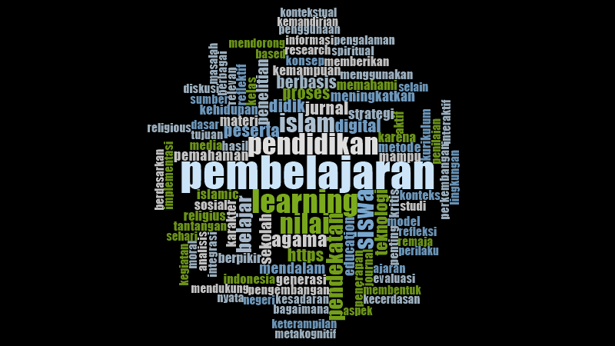
Figure 3. Word Cloud
In Figure 3. Word Cloud, you can see several words that frequently appear in interviews based on qualitative data processing using the Nvivo 12 application. These words were obtained from the following word frequencies:
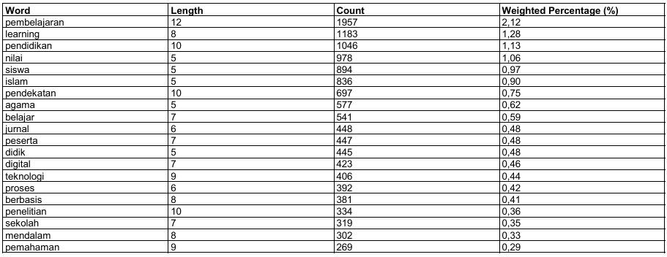
Figure 4. Word Frequency
Based Figure 4, The frequency count above shows the results of the data import and coding. From thousands of words, the top 20 most frequently occurring words were searched based on a minimum of 5 letters per word. The results show that the word "learning" appears most frequently, with 1,957 words, followed by "learning," which also means "learning," with 1,183 words. This is followed by "education," with 1,046 words, "values," with 978 words, "Islam," with 894 words, and "approach," with 697 words.
This demonstrates a strong integration between the terms learning, education, values, Islam, and approach. This means that the approach to learning significantly contributes to the instilling of Islamic values in the realm of education. The Deep Learning approach in Islamic Religious Education (PAI) is consistently understood as in-depth learning that emphasizes understanding values, reflection, and real-life implementation in students' lives. Teachers interpret deep learning not merely as a new technique, but as a reaffirmation of the essence of Islamic education, which demands appreciation and behavior, not just the completion of material. This is reinforced by the statement of the head of the MGMP PAI SMAN 2 Bandung, who said that "learning must be mindful, meaningful, and joyful, where students not only understand concepts but are able to find meaning and connect them to their own realities and social environment." This statement is supported by the agreement of other PAI teachers through interviews conducted by the researcher.
At the pedagogical implementation level, analysis shows that teachers use various active learning strategies such as project-based learning, problem-based learning, case studies, sociodramas, social projects, and the creation of posters or reflective videos. Strengthening reflection is a dominant characteristic that connects these methods to the principles of deep learning. These activities are aimed at encouraging students to analyze phenomena, relate Islamic values to real life, and develop character through direct experience. Teachers apply an approach close to the students' world, including the use of popular digital media such as TikTok, YouTube, Instagram, and Canva. These findings indicate that Deep Learning in Islamic Religious Education tends to be contextual, applicable, and experience-based, in line with the characteristics of Gen Z, which requires varied, interactive, and non-monotonous learning.
Another strong finding is the characteristics of Gen Z students, which are considered a key factor in learning design. Teachers assess this generation as being very close to technology, easily bored, have short focus, and have a relatively low perseverance compared to previous generations. This impacts teacher strategies that emphasize a more personal approach, humanistic communication, storytelling, and student emotional engagement. Deep learning is considered suitable for Gen Z because it allows space for creativity, direct experience, and self-reflection, which has been shown to increase their enthusiasm and understanding.
From an evaluation perspective, findings emerged that teachers emphasize process and attitude assessment, such as congregational worship, cleanliness, discipline, and internalization of moral values. Portfolio assessment, projects, and reflection are the dominant methods in the deep learning approach. However, teachers still face a dilemma because the curriculum demands completion of material and academic examinations (TKA), creating tension between holistic evaluation and the demands of academic standards.
Meanwhile, an interview with the Vice Principal for Curriculum confirmed that school support remains at the policy and initial training level (two IHT sessions). Monitoring of deep learning implementation has not been optimal, and there are no concrete indicators to measure the success of deep learning in students. Although the school culture has long embraced character education, the implementation of deep learning still faces structural barriers such as limited facilities, uneven teacher competency, minimal BOS funds for teacher training, frequent curriculum changes, and high administrative and assessment burdens.
Overall, the analysis results revealed five major findings:
- Deep Learning is understood as deep and transformative value learning,
- Implementation relies on active, creative, and reflective methods,
- Gen Z characteristics greatly influence learning design,
- Evaluation places more emphasis on the process, portfolio, and character formation or daily attitudes of students in learning,
- The implementation of Deep Learning faces structural and competency barriers, but still has opportunities for growth due to alignment with school culture and student development needs.

From these findings, it can be seen that the Deep Learning approach is understood as a learning approach that emphasizes a deep understanding of values, not just memorization or information delivery. This supports the deep learning theory first proposed by Marton and Säljö (1976) which emphasizes the importance of understanding the meaning and relationships between concepts as a whole (Uswatun Khasanah et.all, 2025). This approach positions students as active subjects who build knowledge and values through meaningful learning experiences. In the context of Islamic Religious Education, deep learning functions as transformative learning that not only instills religious values cognitively, but also internalizes them in everyday attitudes and behaviors (Alya Fitriani & Santiani, 2025).
As for the process, the implementation of the deep learning approach in Islamic Religious Education learning relies on active, creative, and reflective methods that are in line with the theory of constructivism and the objectives of meaningful learning (Deny Khusnul Khotimah & Muhammad Rohmad Abdan, 2025). This approach emphasizes the active role of students in building knowledge and values through discussions, projects, and self-reflection. Project-based learning models, collaboration, and reflection have been proven to improve students' in-depth understanding and critical thinking skills. In Islamic Religious Education, this method allows students to apply religious values in real-life contexts, so that learning becomes more meaningful and relevant.
The Deep Learning Approach requires Islamic Religious Education teachers to create Islamic Religious Education lessons that foster students' awareness and focus, understanding of the material's value, and creating a fun learning environment. This approach aligns with the easily bored characteristics of Generation Z, as revealed by interviews with Islamic Religious Education teachers. Therefore, when developing learning sequences, teachers also consider student characteristics (Generation Z), such as digital natives, multitasking, and creativity, which significantly influence deep learning design. This generation tends to learn more effectively through contextual, interactive, and technology-based approaches. Deep learning designs that consider these characteristics will be more easily accepted and internalized by students. Research has shown that learning models that incorporate multimedia elements, engaging discussions, and simulations can enhance engagement and understanding of religious values ​​in Generation Z (Rabiatul Aliyah & Norlianti, 2025). Teachers play a crucial role in developing Lesson Plans (RPPs) or Teaching Modules and implementing learning steps, from observation to communication. Learning evaluation is conducted through authentic assessments covering three domains: cognitive, affective, and psychomotor (Rufianti et al., 2024).
Furthermore, based on evaluation findings, the deep learning approach focuses not only on final results but also emphasizes the process, portfolio, and character development or students' daily attitudes. Comprehensively developed formative and summative assessments can provide more personalized and relevant feedback for student development. This evaluation is able to measure the development of understanding, thinking skills, and religious character development holistically, thus better aligning with the learning objectives of Islamic Religious Education (ISE) in shaping noble individuals (Sumarto & Emmi Kholilah Harahap, 2025).
In this regard, teachers face a tension between holistic assessment and the demands of academic examinations. Despite the successful implementation of the Deep Learning approach by Islamic Religious Education teachers at SMAN 2 Bandung, there are still obstacles such as limited infrastructure, teacher competency, and a school culture that does not fully support a reflective and contextual learning approach. Curricula are often designed with a progressive vision oriented toward character building, 21st-century competencies, and meaningful learning. However, in practice, they face structural constraints such as teacher administrative burdens, limited resources, disparities in human resource quality, and a school culture that is not yet fully adaptive to change. As a result, pedagogical idealism is often reduced to technical routines, while teachers find themselves in a dilemma between the normative demands of policy and the complex realities of the classroom. This suggests that the problem in education lies not solely in the content of the curriculum, but rather in the implementation ecosystem, which does not fully support the realization of educational ideals in a holistic and contextual manner.
Therefore, the government must provide greater support to educators. This is hoped to ensure that the approach can be implemented effectively and developed according to the developmental needs of students and the demands of the times. Teacher training, such as that conducted by SMAN 2 Bandung, combined with policy support and technology integration, can be key to the successful implementation of in-depth learning in Islamic Religious Education (PAI), particularly for instilling religious values ​​in Generation Z. Previous research has concluded that this approach is effective in instilling religious values ​​in Generation Z (Rabiatul Aliyah & Norlianti, 2025). Schools, as educational organizations, particularly those under government institutions, are required to adapt to global cultural developments, including developments in management science. However, they must also not forget the ideological roots that underlie religiosity (Fakhruddin, 2011).
This article confirms that the Deep Learning approach in Islamic Religious Education (PAI) is an effective strategy for instilling religious values ​​and building the character of Generation Z amidst the challenges of moral degradation due to globalization and digitalization. Through attentive, meaningful, and enjoyable learning, teachers are able to improve religious understanding, motivate students, and encourage the internalization of Islamic values ​​in daily behavior. The combination of active methods such as discussions, social projects, reflection, case studies, and digital technology integration has proven relevant to the critical, easily bored, and digitally adept Generation Z character. Quantitative research results show a strong correlation between Deep Learning-based PAI learning and motivation, internalization of religious values, and character formation of students, while qualitative findings reveal that this learning strategy is implemented through interactive and contextual teacher facilitation. Despite facing obstacles such as the negative influence of social media, low interest in learning, limited facilities, and varying teacher readiness, these challenges can be overcome through learning innovation, collaboration between schools, parents, and the community, and strengthening religious culture in schools. This finding broadens the understanding that deep learning in Islamic Education is not just a method, but a paradigm of value transformation that is responsive to the psychosocial conditions of Generation Z. Overall, this article emphasizes that the application of Deep Learning in Islamic Education is very important and relevant to answer the psychological and social needs of Generation Z, overcome moral decline, and prepare a generation that has strong character, religion, and abilities in facing the complexities of the times.
Aliyah, S. R., Norlianti, N., & Mukmin. (2025). Model Pembelajaran PAI Berbasis Deep Learning. Jurnal Pendidikan Indonesia, 6(5), 2341–2354.
Alya Fitriani, & Santiani. (2025). Analisis Literatur: Pendekatan Pembelajaran Deeplearning Dalam Pendidikan. Jurnal Ilmiah Nusantara. https://doi.org/10.61722/jinu.v2i3.4357
Auliya Sholikhatun, Robingun Suyud El Syam, B. S. (2025). Degradasi Etika Murid Generasi Z ( Kajian Kitab Maraqil ‘ Ubudiyah Syarah Bidayatul Hidayah Bab Al-Qoul Fi Adab As-Suhbah Wa Al-Mu ’ Asyarah Ma ’ a Al-Khaliq Azza Wa Jalla Wa Ma ’ a Al-Khalq ). KAMPUS AKADEMIK PUBLISING Jurnal Ilmiah Nusantara ( JINU), 2(3), 615–626.
Azhari, A., & Soleh, A. K. (2024). Memahami psikologi agama dan pengaruh agama dalam perilaku manusia. 2(8), 420–425.
Azima, R., Sabri, A., Nelwati, S., Dasar, S., Rizqiyul, K. R.-, Sabri, A., & Nelwati, S. (2023). Model Pembelajaran Deep Learning Dalam Pendidikan Agama Islam Untuk Sekolah Dasar Kelas Rendah. 03(02), 42–48.
Azis, A. R., & Tamimi, A. R. (2025). Membangun Kompetensi Metakognitif Peserta Didik Melalui Deep Learning Dalam Pembelajaran Pendidikan Agama Islam. Journal of Research an Thought on Islamic Education, 8(1), 134–156.
B P S 2025. (2021). Statistik Indonesia (Statistical yearbook of Indonesia) 2025 Volume 53. In Statistik Indonesia 2020: Vol. 53,2025. https://www.bps.go.id/publication/2020/04/29/e9011b3155d45d70823c141f/statistik-indonesia-2020.html
Deny Khusnul Khotimah, & Muhammad Rohmad Abdan. (2025). Analisis Pendekatan Deep Learning untuk Meningkatkan Efektivitas Pembelajaran PAI di SMKN Pringkuku. Jurnal Pendidikan Dan Pembelajaran Indonesia (JPPI), 5(2), 866–879.
Fakhruddin, A. (2011). Prinsip-Prinsip Manajemen Pendidikan Islam Dalam. JURNAL PENDIDIKAN AGAMA ISLAM - Ta’lim, 9(2), 199–212.
Firmansyah, M. I. (2019). PENDIDIKAN AGAMA ISLAM : PENGERTIAN, TUJUAN, DASAR, DAN FUNGSI. Jurnal Pendidikan Agama Islam - Ta’lim, 17(2), 79–90.
Firmansyah, M. I., Surahman, C., Lestari, W., Septiani, S., & Sudaryat, R. (n.d.). Pendidikan Agama Islam Dan Pembangunan Karakter Siswa Sekolah Dasar: Studi Eksplorasi Islamic Religious Education And Character Building Of Elementary School Students: Exploration Study. http://jurnaledukasikemenag.org
Hasanuddin, M. N., Rohmad, M. A., & Wachidah, H. N. (2025). Penerapan Deep Learning dalam Pembelajaran Pendidikan Agama Islam di Sekolah Menengah Atas Negeri. Paradigma: Jurnal Filsafat, Sains, Teknologi, Dan Sosial Budaya, 31(1), 263–269. https://doi.org/10.33503/paradigma.v31i2.2130
Hoeruman, M. R., Mahamid, M. N. L., Baroud, N., Maryamah, & Prihatin, N. Y. (2025). Pendekatan Deep Learning dalam Pembelajaran PAI Berbasis Sejarah Islam. Edu Society: Jurnal Pendidikan, Ilmu Sosial, Dan Pengabdian Kepada Masyarakat, 5(2), 516–523. https://jurnal.permapendis-sumut.org/index.php/edusociety/article/view/1247
Khotimah, D. K., & Abdan, M. R. (2025). Analisis Pendekatan Deep Learning untuk Meningkatkan Efektivitas Pembelajaran PAI di SMKN Pringkuku. Jurnal Pendidikan Dan Pembelajaran Indonesia (JPPI), 5(2), 866–879. https://doi.org/10.53299/jppi.v5i2.1466
Maulida, K. M., & Makrufi, A. D. (2025). Membangun karakter positif generasi Z dan Alpha : Peran metode pengajaran PAI ala Rasulullah. 18(2), 277–294. https://doi.org/10.32832/tawazun.v18i2
Muhajjalina, K. G. (2025). Desain Pembelajaran Pai Berbasis Deep Learning : Membangun Pengalaman Belajar Memahami ,. 4(1), 53–64. https://doi.org/10.5281/zenodo.16779397
Rabiatul Aliyah, S., & Norlianti, N. (2025). Model Pembelajaran Pai Berbasis Deep Learning. Jurnal Pendidikan Indonesia, 6(5).
Rahmawati, M., & Kusrina, T. (2025). Dekandensi Moral dalam Sudut Pandang Pendidikan dalam Keluarga dan Masyarakat. Tut Wuri Handayani : Jurnal Keguruan Dan Ilmu Pendidikan, 4(1), 9–18. https://jurnal.risetilmiah.ac.id/index.php/jkip/article/view/669
Rufianti, A., Fakhruddin, A., & Surahman, C. (2024). Penerapan Metode Problem Solving dalam Pembelajaran PAI: Upaya Meningkatkan Kemampuan Berpikir Kritis Siswa di SMPN 15 Bandung. Jurnal Pendidikan Islam, 15(1), 48–56. https://journal.uhamka.ac.id/index.php/jpi
Rukiyati, R. (2020). Tujuan pendidikan nasional dalam perspektif Pancasila. Humanika, 19(1), 56–69. https://doi.org/10.21831/hum.v19i1.30160
Shobihah Siti Salma, Fakhruddin Agus, & Firmansyah Iman Mokh. (2024). Implementasi Pembelajaran Bermakna (Meaningful Learning) dalam Mata Pelajaran PAI dan Budi Pekerti di SMA Mutiara Bunda. Allama: Jurnal Pendidikan Islam Indonesia, 1(1), 57–74.
Sofyana, N. L., Haryanto, B., Pendidikan, P., & Islam, A. (2023). Menyoal Degradasi Moral Sebagai Dampak Dari Era Digital. In Jurnal Manajemen dan Pendidikan Islam (Vol. 3, Issue 4).
Sumarto, & Emmi Kholilah Harahap. (2025). Perencanaan Pendidikan dalam Menyusun Kurikulum Deep Learning. Jurnal Literasiologi, 1, 80–86. https://doi.org/10.47783/literasiologi.v9i4
Usman, K. (2025). Transformasi Pembelajaran Pendidikan Agama Islam dalam Era Merdeka Belajar : Pendekatan Deep Learning. 21, 214–225.
Uswatun Khasanah et.all. (2025). Deep Learning dalam Pendidikan: Pendekatan Pembelajaran Bermakna, Sadar, dan Menyenangkan.



