Development of an Android-Based Mu'jam al-Musṭalahāt al-Tarbawiyah Dictionary as a Source of Independent Learning for State Islamic University Students

Muhammad Jafar Shodiq¹
¹Universitas Islam Negeri (UIN) Sunan Kalijaga, Yogyakarta, Indonesia
e-mail: Muhammad.shodiq@uin-suka.ac.id*¹

Abstract
Writing skills are one of the most difficult language skills to achieve. So far, students have used Google Translate to translate "educational terms" that are unknown. However, google translate is often inaccurate. This study aims to (1) develop an android-based Mu'jam al-Musṭalahāt al-Tarbawiyah dictionary application as a source of independent learning for PTKIN students, (2) determine the quality of the Android-based Mu'jam al-Musṭalahāt al-Tarbawiyah dictionary, and (3) find out students' responses to the Android-based Mu'jam al-Musṭalahāt al-Tarbawiyah Dictionary. This research is development research with a procedural model. The development procedure in this study refers to the development research procedure by Timpus Litjaknov with development steps, namely product analysis to be developed, initial product development, expert validation and revision, small-scale field trials and product revisions, large-scale field trials, and final products. The data analysis technique changes the quantitative and qualitative data. The results of this study are: 1) the Android-based Mu'jam al-Musṭalahāt al-Tarbawiyah has been successfully developed as a source of independent learning for state Islamic university students with the name dictionary of three-language education terms, 2) Based on the assessment of media experts Mu'jam al-Musalahāt al-Tarbawiyah dictionary has excellent quality with an average score of 3.50 and based on the assessment of media experts is 3.50, 3) student responses to the Mu'jam al-Musṭalahāt al-Tarbawiyah dictionary application in small-scale field trials obtained an average score of 3.02 while in large-scale field trials obtained an average score of 3.30.
Keywords: Development; Dictionary; Mu'jam al-Musṭalahāt al-Tarbawiyah; android; independent learning resources.

INTRODUCTION
In learning Arabic, there are four skills to be achieved, namely: mahārah al-istimā' (listening skill), mahārah al-kalām (speaking skill), mahārah al-qira'ah (reading skill), and mahārah al-kitābah (writing skill) (Zurqoni et al, 2020). Of the four skills, writing skill occupy the highest position because writing requires the use of language that is accurate, rich, and systematic ideas (Kim et al., 2021; Muhammad Ali al-Khuli, 1989)
In practice, mahārah al-kitābah has not been maximally achieved, indicating a lack of writing an Arabic thesis. Research conducted by Ikhsan Rosadi (2013) on the problems of writing an Arabic thesis in the Arabic Education major from 2009 to 2012 shows that very few students write an Arabic thesis. In 2009 out of 32 students who graduated with an Arabic Education major, only one person wrote an Arabic thesis. In 2010 out of 61 students who graduated there were only 4 students who wrote a thesis in Arabic. The rest, as many as 57 students wrote a thesis in Indonesian. The same thing happened in 2011. Of the 60 students who graduated, only 3 wrote their thesis in Arabic. Graduation in April 2012 was not much different, from 29 Arabic education graduates, none wrote a thesis in Arabic. So it can be concluded from 182 students majoring in Arabic Education who graduated in 2009 - 2012, only 9 students wrote an Arabic thesis or about 16.38%. This data is an indication of the weakness of Arabic writing skills.
Based on respondents' answers in the study, one of the problems faced when writing a thesis in Arabic is the lack of vocabulary. Meanwhile, Nguyen, et al stated that vocabulary mastery significantly impacts students' writing skills (Nguyen et al., 2022). Usually, to overcome these problems, students use conventional or online dictionaries such as Google Translate. Research conducted by Iswah Adriana (2012) stated the inaccuracy of the translation of Google Translate and the translation results from this machine needed to be studied further. In line with the problems these students face regarding technology, an operating system called Android was developed. With Android, internet access on mobile phones is easy to get, anywhere and anytime (Bulus P.Bala, 2022). The education cannot be separated from modern technology to solve the problems it faces (Hamidi et al., 2011). As stated by Snelbecker (1974), technology can be used to improve educational practice, predict the effectiveness of innovation, and direct future research to be more effective. Based on these problems, the author intends to develop an Ansdroid-based Mu'jam al-Musṭalahāt al-Tarbawiyah Arabic dictionary for independent learning resources for state Islamic university (PTKIN) students, knowing the quality of the Android-based Mu'jam al-Musṭalahāt at-Tarbawiyyah dictionary, and knowing the students' responses to the Android-based Mu'jam al-Musṭalahāt at-Tarbawiyyah dictionary.
In this study, the authors found several studies related to the research that the researcher will do. First, the research conducted by Ellly Anasrul Firdaus with the title Development of Making a Visual Basic Arabic Synonym Dictionary for students majoring in Arabic Literature, Faculty of Letters, State University of Malang. This study aims to develop a dictionary of Arabic synonyms with visual basics for students majoring in Arabic Literature while the research that the author conducted aims to develop a musṭalahāt at-tarbawiyyah (educational term) dictionary based on Android. Ellly Anasrul Firdaus (2011) focuses on developing an Arabic dictionary in synonyms, while the author focuses on musṭalahāt at-tarbawiyyah.
Another related research theme is the Development of a Multi-Language Dictionary (Arabic-English-Indonesian-Javanese) for Early Childhood Education Based on Local Wisdom. This research is motivated by the assumption that children at an early age have considerable potential in learning languages. The content in this dictionary is developed based on local wisdom, meaning it has a specific scope that Arabic learners encounter daily, such as the kitchen area. This is of course different from the research that the researcher will do. The background of this research is the obstacles for students majoring in Arabic education when writing an Arabic thesis and encountering difficult vocabulary/terms where they usually use a dictionary line such as google translate which is considered less accurate. So that the contents of this dictionary are developed based on education terms (Dwi Mawanti, 2014).
The thesis was written by Saptiani (2016) titled Development of Learning Media Thematic Dictionary of Three Languages ​​(Indonesian, Arabic, English) To Stimulate Cognitive Early Childhood. In this study, the dictionary was developed with a thematic model according to the first and second-semester of Early Childhood Education curricula such as the theme of self, environment, and needs. While the dictionary that the researcher will develop is based on musṭalahāt at-tarbawiyyah (educational terms), so no research is the same as the research the researcher will do.

METHOD
The research method used in this research is the research and development method. Gall stated that research and development (R&D) aims to produce and develop a development model that can be used as a new product model that has been systematically tested in the field. The product has been carefully studied and improved so that the final result meets certain effectiveness, quality or standards, specifically educational Research and Development (R&D) is an industry-based development model in which the finding of research are used to design new products and procedures, which then are systematically field-tested, evaluated, and refine until they meet specified criteria off effectiveness, quality, or similar standard (D. Meredith Joyce P. Gall & Walter R. Borg, 2003).
Considering this, the final result of the development research must be a new product and be specific or different from existing products. A systematic field-tested product is one of the research procedures that must be carried out in an R & D type of research. Before the product goes through the stages of evaluation and refinement follow the standard criteria that have been determined. According to Borg, the R & D stages include product development, product testing in the field, and product improvement steps based on input or data obtained after the product is tested.
The development model in this study contains 2 (two) main components, namely: (1) development model, (2) product development and testing procedures.
            - Development Style
The development model can be divided into 3 (three): procedural, conceptual, and theoretical. In this study, the conceptual model was chosen with six steps, namely: (1) concept development, (2) product design development, (3) material collection for the product, (4) preparation of a screen map from a dictionary, (5) conducting a trial which includes: expert judgment trials, limited trials, and field trials, (6) distribution of results (dictionary).
            - Product Development and Testing Procedure
The research development procedure is the procedure taken by the researcher in making the product, the researcher mentions the properties of the components at each stage of development, explains analytically the function of the components at each stage of product development, and explains the relationship between components in the system.
The development procedure according to Borg and Gall, can be carried out with 5 (five) main steps, namely: (1) Conducting product analysis to be developed, (2) Developing initial products, (3) Expert validation and revision, (4) Field trials small scale and product revision, (5) Large scale field trial and final product. The procedures in this study include: (1) the preliminary stage, (2) the development stage, and the model testing stage.
This study uses the research method of procedural model development. The procedural model is descriptive, showing the steps that must be followed to produce a product (Tim Puslitjaknov, 2008).
The development procedure in this study refers to the development research procedure by the Puslitjaknov Team. The details of the procedure are:
    - Analyze the product to be developed, at this stage the things to do are needs analysis, material analysis, and media selection.
    - Developing the initial product, at this stage the things to do are the selection of software, collection of reference material that will be inputted in the application of the dictionary of educational terms, and designing the initial product.
    - Expert validation and revision, the validation referred to in this stage is product validation involving 3 experts/validators. After validation, the application of the educational term dictionary is assessed to determine its quality. The assessment was carried out by several raters consisting of 2 Arabic material experts and 2 media experts.
    - Small-scale field trials.
    - Large-scale field trials and final products.
This research was conducted at the Department of Arabic Language Education, Faculty of Tarbiyah and Teacher Training, State Islamic University Sunan Kalijaga Yogyakarta, which is located at Marsda Adisucipto Street, Caturtunggal Village, Depok District, Sleman Regency, Yogyakarta Special Region. This research was conducted in the odd semester of the 2018/2019 academic year. The validator who validates the application of this educational term dictionary consists of one media expert and two material experts. The appraisers who assess the application of this three-language educational term dictionary consist of three material experts and three media experts. The respondents of the small-scale field trial were followed by 15 students majoring in Arabic Education Semester III, Faculty of Tarbiyah and Teacher Training. The respondents of the large-scale field trial were attended by 100 students majoring in PBA.
The instrument used in this research is a questionnaire/questionnaire. The questionnaire instrument as a product quality assessment sheet was used to obtain data on the feasibility of applying the developed educational term dictionary starting from content feasibility, linguistic structure, technical use, and design.
The theoretical basis is needed so that research has a solid foundation, and is not an act of trial and error. Every research always uses theory, as Kerlinger stated:
"Theory is a set of interrelated construct (concepts), definition, and proposition that present a systematic view of phenomena by specifying relations among variables, with purpose of explaining and predicting the phenomena" (Fred Nichols Kerlinger & Howard Bing Lee, 2000).
Meanwhile, William Wiersma stated, "A theory is generalization of series of generalization by which we attempt explain some phenomena in a systematic manner" (William Wiersma, 2009).
Cooper and Schindler (2011) stated, "A theory is a set of systematically interrelated concepts, definition and proposition that are advanced to explain and predict phenomena".
Based on these three views, it can be concluded that the theory can be viewed as follows:
- Theory refers to a group of logically arranged laws that have a deductive relationship, and show a legal relationship between empirical variables that are steady and predictable in advance.
- Theory is a written summary of a legal group obtained empirically in a certain field.
- A theory can also refer to a generalized way of explaining. Usually, there is a functional relationship between the data and theoretical opinion.
The following are some definitions, concepts, and propositions related to this research:
Dictionary Definitions
The dictionary terms found in Indonesian have two equivalents in Arabic, namely qamūs and mu'jam. By the explanations in Arabic dictionaries, the two words have the same meaning or are synonyms. In Arabic, the word qamūs means deep ocean. If this word stands alone with the prefix "al", then what is meant is al-Qamūs al-Muhiṡ by Fairus Abadi. This dictionary is named so because of its broad scope and deep explanations (Lewis Ma'luf, 2008). The word mu'jam comes from ájama which means unclear, the person is called 'ujm plural a'jam, that is, people cannot speak clearly and fluently, even though he is of Arab descent. The word' ujm or a'jam also means people other than Arabs. To get a deeper understanding of al-mu'jam below, several experts' opinions regarding the definition of al-mu'jam are given. Ali al-Qasimi (1411H) stated:
المعجم : كتاب يحتوي على كلمات منتقاة، ترتب عادة ترتيبا هجائيا مع شرح لمعانيها ومعلومات أخرى ذات علاقة بها سواء أعطيت تلك الشروح والمعلومات باللغة ذاتها أم بلغة أخرى.

(A dictionary is a book that contains selected words, sorted alphabetically and given explanations, meanings, and other information related to the same language or other languages.) Ahmad Mukhtar Umar (1997) put forward a similar definition. In his book sina'atu al-mu‘jam al-hadiṡ stated:
المعجم : الكتاب الذي يجمع كلمات لغة ما ويشرحها ويوضح معناها و يرتبها بشكل معين.

(A dictionary is a book that collects the words of a language, explains and describes their meaning, and sorts them according to a certain pattern.) While the definition put forward by Ladslav Zgusta (1971) in the dictionary is as follows:
"A dictionary is a systematically arranged list of socialized linguistic forms compiled from the speech-habits of a given speech-community and commented on by the author in such a way that the qualified reader understands the meaning"
Based on the three explanations above, it can be concluded that the elements that make up the dictionary are:
- A particular collection of words or a collection of sentences of a language,
- Sorting based on a certain pattern, and
- Giving meaning in the same language or another language.

Dictionary Design/Presentation of Dictionary Content
In general, the presentation arrangement of Arabic dictionaries, as stated by Ali Al Qasimi (1979) Tamam Hasan (1985), Hasan Zho Zho (1976) , and Abu al-Faraj (1996)is as follows:
  - Introduction includes information, data sources, purposes of compilation, dictionary objectives, and brief information about the foreign language (at the phonological, morphological, syntactic, semantic, and setting levels). In addition, there is an explanation of the method of compiling and using the dictionary in question.
  - The dictionary arrangement is clear in alphabetical order, using clear punctuation marks and symbols to facilitate its use.
  - Entries or entries are not only limited to words but also include morphemes. The entries in the dictionary endeavored as much as possible to represent all these foreign vocabularies. In addition, idioms, cultural elements, and names of famous figures and places should also be found in the entry.
  - Phonological information, in the form of how to pronounce complete with information about segmental and supra-segmental phonemes
  - Syntax information, in the form of a brief and concise explanation of the morphological structure, time division, word types, I'rab methods, etc.
  - Semantic information, where the dictionary must cover as much as possible all possible meanings with an agreed method of meaning.
  - Information about various languages, dialects, or dialects.
  - Explanatory examples full of foreign languages' cultural aspects and precise and careful understanding.
  - Illustrated examples
  - Etymological information, in the form of an explanation of whether the words are native to a foreign language or are borrowed words
  - Supplements include additional information, such as currency, size, air temperature, state/private institutions, maps, and so on.
  - Format, cover appearance, and content must be attractive, use color and minimize sample errors.

The Development of Science and Technology in the Arabic Dictionary
- Since the Western world has led at the forefront of human progress, this progress has been marked by advances in science and technology. This progress has resulted in various countries that use Arabic as their official language always having to adapt to these developments. In the field of language, advances in science and technology in the Western world gave birth to terms of these advances.
- As a result, all language institutions in the Arab world are busy translating, forming new terms, and absorbing and adapting them to the rules of the Arabic language. The same thing was done by linguists, and dictionary compilers, individually and in teams. Various encyclopedias, encyclopedic dictionaries, term dictionaries, mu'jam, and glossaries were compiled by Arab experts themselves and foreign experts. Based on Samsul Hadi's research (2005), the number of term dictionaries (musthalahat) is more than the general dictionaries, which are around 100.
- Thus, advances in technology and knowledge in the Western world followed by advances in knowledge and technology in the Arab world have influenced the field of Arabic lexicography. The influence is the development of the compilation of various dictionaries of terms in various fields, such as Computer science, Geography, Electrical Engineering, and Education. Furthermore, this research will develop a dictionary of terms in education, making it an Android-based digital dictionary.

The Role of Learning Technology in Learning Organizations
- Our environment undergoes a continuous and fundamental change. As Marquardt (1996) quoted, Albert Einstein stated, "No problem can be solved from the same consciousness that created it; we must learn to see the world new". The problems we face today include environmental changes, workplace changes, societal demands and so on that are impossible to solve in the old ways, including knowledge, technology, management, and old-fashioned leadership. We have to see things with new eyes, not just change glasses to see and solve new problems we face.
- The environment changes either because of natural changes or changes that occur due to human actions and actions. This change raises several new problems that did not exist before. Facing these changes and new problems, every organization if it wants to survive and develop must adapt to using new ways and approaches. Schools, families, communities, and even the state (as an organization) need to learn to adapt to these changes to survive in the face of change.
- One of the organizational development models proposed by Robert Blake and Jane S. Mouton(1970) is internal organizational change. This model is based on eight assumptions, namely: (1) individual change, (2) efficient change needs to be carried out systemically, (3) human behavior and organizational activities can inhibit or otherwise improve performance, (4) education and training must be intertwined with each other. effective, (5) Reasoning and emotion are always related, (6) The relationship between superiors and subordinates in the organization must be open and communicative, (7) Opportunities need to be created in the organization, (8), Everyone wants to participate in decision making regarding herself.
- In subsequent developments, organizational development more oriented to the internal environment is considered inappropriate, partly because the rapid development of information and communication technology triggers it. Every organization needs the knowledge to adapt to change. For that organizations need to learn, the concept of learning organizations emerged.
- The concept of a learning organization was explained in more detail by Peter Senge (1990). Senge did not explicitly define a learning organization but emphasized the five components that unite to form a learning organization. Although each of these components develops separately, each will support the success of the other components. The five components are (1) Thinking systems (system thinking), every human endeavor, including education is a system because it is part of a fabric of actions or events that are interconnected even though the relationship is not always visible, (2) personal mastery. Everyone must commit to lifelong learning, (3) Mental patterns (mental models). Everyone has a mental pattern of how he perceives the world around him and acts on the assumptions of what he sees, (4) Shared vision A successful organization needs to be described in a shared vision, this vision is not just a statement of the wishes of a company. the organization and its members are informed about it, but it is a common desire, (5) Team learning. Teams can display better learning outcomes than their performances.
- Meanwhile, according to Marquardt (1996), a learning organization is an organization that learns together in earnest and constantly transforms itself by collecting, managing, and using knowledge for business success. Technology is used to optimize learning and productivity.
- According to Snelbecker (1974), the development of psychology in the field of education took place in the 1950s. This development is called learning technology. Furthermore, he stated that the use of theory or technology in education is to seek to improve educational practices that are currently taking place. This is the theoretical footing by the author in conducting this research, the use of technology (android technology) is used to develop the mu'jam al-must dictionary musṭalahāt at-tarbawiyyah in order to improve the ability of students at state Islamic universities.
- All technology, including learning technology, is a system created by humans for a specific purpose, which in essence is to make it easier for humans and make their business easier, increase results, and save energy and existing resources. Technology is essentially value-free, but its use is full of value and aesthetic rules. Technology has helped us in all aspects of life (Tuma, 2021), including education (An & Oliver, 2021). In education, technology is needed to reach citizens wherever they are, serve those who have not had formal learning opportunities, and increase effectiveness and efficiency in learning.
- Learning technology is theory and practice in the design, development, utilization, management, assessment, and research of processes, resources, and systems for learning (Barbara B. Seels & Rita C. Richey, 1994). The illustration of the definition can be described as follows:

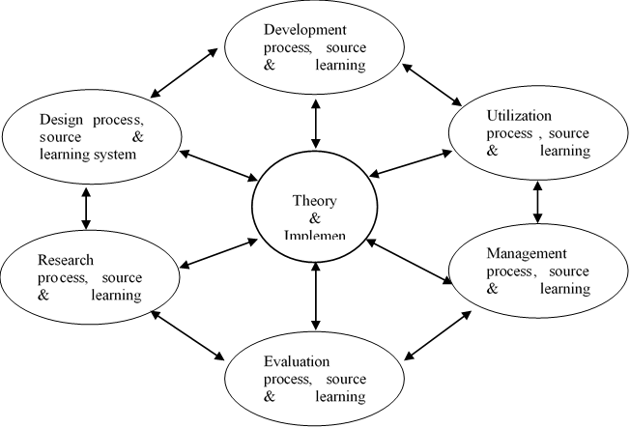
The development of learning technology, unless determined by increasing needs, is also influenced by the development of technology as a product of human engineering. The technology that is currently influencing development is information and communication technology. However, it should be noted that it is the need for learning and conditions that determine what technology will be used, so it is not technology that we should use without considering the needs and conditions of its users.

Framework of Thinking
The problem in this research is the discrepancy between das Sein (what is expected) and das sollen (what happens). Kitābah as one of the highest skills in learning Arabic has not been carried out optimally. One of the proofs is the lack of student scientific works (thesis) written in Arabic. Many factors make it difficult for students to develop skills in the book, including the lack of vocabulary mastered, especially related to new terms in education. So far, to deal with these obstacles, students use conventional dictionaries and google translate. In fact, according to Iswah Adriana's research, the accuracy of the translation results from google translate still needs to be investigated further. Along with these problems in the world of technology developed an open-source Android system. Based on the theory expressed by Glenn E. Snelbecker about the use of technology to improve learning practices, the author intends to develop an android-based mu'jam al-musṭalahāt at-tarbawiyyah dictionary to improve students' book skills. The result of this research is the product of the android-based mu'jam al-musṭalahāt at-tarbawiyyah digital dictionary. While the theoretical contribution that will be generated is the theory of Arabic language learning technology. According to the author, there has been no study specifically discussing Arabic learning technology.

RESULTS AND DISCUSSION
Material experts and media experts carried out the feasibility analysis of the educational term dictionary application. The steps taken are, the first step, changing the results of the assessments from material experts and media experts which are still in letter form, converted into scores according to the Likert scale as stated by Eko Putro Widoyoko (2012).
Table 1. Scoring Rules

Category | Score
Excellent | 4
Good | 3
Bad | 2
Worst | 1
The second step is to calculate the average score of each assessed aspect by calculating the total answer scores of all raters divided by the number of raters multiplied by the number of answer items. In the third step, the average educational term dictionary application assessment score is converted into a qualitative value based on the assessment criteria table. This study uses a scale of 4, the table of qualitative criteria is as follows:
Table 2. Product Evaluation Criteria

No | Average | Qualitative Criteria
1 | 3,25 < X ≤ 4,00 | Excellent
2 | 2,50 < X ≤ 3,25 | Good
3 | 1,75 < X ≤ 2,50 | Bad
4 | 1,00 < X ≤ 1,75 | Worst

Development
The development of a three-language education term dictionary was developed by adapting the research model of the Puslitjaknov team development which consisted of five stages, namely product analysis, initial product development, expert validation and revision, small-scale field trials and product revisions, large-scale field trials, and final products. In detail the stages of developing this educational game learning media are as follows:

Analysis

At this stage, the researchers conducted an analysis including needs analysis, material analysis, benefits analysis, and the purpose of making the Android-based Mu'jam al-Musṭalahāt at-Tarbawiyah dictionary, and device analysis both hardware and software needed.
- Need Assessment
The needs analysis was carried out by researchers by conducting discussions with several students regarding the problems faced in learning Arabic which then emerged an idea to develop the Android-based Mu'jam al-Musṭalahāt al-Tarbawiyah dictionary. The analysis is also based on the results of the researcher's awareness in this case the researcher is an alumnus of the Arabic language education department and is currently one of the permanent lecturers in the Arabic language education department.
The analysis was also carried out indirectly by the researcher when he was talking with other Arabic teaching colleagues. Then the results of these analyses found a problem and a solution or breakthrough in learning Arabic. The problems that exist are concluded as follows, 1) The number of students who write a thesis or scientific papers using Arabic is still very low, especially in the Arabic language education department which does not require students to write a thesis or produce written works in Arabic, 2) Causes they have not or have not written works in Arabic are very diverse, and some of them are because of the limited mastery of Arabic vocabulary, 3) Usually to face the constraints of limited mastery of Arabic, when students are writing Arabic works they use several online dictionaries, such as google translate. According to Iswah Adriana's research, it is still questionable in its validity in translating. Then as an alternative solution to this problem, the researcher intends to develop an android-based Mu'jam al-Musṭalahāt al-Tarbawiyah dictionary. Offline, this dictionary already exists and can be used, except that you are still being translated into two languages ​​Arabic-English or English-Arabic. The selection of the Mu'jam al-Musṭalahāt al-Tarbawiyah dictionary is based on the fact that for word-for-word translation, many developers have developed it. And in word-for-word translation, existing online dictionaries tend to be valid. The problem that arises is when online dictionaries are ordered to translate certain terms, such as test validity. In google translate, the term is translated as لاحية الاختبار while in the dictionary it is translated الاختبار. Of course, the translation from the Mu'jam al-Musṭalahāt al-Tarbawiyah dictionary is more accountable than google translate. Then the selection of Mu'jam al-Musṭalahāt al-Tarbawiyah is also based on current sources, namely the book/dictionary. Because researchers as non-Arabic speakers certainly do not have language priority in translating certain terms. The selection of Mu'jam al-Musṭalahāt al-Tarbawiyah or if translated as a dictionary of educational terms is also based on this researcher's findings because no similar application has been found in the play store. Some dictionaries of terms already exist but in other fields such as banking and medicine.
Based on observations, the use of Android mobile phones is currently so large. Especially among Indonesian youth. So one way to overcome some of these difficulties is to use a mobile phone as a means of independent study for students. Like the Mu'jam al-Musṭalahāt al-Tarbawiyah dictionary which will be developed by researchers.
- Material Analysis
The material in the Mu'jam al-Musṭalahāt al-Tarbawiyah dictionary that will be developed by this researcher is taken from Mu'jam al-Musṭalahāt al-Tarbawiyahfī al-Manāhij wa Ṭuru al-Tadrīs written by Ahmad Husain al-Liqāny and Áli al-Jamal published by 'alām al-Kutub in 1996 in Egypt.
- Dictionary Benefit Analysis
The benefits of the Android-based Mu'jam al-Musṭalahāt al-Tarbawiyah dictionary are:
- Dictionaries can be a source as well as a means of independent study for students, especially when translating terms in the field of education.
- Dictionaries can be a source as well as a practical Arabic learning tool for students because they are paperless and can be used offline.
- Theoretically, it can prove to the audience of the Arabic language education academic community the importance of integrating learning with IT-based technology (Information Technology) along with the advancement of technology and the emergence of new technologies.
- Dictionary Development Analysis
At the initial stage, the researcher conducted a literature study on the dictionary as a good learning medium and could be used as a source of independent learning for students. Researchers conducted several trials or checks on Arabic dictionaries that have been developed and published on the Play Store (a market app service application for Android smartphones).
While in the development of the dictionary, the researcher decided to make a dictionary in educational terms (Mu'jam al-Musṭalahāt al-Tarbawiyah) as a source of independent learning for students. Furthermore, the dictionary is intended as an independent learning medium for when the user/student is outside other educational institutions.
Dictionaries will also be made to support various Android OS types, including Android 1.0, Android 1.1, Android Froyo, Android Donut, Android Ginger Bread, Android Ice Cream Sandwich, Android Jelly Bean, and even the newest Kitkat. This is done so that if a student's mobile phone is old, he can still run the developed dictionary media.
- Device Analysis
Analysis of media maker tools, including analysis of materials needed or used for conducting research. These materials include: computer equipment, with specifications including an intel core i3 processor, 500 gb hard drive, 2 gb ram. Programs or software needed include Sublime Text, Intel XDK, Jquery mobile, Css3, Html5, Android Emulator (Emulator uses genymotion software, virtual box, and android sdk), etc. In addition to programs for programming, you also need support for other programs such as office, web browser, Corel Draw, Adobe Photoshop, Adobe Illustrator, etc.

Design
  - Design and Collecting the References
At this stage, the researcher made the initial design of the Mu'jam al-Musṭalahāt al-Tarbawiyah dictionary to be developed. Then proceed with collecting entries for educational terms that have been developed by adding Arabic translations. The purpose of making the Mu'jam al-Musṭalahāt al-Tarbawiyah dictionary is re-analyzed. It also determines the multimedia content to be used, the form, and the results of the illustrations to be made. At this stage also all the needs for making a dictionary must be collected, namely objects such as dictionary contents, buttons, graphics, images, and so on.
The purpose of the design stage (design) is also to make a detailed specification of the project architecture, style, and material requirements for the project. The specifications are made in detail so that at the next stage, namely the production stage, no new decisions are needed, but use what has been determined at the design stage. However, it is possible that additional materials, changes, or application parts are added or removed at the beginning of the project.
After being designed in a script format, the next step is to design the interface. In addition to designing the display, we also design a flow chart to find out the course of the program/relationship between the designed views.
  - Dictionary Design
The learning media developed in this study is the Mu'jam al-Musṭalahāt al-Tarbawiyah dictionary based on Android OS. The dictionary will contain educational terms in three languages ​​Arabic, English, and Indonesian.
The dictionary sketch or design is made in such a way and with as much detail as possible. The plan (Storyboard) or dictionary concept developed in writing along with some of its initial designs are as follows:
- To Open the Dictionary
As soon as you open the dictionary, a splash screen will appear before going to the front page. The Splash Screen is an image of a hand with three fingers, in which each finger contains flags from three countries listed in the dictionary, Arabic, Indonesian, and English with the text: "Trilingual Dictionary (at the bottom) and Mu'jam al-Musṭalahāt al- Tarbawiyah (at the top)". The splash screen will appear for a few seconds before heading to the start page or game cover. See Figure 1.
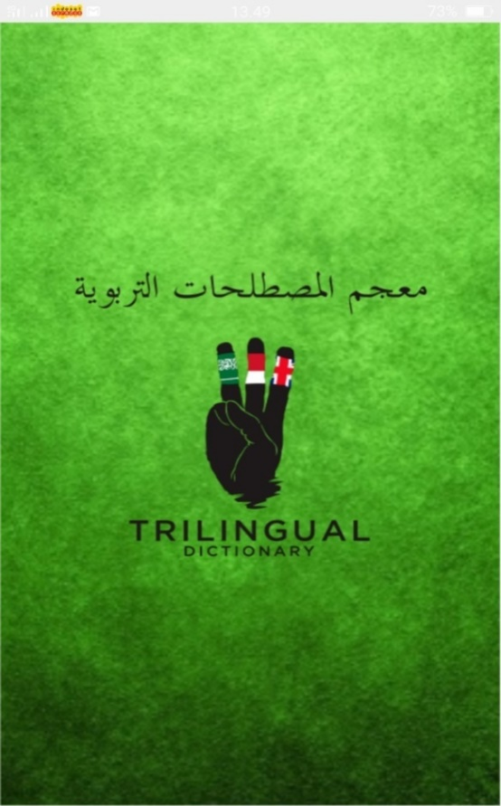
- Cover
The following page, will display the home page of the dictionary as shown in Figure 2 below. To continue to the menu page, just touch the screen in the top corner.

Figure 2
- Menu
To access the menu page can be done by touching the image in the upper right corner. After touching it, the next page will appear as shown in the following image:
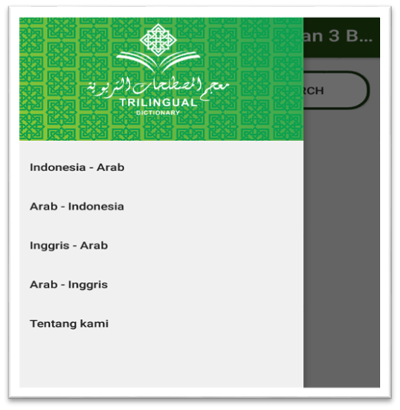
Figure 3
In the display above, there are search menus for educational terms starting from Indonesian – Arabic, Arabic – Indonesian, English – Arabic, Arabic – English, and About us which contain the identity of the dictionary developer.
  - Dictionary Usage
To search for a term, you don't need to write in detail the term you want to search for, but you can just type in the basic word. For example, to search for translations of educational strategies, it can be done by simply typing the word education in the word search field. The terms related to education will appear, including the term educational strategy. After finding the term you are looking for, then touch the term, then a translation of the term will appear in Arabic. The following is a screenshot of an example of a search for the term "education" in the Mu'jam al-Musṭalahāt al-Tarbawiyah dictionary.
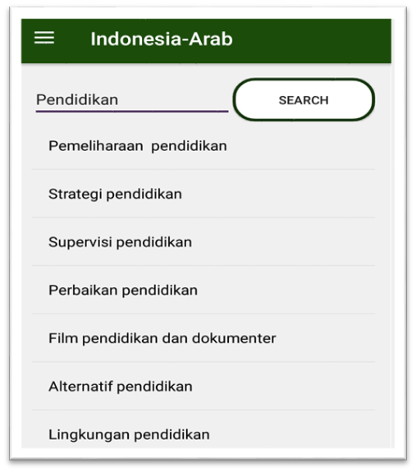
Figure 4
  - Implementation
The trilingual education term dictionary or Mu'jam al-Musṭalahāt at-Tarbawiyah has received several inputs for development. Either indirectly or directly. So are suggestions and criticisms. Start so that you add your dictionary to the play store, a more interactive background, screen splash improvements, etc. Some of these inputs were obtained during presentations as well as indirectly from peer reviews. As said by Mr. Bambang Sugintorose as a validator, and the head of the S2 department of Informatics Engineering at State Islamic University Sunan Kalijaga. He said that the interface design on the cover was good, but for the start page, the contents and so on had to be more complete. The suitability of the theme should also be paid more attention.
  - Evaluation
At this stage, the android-based Mu'jam al-Musṭalahāt at-Tarbawiyah dictionary was assessed by two material experts and two media experts. Also, students majoring in Arabic language education are the main targets of using this dictionary. The purpose of this product assessment is to determine the quality of the products developed. The data on the product quality assessment results obtained from the average scores of the appraisers are presented in the following table.
Table 1. Dictionary Application Quality Assessment Data

No | Aspect | Evaluator
No | Aspect | Material Expert | Media Expert | Average
1 | Content Eligibility | 3,60 | - | 3,50
2 | Design | 3,33 | 3,33 | 3,39
3 | Language Structure | 3,42 | 3,33 | 3,36
4 | Use Technique | - | 3,83 | 3,69
Data collection in the form of student responses was carried out in two stages, namely small-scale field trials and large-scale field trials. Data on the results of student responses are presented in table 4. below.
Table 4. Student Respses Data in Field Trials

No | Aspect | Field Trial |  | Average
No | Aspect | Small-scale | Big-scale | Average
1 | Interest | 3,05 | 3,28 | 3,16
2 | Design | 3,00 | 2,93 | 2,97
3 | Technical | 2,97 | 3,12 | 3.04
4 | Content | 3,05 | 3,27 | 3,16

The overall quality of the educational term dictionary application based on the assessment, both from Arabic material experts and media experts is categorized as very good, this shows that the educational term dictionary application is feasible to use.

CONCLUSION
The Android-based Mu'jam al-Musṭalahāt at-Tarbawiyah dictionary application as a source of independent learning for students majoring in Arabic education has been successfully developed through a development research procedure by the Puslitjaknov Team. The overall quality of the educational term dictionary application based on the assessment of Arabic material experts and media experts is in the Very Good category with an average score of 3.50; 3.50 and 3.56. The response of students in both the small-scale field test and the large-scale field test is Agree with the application of the Arabic education term dictionary that has been developed. These results illustrate that the application of a dictionary of educational terms can be well received by students.

REFERENCES
Ahmad Mukhtar Umar. (1997). Sina’atu al-Mu’jam al-Hadis. Kuliya Dar al-Ulum.
Ali al-Qasimi. (1411). Ilmu al-LughahwaSina’ati al-Mu’jam. Matabi’Jamiáh al-Mulk.
Ali al-Qasimi. (1979). al-Ittajahat Haditsah fi Ta’lim al-‘Arabiyahli an-Nathiqin bi al-Lughah al-Ukhra. Jami’ah Riyadh.
An, T., & Oliver, M. (2021). What in the world is educational technology? Rethinking the field from the perspective of the philosophy of technology. Learning, Media and Technology, 46(1), 6–19. https://doi.org/10.1080/17439884.2020.1810066
Barbara B. Seels, & Rita C. Richey. (1994). Instructional Technology: The Definition and Domains of the Field. AECT.
Bulus P.Bala. (2022). Significant of Smartphone an Educational Technology Tool for Teaching and Learning|. International Journal of Innovative Science and Research Technology.
D. Meredith Joyce P. Gall, & Walter R. Borg. (2003). Educational Research an Introduction. Pearson Publishing.
Donald R. Cooper & Pamela S. Shinedler. (2011). Business Research Methods. Mc Graw Hill International Editon.
Dwi Mawanti. (2014). Pengembangan Kamus Multi Bahasa (Arab-Inggris-Indonesia-Jawa) untuk PAU (Pendidikan Anak Usia Dini) Berbasis Kearifan Lokal . IAIN Walisongo.
Eko Putro Widoyoko. (2012). Teknik Penyusunan Instrumen Penelitian. PustakaPelajar.
Ellly Anasrul Firdaus. (2011). Pengembangan Pembuatan Kamus Sinonim Bahasa Arab berbasis Visual Basic untuk Mahasiswa Jurusan Sastra Arab Fakultas Sastra Universitas Negeri Malang. Universitas Negeri Malang.
Fred Nichols Kerlinger & Howard Bing Lee. (2000). Foundation of Behavioral Research. Hartcourt.
Glenn E. Snelbecker. (1974). Learning Theory, Instructional Theory, and Psyco-educational Design. McGraw-Hill Book.
Hamidi, F., Meshkat, M., Rezaee, M., & Jafari, M. (2011). Information technology in education. Procedia Computer Science, 3, 369–373. https://doi.org/10.1016/j.procs.2010.12.062
Hasan Zho Zho. (1976). Kalam al-Arab min Qadhaya al-Lughah al-‘Arabiyah. Daar al-Nadhah al-‘Arabiyah.
Ikhsan Rosadi. (2013). Problematika Penulisan Skripsi Berbahasa Arab Jurusan Pendidikan Bahasa Arab, UIN Sunan Kalijaga Tahun Ajaran 2009-2012. UIN Sunan Kalijaga Yogyakarta.
Iswah Adriana. (2012). Kesalahan Kebahasaan Hasil Terjemah Teks Bahasa Arab ke dalam Bahasa Indonesia Mahasiswa STAIN Pamekasan Pengguna Google Translate. Jurnal Nuansa, 9(2), 228–228.
Kim, Y.-S. G., Yang, D., Reyes, M., & Connor, C. (2021). Writing instruction improves students’ writing skills differentially depending on focal instruction and children: A meta-analysis for primary grade students. Educational Research Review, 34, 100408. https://doi.org/10.1016/j.edurev.2021.100408
Ladslav Zgusta. (1971). Manual Lexicografy. Academia.
Lewis Ma’luf. (2008). al-Munjid fi al-Lughahwa al-Adab. Dar el-MacreqSarl.
Michael J. Marquardt. (1996). Building the Learning Organisation; A System Approach to Quantum Improvement and Global Success. Mc Graw-Hill.
Muhammad Ahmad Abu al-Faraj. (1996). al-Ma’ajim al-Lughawiyah fi Dhau’‘Ilmial-Lughah al-Hadits. Daar al-Arabiyah.
Muhammad Ali al-Khuli. (1989). AsalibTadris al-Lughah al-‘Arabiyah.
Nguyen, T.-H., Hwang, W.-Y., Pham, X.-L., & Pham, T. (2022). Self-experienced storytelling in an authentic context to facilitate EFL writing. Computer Assisted Language Learning, 35(4), 666–695. https://doi.org/10.1080/09588221.2020.1744665
Peter Senge. (1990). The Fifth Discipline: The Art and Practice of Learning Organization. Doubleday Currency.
Robert Blake, & Jane S. Mouton. (1970). Organisation Development- Fad or Fundamental. American Society for Training and Development inc.
Samsul Hadi. (2005). Perkembangan Leksikografi Arab dalam Berbagai Hal Tentang Leksikologi dan Leksikografi Arab. FIB UGM.
Saptiani. (2016). Pengembangan Media Pembelajaran Kamus Tematik Tiga Bahasa (Indonesia, Arab, Inggris) Untuk Menstimulasi Kognisitif Anak Usia Dini. UIN Sunan Kalijaga.
Tamam Hasan. (1985). Al-Lughah al-‘Arabiyah Ma’naha wa Mabnaha. al-Haiah al-Misriyah li al-Kitab.
Tim Puslitjaknov. (2008). Metode Penelitian Pengembangan. Badan Penelitian dan Pengembangan Departemen Pendidikan Nasional.
Tuma, F. (2021). The use of educational technology for interactive teaching in lectures. Annals of Medicine and Surgery, 62, 231–235. https://doi.org/10.1016/j.amsu.2021.01.051
William Wiersma. (2009). Research Methods in Education: An Introduction. Pearson/Allyn Bacon.
Zurqoni et al. (2020). Has Arabic Language Learning Been Successfully Implemented? . International Journal of Instruction, 13(4), 715–730.

