Implementation of Instagram Media in the Teaching of Reading Skill (Maharah Qiro'ah) To Increase Students Learning Motivation

Ismatul Hidayah Fitriani¹, Dewi Chamidah²
¹ UIN Maulana Malik Ibrahim Malang, Indonesia
² UIN Maulana Malik Ibrahim Malang, Indonesia
e-mail: ismatulhidayahfitriani.05@gmail.com¹, dewichamidah@pba.uin-malang.ac.id²

ABSTRACT
This study aims to analyze the use of Instagram for the teaching of reading skills (maharah qira’ah) and its influence on student learning motivation and its impact on the learning process. This study uses a quantitative-qualitative approach (mixed method) to obtain comprehensive data. Data was obtained through observations, interviews, and questionnaires to students of class X Language MAN 2 Malang City for the 2023/2024 school year, totaling 34 students. Qualitative data analysis uses the Miles & Huberman model which involves data collection, data reduction, and drawing conclusions. Meanwhile, quantitative data analysis uses the francis galton model which involves a type of descriptive analysis. The results of the study show that the use of Instagram as a learning medium has a significant positive influence on student learning motivation. Instagram features such as interactive visual reels make it easier for students to understand the qiro'ah maharah material and increase their interest in actively learning. Students feel more interested because learning is delivered through digital platforms that are relevant to their interests, so that the learning process is fun and effective. As a result, Instagram media has proven to be effective in increasing students' learning motivation because they are directly involved in the learning process of maharah qiro'ah. This study recommends the integration of social media such as Instagram as one of the innovative strategies in learning Arabic in the digital era.

Keywords: Implementation;Instagram;Maharah;Qiroah;Motivation.

INTRODUCTION
Learning facilities are one of the main elements in supporting an effective educational process, especially in the context of modern education that emphasizes active and collaborative learning. Based on the theory of constructivism developed by Jean Piaget and Lev vygotsky, students not only become passive recipients of information, but also actively build understanding based on their personal experiences, social interactions, and environmental exploration. In this case, the right learning facilities, such as teaching aids, digital technology, interactive media, and online learning platforms, play an important role in creating a dynamic and engaging learning environment. This means allows students to be directly involved in the learning process, explore new concepts, and connect theory with practice. (Wardani & Afriansyah , 2019) ( Nurulloh Olla Fransisca et al., 2021) ( Tiarma Fitri Malau et al., 2022)
Thus, learning technology serves as a means that not only supports the needs of modern learning, but also prepares students to face real-world challenges in the digital era. In this era, skills such as critical, creative, adaptive, and collaborative thinking are becoming increasingly important, and educational technology provides the means to hone these skills effectively and thoroughly. Therefore, the integration of technology in learning facilities is an important investment to create a competent and innovative generation, and one of the effective and existing media in use is Instagram. (Muhaimin et al., 2024) (Halimah, 2020) (Zahran Dhia et al., 2021)
In the context of education, Instagram can be an innovative platform for students and educators to explore creativity through the creation of content related to learning materials. The use of Instagram encourages a project-based learning approach (Saputra et al., 2021) , where students not only passively receive material, but also actively participate in the learning process through the creation and curation of digital content. Interesting visualizations and multimedia media-based content allow students to understand the learning material more deeply, especially in learning ( Khoiriya et al., 2023) maharah qiro'ah or reading skills. (Wibisono, 2020)
This has been done in previous research that utilizes technology in the form of youtube media as a means to facilitate learning. As a result, learning through youtube media is effective because educators use media that is commonly used by students to find new things. In addition, learning through Instagram media has also been carried out by researchers who use (Loyal & Rangkasbitung , 2023) Instagram reels (short videos) to support PAI learning which results can increase students' interest in learning. (Akbar et al., 2023)
Through platforms such as Instagram, teachers can present reading materials in a more interactive format, such as video reels that bring the reading content to life. For example, in studying Arabic texts, teachers can upload readings about the material in Arabic texts that are equipped with examples from teachers to help students understand the meaning and practice their intonation. This multimedia-based content not only makes learning more interesting, but also provides opportunities for students to learn independently according to their learning style. ( Sugiarto & Farid, 2023) (Bery Mokalu et al., 2022)
Maharah Qiro'ah qiroah (reading skills) is one of the core skills in learning Arabic which includes the ability to read texts correctly, understand their meaning, and interpret them. Maharah Qiro'ah's mastery is an important foundation for other language skills such as writing, speaking, and listening. In this context, ( Chalely et al., 2024) (Rahmi, 2022) maharah qirā'ah is not only a mechanical skill in reading texts, but also skills related to more in-depth language analysis abilities, such as punctuation recognition, intonation, and understanding of the socio-cultural context contained in the text. ( Sungkar et al., 2022)
In Maharah Qiro'ah learning, students are trained to read with the right techniques and methods in order to gain a deep understanding of the text read. Students are also trained to read texts with appropriate intonation. This involves understanding punctuation in Arabic, which affects the way of pronunciation and appreciation of the text. In addition, this learning also trains students to read quickly without overriding understanding the meaning of the text. Next, students learn to analyze and interpret the text read. This skill is important, especially in reading religious texts such as the Qur'an and Hadith, which often require a deeper understanding. (Hidayat & Zulvanni Anggraini , 2021) (M. Taufik Arkan et al., 2024) (Jamaludin et al., 2024) (Roji, 2020) ( Khoiriyah , 2020)
Based on the results of Ishida et al's research, there are six main factors that affect learning motivation, namely psychological values, cognitive factors, social and environmental influences, demographic factors, academic background and learning habits, and educational interventions or programs. This approach highlights that learning motivation is a complex phenomenon that is influenced by the interaction of various elements, both intrinsic and extrinsic. The study also reveals a difference in focus on motivational factors between countries in the East and West. In Eastern countries, psychological values are more dominant, while in Western countries, social and environmental influences are more studied. (Rahman, 2022) (Ishida & Sekiyama , 2024) ( Palittin et al., 2019)
From the results of the theory presented by Ryan and Deci (2000) provide an in-depth view of what motivates individuals, including students, to learn. According to this theory, learning motivation can be divided into two main types, namely intrinsic and extrinsic motivation Both theories highlight the importance of creating a supportive learning environment. Teachers need to design relevant and engaging learning experiences for students to feel intrinsically motivated, while still providing proportionate external rewards to encourage students who need additional encouragement. This will ensure an effective, meaningful, and sustainable learning process. (Andriani & Rasto, 2019)
Motivation serves as the main driver for students to actively participate in learning activities. With high motivation, students tend to have the energy and passion to explore, understand, and complete academic tasks. Motivated students tend to be more diligent, even when facing learning challenges. This perseverance helps them achieve their learning goals despite experiencing obstacles or difficulties. Learning motivation helps students develop a positive attitude towards the educational process, so that they are more open to intellectual challenges and have an optimistic view of their potential. It is also supported by the environment in which they learn, such as parents, teachers, friends, and adequate facilities. (Dwi Retno Khari , 2024)
In learning Arabic at MAN 2 Malang City, educators use Instagram as a medium to help students understand in receiving the material provided. Instagram, which is usually used to post someone's activity, can now be an important medium to exemplify reading in the creation of descriptive texts for students. At first, educators can make interesting material videos with the help of a video editing application, namely Capcut so that it have good quality. (S. U. Rahmawati et al., 2024) (A. Rahmawati et al., 2023)
On the basis of the previous researchcapc, currently the researcher will dig deeper into the implementation of Instagram media for the teaching of maharah qiroah the practice of reading descriptive texts for students at MAN 2 Malang City. Will the researcher review how the implementation process is? How effective is the implementation of Instagram on students' learning motivation? And what impact does learning through Instagram have? In this case, social media has an important role in the sustainability of the student learning process, so that the use of social media is not only a benefit for students but other Instagram social media users will automatically feel the benefits. ( Martyrdom & Mufti, 2021) (Fuadah, 2020)

METHOD
This study uses a quantitative-qualitative approach (mixed method) to obtain comprehensive data related to the implementation of Instagram media in learning maharah qiro'ah and its influence on the impact and motivation of students. Quantitative approach: Used to measure the influence of Instagram media on student learning motivation through questionnaire questionnaires with adaptation of intrinsic and extrinsic learning motivation theories and qualitative approaches used to explore the experiences of students and teachers during the Instagram media implementation process through interviews and observations. The subjects of this study are students of class X Language MAN 2 Malang City for the 2023/2024 school year which totals 34 students. Qualitative data analysis uses the Miles & Huberman model which involves data collection, data reduction, presentation, and conclusions drawn. Meanwhile, quantitative data analysis uses the Francis Galton model which involves a type of descriptive analysis. Meanwhile, quantitative data analysis uses the francis galton model which involves a type of descriptive analysis. As a result, the researcher comprehensively elaborated based on the analysis of data obtained from the subjects studied.

RESULTS AND DISCUSSION
Intagram Media Implementation Process
In making a maharah qiroah project through Instagram, students do various tasks that are relevant to the syntax of the project based learning (PJBL) model: (1) Starting with a question given by the teacher in accordance with the theme, namely about food, the teacher asks how many times students eat in a day and what they eat then the teacher directs students to see an example video on the following Instagram link as a medium for teaching maharah qiroah to students
https://www.instagram.com/arabankuyy/profilecard/?igsh=endvdXYyenRqajBu.( 2) The teacher gives rules for working on the project starting from the title listed, the number of paragraphs and the relevance of the text to the student's meal activity for one day. (3) Then the teacher asks students to create a text for 30 minutes with a minimum number of one paragraph, while viewing the video on the teacher's Instagram should not be less than twice.
(4) The teacher checks the students' work one by one, by merivew what they have written on the text. (5) Next, the teacher asks the students to come forward one by one to read the results of the texts that have been made, then the teacher asks the other students about what has been read by the students who are advancing in front, for example "what did Azam eat in the morning?". (6) After all the students came forward, the teacher asked the students what difficulties they experienced in making and reading the qiroah maharah text, and reviewed the intonation they used in reading. And finally the teacher asked students to make a video that matched their respective texts as homework assignments which would later be uploaded on the Instagram platform @arabankuyy as a result of the learning project.
Based on the process of the PJBL, initially educators can make material by exemplifying the reading of descriptive texts about the theme that has been spoken with a good and correct Arabic fushah dialect. Then the educator uploads the video to the Instagram reels platform which is attractively named, such as @arabankuyy. After the upload process, educators can ask students to observe existing Instagram reels, as a reference for descriptive text reading examples. In this case, students will understand and study in a fun and exciting way, because they can learn to read descriptive texts through Instagram flexibly. They not only observe, but can also react to the comment column of the Instagram reels. (Bery Mokalu et al., 2022)
When watching the video three times, students are asked to make descriptive texts with the qiroah jahriyah model or read clearly using intonation as exemplified in the class x book published by the Ministry of Religion on descriptive text material about food in their respective books. After that, the educator corrected the results of the student's project and was given a score. As for students who are not correct in pronunciation, they will be asked to revise it until it is in accordance with what is exemplified. At this stage, students learn to observe and analyze existing Instagram reels videos to be implemented through their writing. Students also give them the flexibility to make innovations that are relevant to their lives. The majority of students write down things related to their personalities, because they think that the assignments made can be used to practice speaking Arabic every day. ( Anonymous • Muid, 2021)
The last stage is the process of assessing the reading of the qiroah maharah in the form of texts that have been made by students. After the process of observing the form of the dialysis, intonation and how to read descriptive texts are expected to be able to minimize mistakes made by students, such as reading Arabic texts that are almost the same as reading the Qur'an, improper text intonation and other errors. Students are asked to advance one by one in front of the class reading the text that has been made with the intonation exemplified through Instagram reels. In this case, students are taught to appreciate and appreciate their friends who are advancing in front of the class. This is also one of the efforts to train the mental courage of students.
In addition to observing, educators also immediately correct the results that have been displayed by students. This is intended so that other classmates can listen well so that mistakes that occur do not recur. This method has proven to be effective, judging from the increasing scores of students before and after the study through Instagram reels. The majority of students who request learning can always be correlated with digitalization so that it can be seen again in the future. At this stage of the project, students are asked to make a video of their descriptive text reading which will later be uploaded on the Instagram platform @arabankuyy. Not only the scope of their class is watching, but millions of Instagram users can witness their descriptive text practice which can certainly have a positive impact.
The majority of students interviewed revealed that the implementation of Instagram as an Arabic language learning medium provides significant convenience, especially for those who are at the beginner level and are just starting to learn and know Arabic. The features provided by Instagram, such as reels, are considered to be very helpful for them in understanding the material in a more in-depth and practical way. Reels allow the delivery of material in the form of short videos that are interesting and informative, so that it is easier for students to understand the basic concepts of Arabic, especially at the stage of practicing reading texts.
In addition, the flexibility of material access offered by Instagram is one of the main advantages. Students can access the material anytime and anywhere without being limited by time and place. This gives them the opportunity to learn at their own pace and needs. With the ability to replay videos and practice the material independently, the learning process becomes more effective and enjoyable. Ultimately, the integration of Instagram as a learning medium not only helps students understand the material, but also increases their interest in continuing to learn Arabic in a more modern and relevant way to their daily lives.
The Instagram platform provides a great opportunity to disseminate Arabic learning more widely through engaging and accessible material posts. This post not only benefits the students who are the main targets, but also has the potential to influence millions of other Instagram users who indirectly participate in learning Arabic through the content. This impact shows how technology, if managed and utilized properly, can be an effective educational tool as well as a means to disseminate knowledge more widely.
In addition, the use of Instagram as a learning medium also has another positive impact, namely teaching students the courage to appear in public. The practice videos uploaded by students are part of the learning process, where they not only practice Arabic skills but also hone their confidence. The videos can be seen by many people, including individuals they don't know yet, thus training them to be more open and confident in demonstrating their abilities. This approach not only improves Arabic language competence, but also provides added value in the development of communication and presentation skills, which are crucial to face challenges in the digital age
The implementation of Instagram as a learning medium encourages teachers to create creative and interesting content, such as reels, that are relevant to the maharah qiro'ah. This process inspires teachers to take advantage of modern technology in delivering material in an interactive and flexible manner. The use of Instagram in teaching requires teachers to master digital skills, including video editing. This increases the digital competence of teachers, which is one of the important needs in the modern world of education.
Instagram media also opens opportunities for teachers to collaborate with other educators and other Instagram users in sharing ideas or developing learning materials. This enriches the teaching methods applied and creates a more inclusive learning community. Overall, the use of Instagram media in learning maharah qiro'ah has a significant positive impact on teachers, both in improving teaching competence, building relationships with students, and utilizing technology as an effective means of learning.

Evektivitas implementasi Instagram untuk maharah qiroah terhadap motivasi belajar siswa berdasarkan teori motivasi Intrinsik dan Ekstrinsik (Ryan & Deci, 2000)
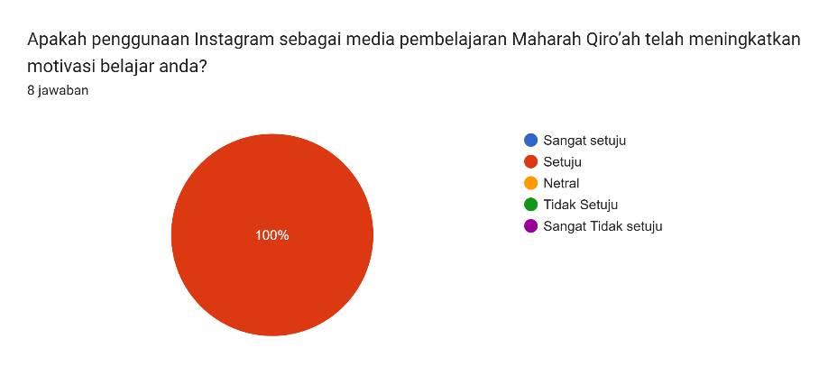

In this first question, 100% of students agree that the Instagram platform can increase the learning motivation of all students.
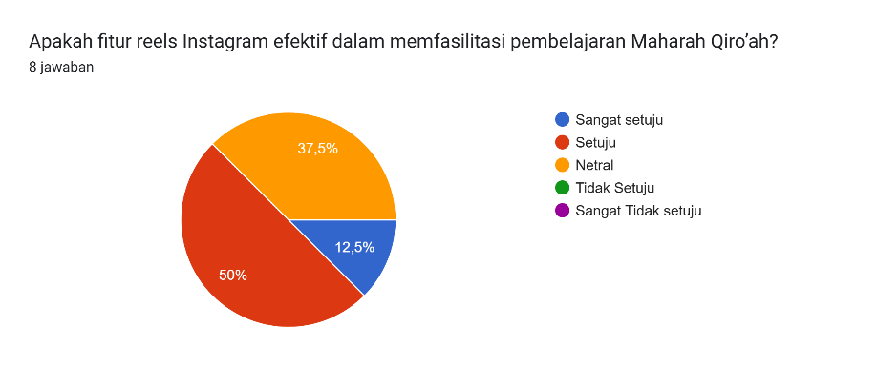

In this second question, 50% of students agreed that the Instagram platform is effective in facilitating the learning of maharah qiroah. 37.5% of students are neutral and 12.5% of students strongly agree.

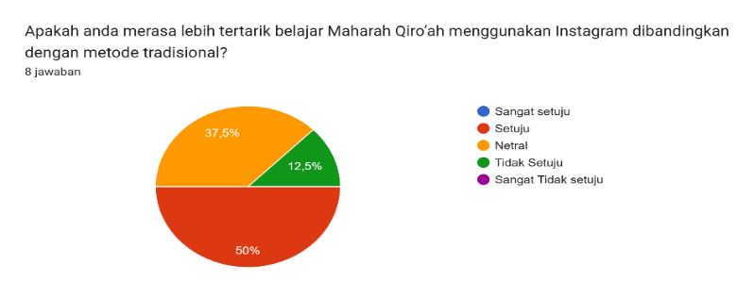

In this third question, 50% of students are more interested in learning Maharah Qiro'ah using Instagram compared to traditional methods. 37.5% of students were neutral and 12.5% of students disagreed.
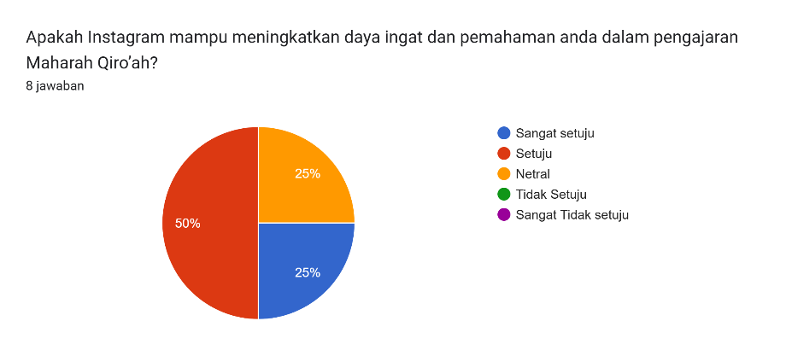

In this fourth question, 50% of students felt that Instagram was able to increase the interaction between teachers and students in teaching Maharah Qiro'ah. 25% of students are neutral and 25% of students strongly agree.
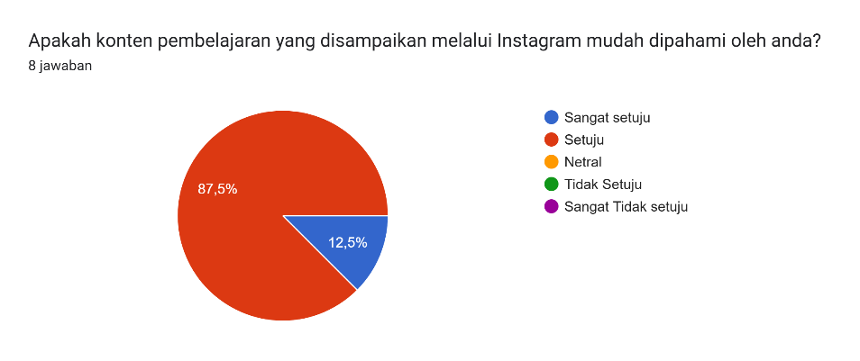

In this fifth question, 87.5% of students felt that the content conveyed through Instagram was easy for students to understand while 12.5 other students strongly agreed.

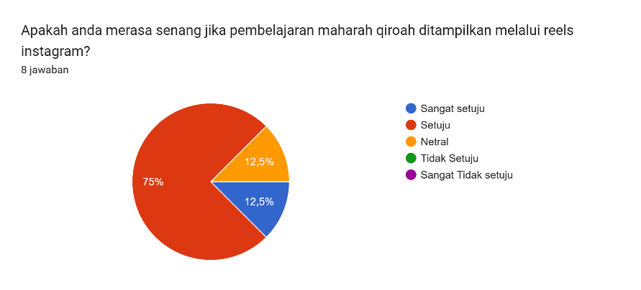

In this sixth question, 75% of students felt happy if the learning of mahara qiroah was displayed through Instagram reels. 12.5% of students are neutral and 12.5% of students strongly agree.

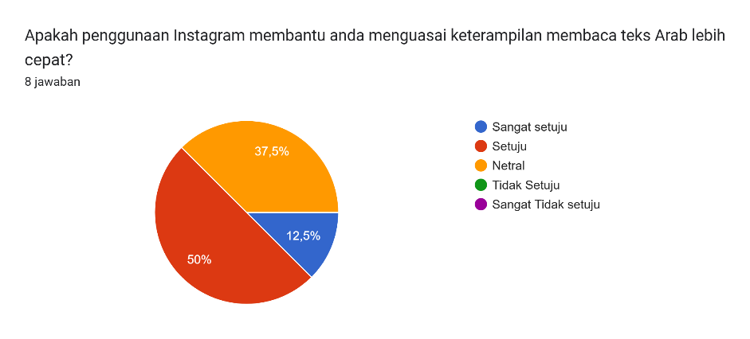

In this seventh question, 50% of students agreed that the use of Instagram helps students in mastering the skills of reading Arabic texts faster. 37.5% of students are neutral and 12.5% of students strongly agree
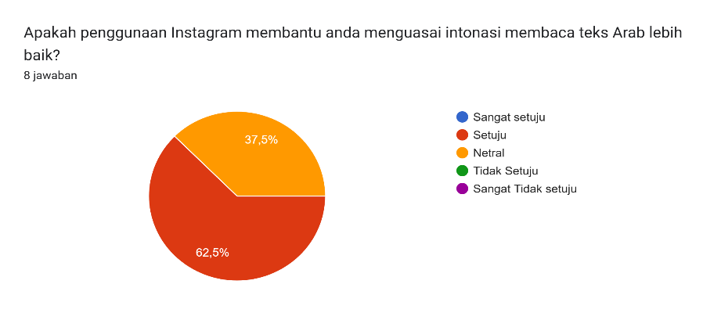

In this eighth question, 62.5% of students agreed that the use of Instagram helped students master the intonation of reading Arabic texts better, while the other 37.5% of students were neutral.

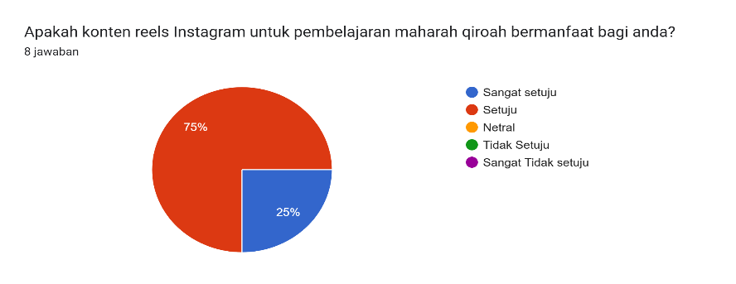

In this ninth question, 75% of students agreed that Instagram reels content for learning maharah qiroah was beneficial for students and another 25% of students strongly agreed.
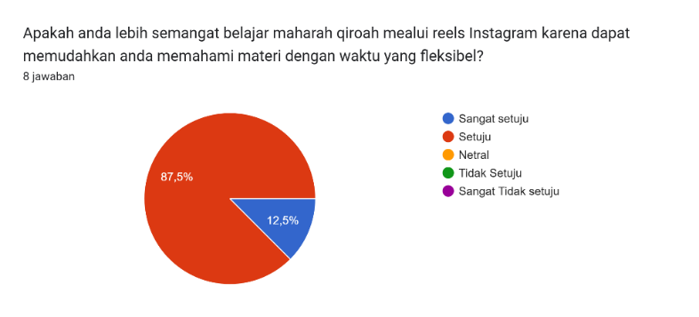

In this tenth question, 87.5% of students agreed that they were more enthusiastic about learning maharah qiroah through Instagram reels because it can make it easier for students to understand the material with flexible time and another 12.5 students strongly agreed.

CONCLUSIONS
This study concludes that the use of Instagram as a learning medium has a significant positive effect on students' learning motivation in teaching maharah qiro'ah. Instagram's interactive features, such as visual reels, make it easier for students to understand the material better, increase interest, and encourage their active involvement in the learning process. The use of digital platforms that are relevant to students' interests makes learning more interesting, fun, and effective. Thus, Instagram media has proven to be an innovative and effective learning tool in increasing students' learning motivation. This study recommends the integration of social media such as Instagram as one of the strategies for teaching Arabic in the digital era, especially for teaching qiro'ah skills more interactively and contextually.

REFERENCES
Akbar, S., Salminawati, S., & Rakhmawati, F. (2023). Development of pie learning media based on Instagram reels to increase students' interest in learning. EDUCATIO Journal: Indonesian Education Journal, 9(2), 733. https://doi.org/10.29210/1202323204
Andriani, R., & Rasto, R. (2019). Learning motivation as a determinant of student learning outcomes. Journal of Office Management Education, 4(1), 80. https://doi.org/10.17509/jpm.v4i1.14958
Bery Mokalu, Y., Wowor, E. C., & Tumewu, W. A. (2022). Developing Instagram Application-Based Media To Optimize Student Learning Outcomes Of The Natural Science Education Department Unima ( Vol. 5, Issue 2).
Chalely, L. M. U. H., Siti Durotun Naseha, & Izzah Nur Hudzriyah Hasan. (2024). Study on the Implementation and Effectiveness of TPACK in Maharah Qiro'ah Learning. DAARUS TSAQOFAH Journal of Postgraduate Education, Qomaruddin University, 1(2), 129–137. https://doi.org/10.62740/jppuqg.v1i2.144
Dwi Retno Kharian. (2024). The Relationship between Motivation and Interest in Learning and the Learning Outcomes of Class V Students of Sdn No 100311 Palsabolas in the 2023/2024 Social Sciences Subject.
Fuadah, S. (2020). The use of Instagram Media @Nahwu_Pedia in Mahārah Al Qira'ah and Mahārah Al Kitabah Arabic Language Students. Arabic Studies, 11(2), 137–151. https://doi.org/10.35891/sa.v11i2.2513
Halimah, 'Aqif. (2020). تعليم مهارة القراءة للناطقين بغيرها. لسـانـنـا (LISANUNA): Journal of Arabic Language and Its Learning, 9(2), 249. https://doi.org/10.22373/ls.v9i2.6744
Hidayat, A. F. S., & Zulvanni Anggraini, F. (2021). العلاقة بين القدرة على قراءة القرآن بالقدرة على مهارة القراءة. Shaut al Arabiyyah, 9(1), 78. https://doi.org/10.24252/saa.v9i1.20830
Ilmiani, A. M., & Muid, A. (2021). BI'AH LUGHAWIYYAH ERA SOCIETY 5.0 THROUGH THE USE OF STUDENT SOCIAL MEDIA. Arabic : Journal of Arabic Studies, 6(1), 54. https://doi.org/10.24865/ajas.v6i1.348
Ishida, A., & Sekiyama, T. (2024). Variables influencing students' learning motivation: critical literature review. In Frontiers in Education (Vol. 9). Frontiers Media SA. https://doi.org/10.3389/feduc.2024.1445011
Jamaludin, M. J., Munir, D. R., Luthfi, T., & Fajar, A. (2024). تطبيق الطريقة التركيبية والتحليلية في تعليم اللغة العربية لتحسين مهارة القراءة لدى طلبة المدرسة الدينية التكميلية إعانة المبتدي دارنجدان برواكرتا. Ta'limi | Journal of Arabic Education and Arabic Studies, 3(1), 25–35. https://doi.org/10.53038/tlmi.v3i1.94
Khoiriya, U., Alamsyah Kusumadinata, A., Hasbiyah, D., & Kusumadinata, A. A. (2023). Marketing Communication of Indigenous People's Products Through Instagram Social Media @Gerainusantara_Aman. Indonesian Journal of Applied and Industrial Sciences (ESA), 2(5), 507. https://doi.org/10.55927/esa.v2i5.6008
Khoiriyah, H. (2020). QIRĀ'AH METHOD IN LEARNING ARABIC RECEPTIVE SKILLS FOR SECONDARY EDUCATION. لسـانـنـا (LISANUNA): Journal of Arabic Language and Its Learning, 10(1), 32. https://doi.org/10.22373/ls.v10i1.7804
M. Taufik Arkan, Bernan Dwi Atmojo, Tiara Pelangi Arafah, Ahmad Hudaebiah, Fadly Alfarissy, Muhamad Zakariya, & Humairo Azizah. (2024). The Effectiveness of Windmill Media to Train Maharah Qiro'ah in Arabic Language Learning for PAUD Students and BTQ (Reading and Writing the Qur'an) for TPA Students and the Importance of Islamic Economic Literacy for Micro, Small and Medium Enterprises (MSMEs).
Muhaimin, R., Tinggi, S., Negeri, A. I., & Natal, M. (2024). The Role of Infrastructure Facilities in Increasing the Effectiveness of Learning at SD Negeri 161 Bangun Purba.
Nurulloh Olla Fransisca, Novitaria Arti Pujiastuti, Pupung Puspita Ningrum, Almira Dini Khairina, & Edy Suprapto. (2021). Mathematics Learning Based on a Media-Assisted Constructivism Approach for Students in Inclusion Schools.
Palittin, I. D., Wolo, W., & Purwanty, R. (2019). THE RELATIONSHIP BETWEEN LEARNING MOTIVATION AND PHYSICS LEARNING OUTCOMES. MAGISTRA: Journal of Teacher Training and Education, 6(2), 101–109. https://doi.org/10.35724/magistra.v6i2.1801
Rahman, S. (2022). THE IMPORTANCE OF LEARNING MOTIVATION IN IMPROVING LEARNING OUTCOMES.
Rahmawati, A., Astuti, D. M., Harun, F. H., & Rofiq, M. K. (2023). THE ROLE OF SOCIAL MEDIA IN STRENGTHENING RELIGIOUS MODERATION AMONG GEN-Z. J-ABDI: Journal of Community Service, 3(5), 905–920. https://doi.org/10.53625/jabdi.v3i5.6495
Rahmawati, S. U., Aisyah, S. N., Mufidza, S., & Umbar, K. (2024). Instagram Content Analysis @alazharcenterpare in Learning Arabic Online. Ukazh: Journal of Arabic Studies, 5(1), 20–30. https://doi.org/10.37274/ukazh.v5i1.895
Rahmi, S. (2022). استخدام وسائل نص القصة لترقية مهارة القراءة. AL-IHDA JOURNAL : Arabic Language Scientific Media, 10(1), 15–37. https://doi.org/10.58645/alihda.v10i1.119
Roji, F. (2020). تطبيق طريقة التمييز في تعليم مهارة القراءة بمدرسة الثانوية الإسلامية الحكومية الأولى جاكرتا. Al-Tadris: Journal of Arabic Language Education, 8(1), 170–200. https://doi.org/10.21274/tadris.2020.8.1.170-200
Saputra, H., Marsiah, M., & El Bilad, C. Z. (2021). Instagram Quality Analysis @kursus_arab_alazhar in Learning Arabic Online. El-Tsaqafah : Journal of the Department of PBA, 20(1). https://doi.org/10.20414/tsaqafah.v20i1.3107
Setia, U., & Rangkasbitung, B. (2023). THE EFFECT OF THE USE OF YOUTUBE MEDIA ON LECTURE TEXT MATERIAL ON THE LEARNING OUTCOMES OF STUDENTS IN CLASS XI OTKP 1 SMK NEGERI 1 BAYAH Reni 1) , Elih Solihatulmilah 2) , Eka Nurul Mualimah 3) (Vol. 4).
Sugiarto, & Farid, A. (2023). Digital Literacy as a Way to Strengthen Character Education in the Society 5.0 Era. Cetta: Journal of Educational Sciences, 6(3), 580–597. https://doi.org/10.37329/cetta.v6i3.2603
Sungkar, A., Raden, U., & Lampung, I. (2022). PROBLEMATIKA LINGUISTIK DALAM PEMBELAJARAN MAHĀRAH QIRĀ’AH PADA JURUSAN PENDIDIKAN BAHASA ARAB UIN RADEN INTAN LAMPUNG اﻟ‬ ﻤﻠﺨ‬ ﺺ‬ (Vol. 11, Issue 1).‬‬‬‬‬‬
Syahid, A. H., & Mufti, M. A. (2021). USING INSTAGRAM ON ARABIC LEARNING IN THE POST-PANDEMIC ERA: STUDENTS' VOICES. Arabiciyat : Journal of Arabic Language and Arabic Language Education, 8(2), 241–254. https://doi.org/10.15408/a.v8i2.22909
Tiarma Fitri Malau, Kurnia Novita Harianja, Yesiana Simarmata, & Helena Turnip. (2022). THE IMPORTANCE OF THE ADMINISTRATION OF EDUCATIONAL FACILITIES AND INFRASTRUCTURE. Dewantara : Journal of Social Education Humanities, 1(4), 186–195. https://doi.org/10.30640/dewantara.v1i4.462
Wardani, A., & Afriansyah, H. (2019). The Importance of Educational Facilities and Infrastructure. https://doi.org/10.31227/osf.io/39dqy
Wibisono, D. (2020). THE EFFECT OF INSTAGRAM USE ON THE SELF-EXISTENCE OF ADOLESCENTS (Study on Students in the FISIP UNILA Environment). SOCIOLOGY: Scientific Journal of Social and Cultural Studies Studies, 22(2), 145–164. https://doi.org/10.23960/sosiologi.v22i2.65
Zahran Dhia, H., Khoiriyatunnisa Arabic Language and Culture Study Program, L., & Cultural Sciences, F. (2021). THE USE OF THE INSTAGRAM PLATFORM AS AN ARABIC LANGUAGE LEARNING MEDIUM FOR BEGINNERS.

