Analysis of e-Banking Development in Commercial Banks (Conventional and Sharia) on the number of ATM machines, number of branches, BOPO and NIM in Indonesia

Yaya R.C. Pujiharto¹, Titien Yusnita²
¹Program Pasca Sarjana Ekonomi Syariah IAI Sahid Bogor, Indonesia
²Program Pasca Sarjana Ekonomi Syariah IAI Sahid Bogor, Indonesia

ABSTRACT

This research aims to analyze the extent of the effect of the development of IT-based banking services commonly known as electronic banking (e-banking) which includes internet banking, mobile banking and QRIS in commercial banks, both in conventional banks and in sharia banks (BUS &UUS) on the number of commercial bank branches, the number of ATM machines (Automatic Teller Machines), Operating Costs (BOPO) and Net Interest Income in Indonesia. The purpose of this study is to see the extent of the influence of the simultaneous and partial development of electronic banking services (e-banking) in Banking that is currently being developed in Indonesia on the number of branches, the number of ATM machines and operational costs (BOPO) and its influence on the NII revenue of Commercial Banks, both conventional and sharia
The research method uses secondary data obtained from OJK statistical data, Indonesia's banking surveillance reports from the OJK, the Indonesia Payment System Association (ASPI) and Bank Indonesia from the period 2018 to 2023. Data used time series on a monthly basis during the research period, data analysis techniques using the ECM (Error Correction Model) method, data processing using the Eviews 9 application. The population or number of samples in this study is all monthly historical data during the study period.
This research is expected to produce new discoveries (novelty) in the form of the effects of e- banking development which includes internet banking, mobile banking and QRIS in commercial banks, both in conventional banks and in sharia banks (BUS &UUS) on the mumber of commercial bank branches, the number of ATM (Automatic Teller Machines), Operating Costs (BOPO) and Net Interest Income in Indonesia. Based on the analysis data carried out, it can be concluded that The results of the simultaneous test based on the F-statistic value show that the independent variables simultaneously have a significant effect on the dependent variables (Branches, ATMs, BOPO and NII). The results of the partial test of the Branch model for the long term show that MB (Mobile Banking) and IB (Internet Banking) have a significant effect on the number of branches, while in the short term it shows that MB (Mobile Banking), IB (Internet Banking) and dummy QRIS have no effect on the number of branches. The partial test results of the ATM model for the long term show that MB (Mobile Banking) and IB (Internet Banking) have a significant effect on the number of ATMs. In the short term, it shows that MB (Mobile Banking), IB (Internet Banking) and dummy QRIS have a significant effect on the number of ATMs. The partial test results of the BOPO model for the long term show that MB (Mobile Banking) and dummy QRIS have a significant effect on BOPO. In the short term, it shows that IB and dummy QRIS have a significant effect on BOPO. The partial test results of the NIM model for the long term show that MB (Mobile Banking) and dummy QRIS have a significant effect on NIM. While in the short term it shows that MB (Mobile Banking), IB (Internet Banking) and dummy QRIS have no significant effect on NIM.
Key: Digital Banking, Internet Banking. Mobile Banking, QRIS, Branches, BOPO, NIM

- Introduction
E-banking services are currently owned by almost all commercial banks, both with very common types of delivery channels (such as ATMs) and with other types of delivery channels such as SMS, telephone, EDC (Electronic Data Capture) and the internet. This is also in line with the trend of social media development and existing policies to realize or direct transactions to the public to be carried out not only with cash (less cash society), so that many economic actors or people have taken advantage of modern banking services that are more efficient and effective through e-banking (OJK, 2015). Bank tries to provide ease of service by utilizing information technology for safe and appropriate services in the transaction. The Bank also provides ease of service in the aspect of flexibility, efficiency, and simplicity. Customers do not need to come to the bank and wait for the long queue with e-banking. E-banking products have a wide range of derivative products, including one of the latest products in the form of mobile banking that is known as M-banking (Usman et al., 2020). Public interest in using electronic banking services consists of several factors, including security and convenience factors (Sulistianingsih & Trishananto, 2021).
Commercial bank is a bank that carries out business activities conventionally and or based on sharia principles which in its activities provide services in payment traffic (UU no 10, 1998). Internet Banking is a service for conducting banking transactions through the internet. Customers can use desktop computer devices, laptops, tablets, or smartphones connected to the internet network as a link between customer devices and the bank system (OJK, 2015). Internet Banking is a bank service that allows customers to access information, communicate and perform banking transactions via the Internet. As such, financial institutions are providing a new way of financial services in many developed and developing countries (Triwardhani et al., 2023).
Mobile banking offers numerous benefits for banks and bank customers (Sitorus et al., 2019) Still according to (OJK, 2015). Mobile Banking is a service that allows bank customers to conduct banking transactions through mobile phones or smartphones. The QRIS or Quick Response Code Indonesian Standard is the unification of various types of QR from various Payment System Service Providers (PJSP) using QR Codes. QRIS was developed by the payment system industry together with Bank Indonesia so that the transaction process with QR Codes can be easier, faster, and more secure (BI, 2024). ATM or better known as the Mandiri Cash Machine is a computer terminal/machine connected to the bank's communication network, which allows customers to make financial transactions independently without the help of tellers or other bank officers (OJK, 2015). Likewise, according to (Desmadirega & Hermana, 2023) The he first Payment Instrument Using Cards (APMK) are Automated Teller Machine (ATM) and debit cards. ATMs are electromechanical devices enabling authorized customers to withdraw cash from their accounts and/or access other services such as balance inquiry, funds transfer, or deposit acceptance using a machine-readable plastic card.
A Branch Office is a legally domiciled office in Indonesia that carries out banking business activities that are directly responsible to the Head Office, in addition to branch offices, it is also known as auxiliary branch offices and functional branch offices (POJK, 2021). ВОРО is the Operating Cost Ratio of Operating Income (POJK, 2016)(Awintasari & Nurhidayati, 2021). Low BOPO ratio could indicate more organized management reflected in the company'sefficacy. A sufficient efficiency score impactsa, bank's operating profit level which is higher and more efficient in its operations so that operating costs are relatively lower. The greater the BOPO ratio means that the bank's operations are less efficient so the final profit will be even smaller (Wiadnyani & Artini, 2023)
Net interest margin (NIM) is a measure of the difference between the interest on income generated by banks or other financial institutions and the value of interest paid to their lenders (e.g. depositors), relative to their amount (productive interest) assets, this is similar to the gross margin of non-financial companies (Akbar & Iradianty, 2020). Net Interest Margin ratio is the comparison between net interest income and the average total productive assets (OJK, 2020) Net Reward (NI) in Islamic banking or net interest margin (NIM) in conventional banking is a ratio used to measure the ability of bank management to manage productive assets owned by banks so that they can generate net profit, NI or Net Reward is a ratio used to understand the ability of a bank's productive assets to bring profits or profits (Awintasari & Nurhidayati, 2021). Currently. the use of digital banking, especially internet banking, mobile banking and QRIS transactions in commercial banking, both conventional and Islamic banks, continues to increase, as shown in the graph below:
Graph 1. Use of Internet Banking of Commercial Bankis in Indonesia for the Period 2028-2023
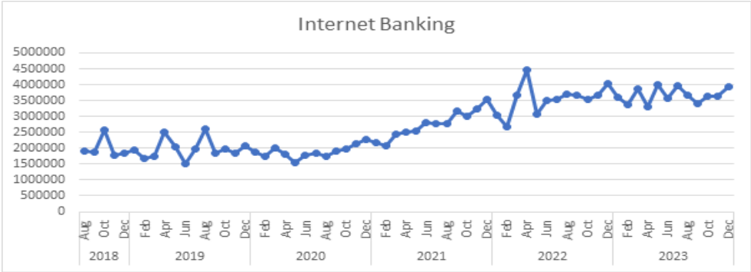
(Source :OJK 2018-2023)
Graph 2. Use of Mobile Banking of Commercial Banks in Indonesia Period 2018-2023
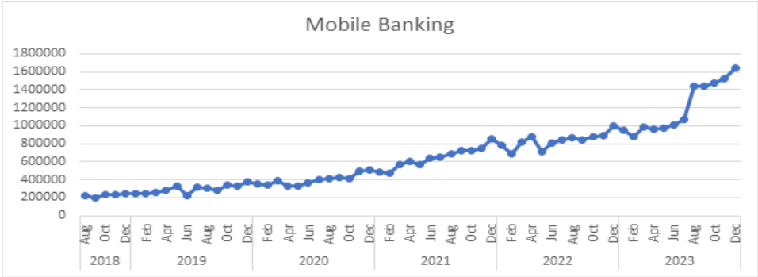
(Source :OJK 2018 -2023)

Graph 3. Use of Commercial Bank QRIS in Indonesia Period 2020-2023
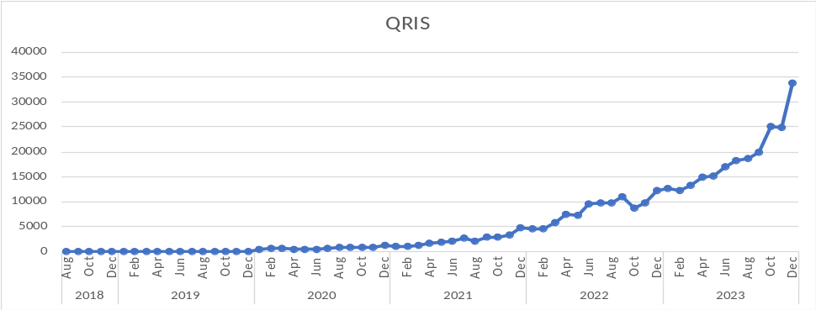
(Sources :ASPI & BI 2020 -2023)
From the graph above, it can be seen that the use of internet banking, mobile banking and QRIS has increased from year to year. Especially for the use of QRIS data available starting in 2020 because QRIS itself was just launched by Bank Indonesia and the Indonesia Payment System Association (ASPI) on August 17, 2019, so that the data on the use of QRIS from 2018 to 2019 uses variable dummy data because of the time balance of each variable used for research. However, the use of internet banking, mobile banking and QRIS in commercial banks (both conventional and sharia) above turns out to have the opposite impact on the development of the number of branches and ATM machines as seen in the graph below:
Graph 4. Development of the number of branches of commercial Banks in Indonesoa for the 2020-2023 Period
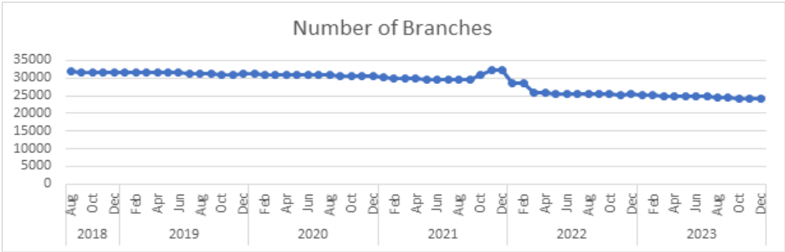
(Source :OJK,2020 - 2023)
Graph 5. Development of the Number of Commercial Bank ATMs in Indonesia for the Period 2020-2023
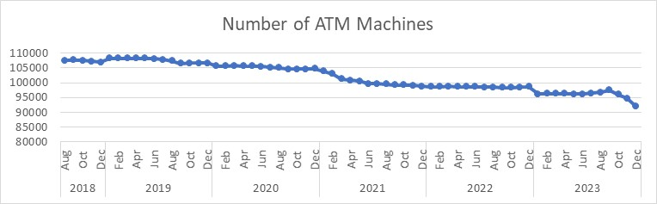
(Source :OJK, 2018 -2013)
From the graph of the development of digital banking in commercial banks, especially internet banking, mobile banking and QRIS, it turns out that it has had an impact on reducing the number of branches and the number of ATM machines. Furthermore, whether the impact of the increase in internet banking, mobile banking and ATM machines and the decrease in the number of branches and ATM machines affects BOPO and NIM (net interest margin), or if in Islamic banks it is known as Net Reward (NI), it can be seen in the graph below:
Graph 6. Development of BOPO (%) of Commercial Banks in Indonesia for the 2020-2023
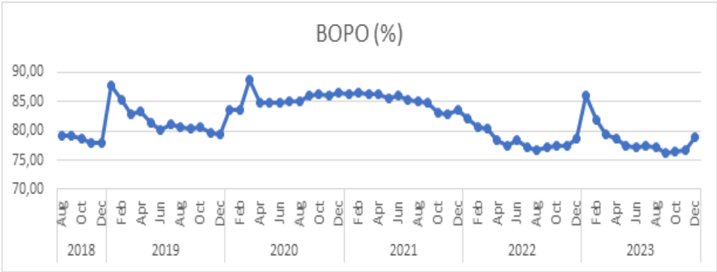
(Source :OJK,2018 - 2023)
Graph 7. Development of Commercial Bank NIM/NI in Indonesia for the 2020-2023 Period
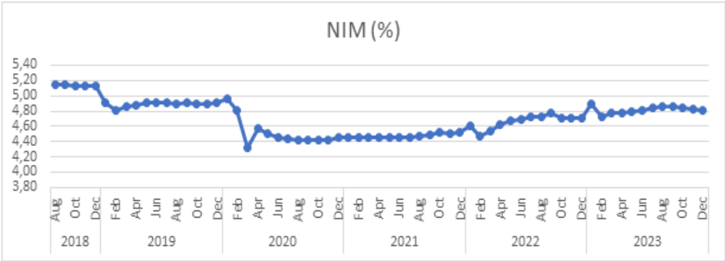
(Source :OJK,2018 - 2023)
From the data, it can be seen that the development of BOPO and NIM data in commercial banks during the research period seems to be quite volatile.
From all the data presented above, it is necessary to know the extent of the influence of the development of banking digitalization specifically for internet banking, mobile banking and QRIS both simultaneously on the number of branches, the number of ATM machines and operational costs (BOPO) and the impact on the NIM revenue of Commercial Banks (conventional/sharia) in Indonesia. In addition, this research also aims to partially see which variables are most influential among internet banking, mobile banking and QRIS on the decrease in the number of branches, ATM and BOPO machines as well as NIM (Net Interest Margin) in commercial banks, both conventional and sharia in Indonesia.
- Literatur Review
A.Electronic Banking
IT-based banking services, commonly known as electronic banking (e-banking), make it easier for customers to carry out financial transactions through various delivery channels, including Automatic Teller Machine (ATM), Electronic Data Capture (EDC), internet banking. Short Messaging Service (SMS) banking, phone banking, and mobile banking. The development of e-banking began with the opening of ATMs which have the main function for cash withdrawals. Furthermore, it was followed by the implementation of EDC which functions to serve customer payment transactions. Along with the development of the internet network, e-banking has increased with the existence of internet banking services that can be accessed through computers by customers (OJK, 2016). Electronic banking is proven effective to opportunities and Challenges of Islamic economy (Maharani et al., 2020), also according to (Oppusunggu et al., 2024) e-banking has a significant positive influence on consumer electronic trust and financial performance. The value of the internet and mobile transactions in Malaysia has increased since 2016. Consumers turned to internet and mobile banking services to conduct contactless banking and ensure social distancing. In addition, past literature also found that the convenience, cost-effective benefits and advances in financial technology innovations had heightened internet and mobile banking usage (Ong et al., 2023). The objective of the study was to know if electronic banking products and services have significantly improved customer satisfaction(Uchechukwu & Stella, 2019). Saudi Arabia e-banking has succeeded - from a customer perspective – in attaining significant satisfaction through effective communication using reports and notices about daily account operations, as well as ensuring the speed of electronic applications. While e-banking has paid considerable attention to the confidentiality of customers' personal information, in addition to the confidentiality and privacy of electronic services, it has ignored the issue of customer awareness of the importance of confidentiality and privacy of their personal data (AlHaliq & AlMuhirat, 2016)
B.Internet Banking
Internet banking is a service to conduct banking transactions through the internet network. Features of internet banking services include general-information on savings/current accounts, deposit accounts, credit cards, account mutation information, fund transfers, both inter-account and inter-bank transfers, credit purchases, ticket purchases, deposit placements, information services such as interest rates and exchange rates, and payments, such as telephone payments, internet, cable TV, insurance, electricity and various other types of payments(OJK, 2015). Internet banking adoption is around 97% in developed countries such as the US, Germany, and the UK. According to OJK (Financial Services Authority), in Indonesia in 2016, only 50.4 million e-banking users, about 19.0 percent of the Indonesian population and about 38.0 percent of the total social media users. In addition, the use of e-banking in Indonesia is one of the early adopters of technology with promising development potential. This is reinforced by increased internet usage supported by lower internet rates. Internet banking has an effect on customer satisfaction (Triwardhani et al., 2023). The data for this study consisted of 213 Islamic bank customers and 410 Conventional bank customers. The findings show that this research successfully predicted the intention of customers to use internet banking (Sudarsono et al., 2020). Factors that affect the intention to use internet banking in Indonesia is perceived trust and social influence (Pratama.et.al, 2022). This study found that Internet banking the capability has a significant positive effect on perceived ease of use (Nurbaiti.et.al, 2021)
C.Mobile Banking
Mobile banking is a service that allows bank customers to make transactions banking via mobile phone or smartphone, mobile banking service features include balance information services, account mutations, credit card bills, interest rates, and the location of the nearest branch/ATM); and transaction services, such as transfers, bill payments (electricity, water, taxes, credit cards, insurance, internet), purchases (credit, tickets), and various other features (OJK, 2015). Mobile Banking has a positive and significant effect on customer satisfaction (Fitria et al., 2021), Mobile banking itself is a facility of banks in this modern era, with the role of mobile banking it is hoped that in the future it can improve financial performance in a bank (Ayuningtyas & Sufina, 2023). that perceived usefulness has a significant influence on decisions to use mobile banking (Aqilah & Fathoni, 2023). It is the perceived usefulness that plays an important role in the relationship between attitudes towards Islamic mobile banking and intention to use Islamic mobile banking. It has been proven that religiosity is a factor that can determine attitudes towards Islamic mobile banking and intention to use Islamic mobile banking. Customers with higher religiosity scores tended to use lamic mobile banking applications compared to those with a lower level of religiosity. This makes consumers' religiosity a key factor that Islamic banking should consider as a service provider (Riptiono et al., 2021).

D. QRIS

Quick Response Code Indonesian Standard (QRIS) or commonly abbreviated as QRIS (pronounced KRIS) is the unification of various types of QR from various Payment System Service Providers (PJSP) using QR Codes. QRIS was developed by the payment system industry together with Bank Indonesia so that the transaction process with QR Code can be easier, faster, and more secure. All Payment System Service Providers who will use the Payment QR Code are required to implement QRIS. Currently, with QRIS, all payment applications from any operator, both bank and non-bank, used by the public, can be used in all stores, traders, stalls, parking, tourist tickets, donations (merchants) with the QRIS logo, even though the QRIS provider at the merchant is different from the application provider used by the public (BI, 2024). Digital transactions play a role in the growth of Indonesia's digital economy, both today and in the future. Indonesia will connect the QRIS system to several other countries, namely Thailand, Singapore, Malaysia to the Philippines. QRIS has enormous opportunities because it is one of the instruments in encouraging digital economic acceleration that is inclusive and efficient. QRIS has huge market potential because there is an increasing number of smartphone users every year. QRIS provides ease of use by eliminating the need to carry a lot of cash, physical cards, or loose change(Rachman et al., 2024). The use of QRIS can provide good efficiency in increasing money supply and can encourage economic inclusiveness. This is based on the implementation of the development of technology 4.0 Indusrty, where one of the drivers of the economy is to comprehensively lent telecommunication technology in order to maximize the sales performance of MSMEs and several other industries without having to incur other production costs (Nada et al., 2021). According to (ASPI, 2024) , QRIS (QR Code Indonesia Standard) is a payment QR Code standard for Indonesia's payment system developed by Bank Indonesia and the Indonesia Payment System Association (ASPI). QR payment feature on mobile banking with QRIS standards to make it easier for customers to make payment transactions at various merchants (Putera KOSIM & Legowo, 2021).

E. Branch Office

Branch Office is a legally domiciled Bank office in Indonesia that carries out banking business activities that are directly responsible to the Head Office, in addition to branch offices, it is also known as sub-branch offices and functional branch offices (POJK, 2016). Throughout 2023, a number of banking branch office networks have shrunk. There are various factors that affect it, ranging from office productivity to the bank's transition to digitalization. The downward trend in the number of bank branch offices is in accordance with OJK Statistics data as of November 2022 (Setiawan, 2024). Compared to the previous quarter, there was a decrease in the office network in all regions with the largest decline in Java and Sumatra(OJK, 2023). The decline in the number of bank offices in Indonesia occurs in line with the rapid digitalization of banking (Burhan, 2024). Bank banks in Indonesia are actively closing branches (Aprilia, 2024). In the fourth quarter of 2023, there were 115,539 BUK office networks, consisting of 115,473 office networks in the country and 66 office networks abroad. The largest office network is still dominated by electronic banking terminals (ATM/CDM/CRM) as many as 91,412 units. Compared to the previous quarter, there was a reduction of 4,676 office networks, especially in UUS sharia services and electronic banking terminals (ATM/CDM/CRM). The reduction in UUS sharia services is influenced by the issuance of POJK Number 12 of 2023 concerning Sharia Business Units (POJK UUS) which, among other things, regulates the adjustment of office network data reporting by deleting reporting for KCP LN, cash offices, payment points, mobile cash, and UUS sharia services (OJK, 2023)

F. ATM Machine

ATMs are the most distracted e-banking channel. The conventional element of ATMs is to find balance data and make cash withdrawals (Firjatullah et al., 2021) and (FUDDIN et al., 2023). An ATM or better known as the Mandiri Cash Machine is a computer terminal/machine connected to the bank's communication network, which allows customers to make financial transactions independently without the help of tellers or other bank officers (OJK, 2015). Likewise, according to (Desmadirega & Hermana, 2023) The he first Payment Instrument Using Cards (APMK) are Automated Teller Machine (ATM) and debit cards. ATMs are electromechanical devices enabling authorized customers to withdraw cash from their accounts and/or access other services such as balance inquiry, funds transfer, or deposit acceptance using a machine-readable plastic card. The rapid pace of digital transactions has made ATM machine outlets and bank offices increasingly quiet and closed, this is due to banks' steps to make operational savings and the development of digital transactions that have brought significant changes (Haris, 2024). The cause of the decline in the number of Indonesian ATM machines also occurs in other countries, the cause of this phenomenon can be seen from various perspectives, including the fact that transactions have shifted to digital services (mobile banking and apps) that are easy to use and easily accessible from various places of customer choice. The decline in the number of ATM machines mostly comes from state-owned banks (Rakhmayanti, 2024) and (CNBC, 2024)

G. BOPO

BOPO is the OJK's Operating Cost Ratio (Awintasari & Nurhidayati, 2021). Low BOPO ratio could indicate more organized management reflected in the company'sefficacy, A sufficient efficiency score impactsa bank's operating profit level, which is higher and more efficient in its operations so that operating costs are relatively lower. The greater the BOPO ratio means that the bank's operations are less efficient so the final profit will be even smaller (Wiadnyani & Artini, 2023). The BOPO (Operating Expense Operating Income ratio) is a ratio that measures the operational efficiency of banks by comparing operating expenses with operating income. This ratio shows how much the bank spends to get operating income. This ratio can also be referred to as the efficiency ratio or the cost-income ratio (Pranata &Sakti, 2024), The higher the BOPO value, the more inefficient it is in managing its operational costs (Almurni et al., 2023). The results of this research show that Internet Banking has a negative and significant effect on efficiency as measured by BOPO in the conventional banking sector in the 2017-2021 period. The results of this research show that the higher the transaction volume and transaction nominal, the more influence against the decline in BOPO. Transactions using Internet Banking require investment in the information technology used, including systems, applications and human resources issued by the Bank (Ermawan & Raharja, 2022).

H. NIM

Net interest margin (NIM) net interest margin is a measure of the difference between the interest income generated by a bank or other financial institution and the amount of interest paid to their lenders (e.g. depositors), relative to their total (interest earning) assets, this is similar to the gross margin of non-financial companies (Akbar & Iradianty, 2020). Net Interest Margin ratio is the comparison between net interest income and the average total earning assets (Otoritas Jasa Keuangan, 2024) (OJK, 2024). Net Return (NI) in Islamic banking or net interest margin (NIM) in conventional banking is a ratio used to measure the ability of bank management to manage the earning assets owned by the bank so that they can generate net profit, NI or Net Return is a ratio used to understand the ability of a bank's earning assets to generate profits or profits (Awintasari & Nurhidayati, 2021)

Hypothesis

1.Hypothesis for Dependent Variable Number of Bank Branches (Y1)

H0: Internet Banking, Mobile Banking, and QRIS do not have a significant influence on the number of bank branches.

H1: Internet Banking, Mobile Banking, and QRIS have a significant influence on the number of bank branches.

2.Hypothesis for Dependent Variable Number of ATM Machines (Y2)

H0: Internet Banking. Mobile Banking, and QRIS do not have a significant influence on the number of ATM machines.

H1: Internet Banking, Mobile Banking, and QRIS have a significant influence on the number of ATM machines.

- Hypothesis for Operating Cost Dependent Variable (BOPO) (Y3)

H0: Internet Banking, Mobile Banking, and QRIS do not have a significant influence on operational costs (BOPO).

H1: Internet Banking, Mobile Banking, and QRIS have a significant influence on operational costs (BOPO).

- Hypothesis for the Dependent Variable Net Interest Income (NIM) (Y4)

H0: Internet Banking. Mobile Banking, and QRIS do not have a significant influence on Net Interest Income (NIM).

H1: Internet Banking, Mobile Banking, and QRIS have a significant influence on Net Interest Income (NIM).

2. Research Methodology
- Data Source
The data used in this research uses secondary data on a monthly time series from 2018 to 2023 obtained from various sources such as OJK statistical data, OJK Banking surveillance reports, the Indonesia Payment System Association (ASPI) and Bank Indonesia (BI). The dependent variables are the number of branches (Y1), the number of ATM machines (Y2), BOPO (Y3) and NIM (Y4) and the independent variables used Mobile Banking (X1), Internet Banking (X2) and QRIS (X3).

- Data Analysis Techniques
The data analysis technique in this study uses the ECM (Error Correction Model) analysis method. The data processing aims to determine the magnitude of the influence of independent variables on the dependent variables. Furthermore, data processing uses the Eviews 9 application. The Error Correction Model was first introduced by Sargan in 1984 and then popularized by Engle-Granger in 1987 (Widarjono, 2018). The error correction model has several main uses, namely forming a long-term relationship model, overcoming the problem of time series data that is not stationary, correcting short-term imbalances, and the emergence of lancing regression problems (Sulistianingsih&Sari, 2019). Random regression is a situation that shows a statistically significant regression coefficient and a high determination coefficient value, but the relationship between the variables in the model is not related (Widarjono, 2009). To be able to build a model with an error correction approach, there are several stages that are carried out, namely:
- Data Stationary Test
To detect a data whether stationary or not, this study uses the ADF (Augmented Dickey-Fuller) test. This ADF test is to determine whether or not a data is stationary by comparing the statistical value of the ADF with its critical value called Mackinnon. If the value of the Mackinnon probability value is greater than the 10% level, then the data is not stationary and vice versa if the Mackinnon probability value is less than the 1% or 5% or 10% level, the data is stationary. If the ADF test shows that the data is not stationary at the level, then it is continued to test the stationarity of the data at the first difference.

- Cointegration Test

Two variables can be called cointegrated if there is a balance or long-term relationship between the two. Engel and Granger also stated that a cointegration test can be considered a preliminary test to avoid false regression. The Engel-Granger cointegration method is carried out using the ADF method which consists of two stages. The first stage is to regress the multiple linear regression equation and obtain the residuals of the equation. The second stage is to test the residual stationarity using the ADF test method. If the residual is stationary at the level, it means that the combination between the research variables is stationary, so it can be concluded that there is a cointegration in the equation. This means that even though the variables used are not stationary, in the long run these variables tend to be balanced.

- Classical Assumption Test
To get a BLUE (best linear unbias, estimator) result, the model must meet the classical assumption requirements. The classical assumption test includes four tests, namely the normality test, the multicollinearity test, the heteroscedasticity test, and the autocorrelation test..

- ECM Test
The ECM test is intended as a step to correct the imbalance in the influence of digital banking (mobile banking, internet banking, QRIS) on the number of branches, the number of ATMs, BOPO and NII/NI. In addition, ECM is used as data validity based on the value of the Error Correction Term (ECT) coefficient, if the ECT coefficient at lag 1 is significant and has a negative value, then the ECM test can be justified. The long-term model is used to obtain the Error Correction Term (ECT) variable which is then included in the short-term model.. The long-term model is as follows:

LnY_{t} = b₀ + b₁ LnMB_{t} + b₂ LnIB_{t} + b₃ DQRIS_{t} + e_{t}
Where:
Y_{t} | = | Branch (CAB)/ATM/BOPO/NII at the time to-t
MB_{t} | = | Use of Mobile Banking at the time to-t
IB_{t} | = | Use of Internet Banking at the time to-t
DQRIS_{t} | = | Dummy QRIS at the time to-t  (1=there QRIS;0=no QRIS)
e_{t} | = | Residual model
b_{i} | = | Constant/Coefficien
Ln | = | Natural Logarithms

Short term models as as follows :

D(LnY_{t}) | = | b₀ + b₁ D(LnMB_{t})+ b₂ D(LnIB_{t})+ b₃ D(DQRIS_{t})  + ECT_{t-1} + e_{t}
Where:
D | = | Differensi pada first difference
Y_{t} | = | Branch (CAB)/ATM/BOPO/NII at the time -t
MB_{t} | = | Use of Mobile Banking at the time -t
IB_{t} | = | Use of Internet Banking at the time -t
DQRIS_{t} | = | Dummy QRIS at the time -t  (1=ada QRIS;0=Tidak ada QRIS)
ECT_{t-1} | = | Error Correction Term at lag 1
e_{t} | = | Residual model
b_{i} | = | Constant/Coefficient
Ln | = | Natural Logarithms

- Statistical Test Model
Statistical testing is carried out to determine the influence of independent variables on dependent variables, by testing the following statistical tests:
- Determination Coefficient Test (R²)
The coefficient of determination (R2) is used to measure how much of the proportion of variation in the dependent variable can be explained by the independent variables in the model (Widarjono, 2009).
- F Test
The F test is conducted with the aim of determining the magnitude of the influence of independent variables on the dependent variable simultaneously. If the p-value of the F- statistic is less than 0.05 (a-5%), it means that there is a simultaneous influence of the independent variables on the dependent variable.
- T Test
T-test is conducted to determine the magnitude of the influence of independent variables on the dependent variable partially (each variable). If the p-value of the T-statistic is less than the real level of 1% or 5% or 10%, it means that there is an influence of the independent variable on the dependent variable.

- Finding & Result

Data Stationary Test Result
The stationarity test aims to determine whether a data is stationary or not. Data that is not stationary when included in the model will produce invalid equations so that the conclusions obtained will be wrong. To test the stationarity in this study, a root test unit test was carried out using the Augmented Dickey-Fuller (ADF) test method. The stationarity test of the data using the ADF test was carried out in the form of level as well as the form of first difference. The results of the ADF root test unit on each variable are shown in Table 1.
Tabel 1 Result of data stationary test
Variabel | MacKinnon (p-values)
Variabel | Level | First Difference
Nbr of Branch | 0.9279 | 0.0000***
Nbr of ATM | 0.9934 | 0.0003***
BOPO | 0.1431 | 0.0000***
NII | 0.1850 | 0.0000***
Mobile Banking | 0.9796 | 0.0000***
Internet Banking | 0.9262 | 0.0000***
Note: ***) stationary at 1%
The results of the root unit test show that in the form of the level, both independent and dependent variables have a unit root indicated by a MacKinnon p-value of more than 0.10 (10% level), so it can be said that each variable is not stationary at the level. Next, the root test unit was carried out in the form of first difference. The results show that the MacKinnon p-value of each variable is less than 0.01 (1%), so it can be concluded that each variable is stationary in the form of first difference.
Co Integration Test Results
After the stationarity test and degree of integration test are conducted, a cointegration test is conducted. This test uses the Engel-Granger (EG) test which utilizes the Augmented Dickey Fuller (ADF) test. The cointegration test aims to see whether or not there is long-term equilibrium between the variables used. Cointegration testing is carried out by testing the stationarity of the residuals of the long-term equation. Data is said to be cointegrated if the residual value (disequilibrium error) is stationary at the level. Table 2 shows the results of the ADF unit root test on the residual model.
Tabel 2 Results of residual stationary test of the model
Model | t-Statistic (ADF) | MacKinnon (p-values)
residual Branch | -3.0083 | 0.0394***
residual ATM | -4.9873 | 0.0001***
residual BOPO | -4.3952 | 0.0007***
residual NII/NI | -4.5931 | 0.0004***
Note: ***) stasioner at the level 1%; **) stasioner of the level 5%
The results of the cointegration test using the ADF root test unit in Table 2 show that the MacKinnon p-value values are smaller than 0.01 and 0.05 (1% and 5% levels), meaning that there is a stationary residual at the level, so it can be concluded that there is a long-term integration or relationship in the research model.
Classical Assumption Test of ECM Model Equations
In general, the results of the equation test on the regression model show that there is no deviation in the ECM estimation. The tests carried out are normality test, autocorrelation test, heteroscedasticity test, and multicollinearity test.
- Normality Test
The Jarque-Bera normality test was carried out to check that the error term was close to the normal distribution. The results obtained for the branch, ATM, BOPO and NII models show that the residual is normally distributed because the probability value > a = 0.05 (see Appendix 10).

- Heteroscedasticity Test
he heteroscedasticity test was carried out using the ARCH test. The results of the analysis in Appendix 11 show that the probability of chi-square of Obs* R-Squared is greater than a 0.05. So it can be concluded that there is no heteroscedasticity or residual has a homogeneous variance

- Multicollinearity Test
The multicollinearity test can be done by looking at the Variance Inflation Factor (VIF) value. If the VIF value is less than 10, it is said that there is no multicollinearity problem. The estimation results show that the independent variables in the model do not have multicollinearity problems because the VIF values of all independent variables are less than 10 (see Appendix 12).

- Autocorrelation Test
The autocorrelation test was carried out using the Breusch-Godfrey Serial Correlation LM Test. The results of the analysis in Appendix 13 show that the chi-square probability of Obs* R-Squared is greater than a 0.05. Therefore, it can be concluded that there are no autocorrelation symptoms in the model..

Model Estimation Results
The results of the model estimation with the ECM approach show the relationship between variables in the short and long term. The ECM model can be said to be valid if the ECT (Error Correction Term) has a negative value and the probability is smaller than the actual level used. Table 3 shows that the model is cointegratee with the expected ECT(-1) parameter with negative and significant values, so the estimated error correction parameter can be used to correct the short-term to long-term equation. The value of the ECT(-1) coefficient describes the speed of the model to adjust towards long-term equilibrium (speed of adjustment). The ECT(-1) coefficient in the Branch model shows that 39.69% of short-term models can be corrected towards long-term equilibrium. The ECT(-1) coefficient in the ATM model shows that 60.85% of the short-term model can be corrected towards long-term equilibrium. The ECT(-1) coefficient in the BOPO model shows that 70.17% of short-term models can be corrected towards long-term equilibrium. The ECT(-1) coefficient in the NII model shows that 51.41% of short-term models can be corrected towards long-term equilibrium.
The ECM estimation results on the branch model show an R-squared value of 0.4333, meaning that the variables used in the model are able to explain the diversity of the number of branches by 43.33% and the remaining 36.67% explained by other factors outside the model (Table 3). The R-squared value in the ATM model is 0.7876, meaning that the variables used in the model are able to explain the diversity of the number of ATMs by 78.76% and the remaining 21.24% explained by other factors outside the model. In addition, the BOPO model shows an R-squared value of 0.6519, meaning that the variables used in the model are able to explain the diversity of BOPO by 65.19% and the remaining 34.81% explained by other factors outside the model. The NII model shows an R-squared value of 0.4009, meaning that the variables used in the model are able to explain the diversity of the NII by 40.09% and the remaining 59.91% explained by other factors outside the model.
The results of the simultaneous test based on the F-statistic value showed that the independent variables together had a real effect on the dependent variables (Branch, ATM, BOPO and NII). Table 3 shows that the p-value of the F-statistic is less than the real level of 1% and 5%, meaning that there is at least one independent variable that has a significant effect on the model.
Tabel 3 Model Estimation Results
Variabel | Cabang |  | ATM |  |  | BOPO |  |  | NII
Variabel | Koefisien | P-value |  | Koefisien | P-value |  | Koefisien | P-value |  | Koefisien | P-value
Jangka Panjang
MB | -0.1206 | 0.0000*** |  | -0.0560 | 0.0000*** |  | -4.0261 | 0.0238*** |  | 0.1875 | 0.0214***
IB | -0.1183 | 0.0010*** |  | -0.0317 | 0.0038*** |  | -4.0729 | 0.1127*** |  | 0.1714 | 0.1486***
DQRIS | 0.0234 | 0.1710*** |  | -0.0075 | 0.1418*** |  | 6.3792 | 0.0000*** |  | -0.5917 | 0.0000***
C | 13.5786 | 0.0000*** |  | 12.7453 | 0.0000*** |  | 190.318 | 0.0000*** |  | 0.1167 | 0.9039***
Jangka Pendek
D(MB) | 0.1380 | 0.2610*** |  | -0.0432 | 0.0000*** |  | -1.9378 | 0.3507*** |  | 0.0936 | 0.3518***
D(IB) | 0.0587 | 0.5374*** |  | -0.0191 | 0.0377*** |  | -2.3267 | 0.0675*** |  | 0.0714 | 0.4129***
D(DQRIS) | -0.0021 | 0.9689*** |  | -0.0091 | 0.0163*** |  | 4.3058 | 0.0568*** |  | -0.0070 | 0.7350***
ECT(-1) | -0.3969 | 0.0094*** |  | -0.6085 | 0.0000*** |  | -0.7017 | 0.0000*** |  | -0.5141 | 0.0002***
C | 0.0269 | 0.1402*** |  | 0.0025 | 0.0005*** |  | -0.5684 | 0.0061*** |  | 0.0253 | 0.0294***
R-Squared |  | 0.4333*** |  |  | 0.7876*** |  |  | 0.6519*** |  |  | 0.4009***
F-statistik (F) |  | 3.4413*** |  |  | 25.034*** |  |  | 27.625*** |  |  | 4.1815***
P-value (F) |  | 0.0295*** |  |  | 0.0000*** |  |  | 0.0000*** |  |  | 0.0100***
Note: ***) signifikan of the level 1%; **) signifikan at the level 5%; *) signifikan at the level 10%;
Based on the results of the partial test of the long-term Branch model, it shows that MB (Mobile Banking) and IB (Internet Banking) have a significant effect on the number of branches. The influence of MB of -0.1206 means that every 1% increase in MB will decrease the number of Branches by 0.1206%. Likewise, the influence of IB of -0.1183 means that every 1% increase in IB will reduce the number of Branches by 0.1183%. Meanwhile, in the short term, MB, IB and dummy QRIS have no effect on the number of branches..
The results of the partial test of the ATM model for the long term show that MB (Mobile Banking) and IB (Internet Banking) have a significant effect on the number of ATMs (Table 3). The influence of MB of -0.0560 means that every 1% increase in MB will decrease the number of ATMs by 0.0560%. Likewise, the influence of IB of -0.0317 means that every 1% increase in IB will reduce the number of ATMs by 0.0317%. In the short term, it shows that MB, IB and dummy QRIS have a significant effect on the number of ATMs. The effect of MB in the short term is -0.0432, meaning that every 1% increase in MB will reduce the number of ATMs by 0.0432%. Likewise, the influence of IB in the short term is -0.0191, meaning that every 1% increase in IB will reduce the number of ATMs by 0.0191%. In addition, in the short term, the QRIS dummy also affects the number of ATMs by -0.0091, meaning that after the use of QRIS, the number of ATMs decreased by 0.0091% compared to before QRIS.
The results of the partial test of the long-term BOPO model show that MB (Mobile Banking) and the QRIS dummy have a significant effect on BOPO (Table 3). The influence of MB of - 4.0261 means that every 1% increase in MB will reduce BOPO by 4.0261%. Meanwhile, the influence of the QRIS dummy of 6.3792 means that after the use of QRIS, the BOPO value increased by 6.3792% compared to before the QRIS. In the short term, it shows that IB and dummy QRIS have a significant effect on BOPO. The effect of IB in the short term of -2.3267 means that every 1% increase in IB will reduce BOPO by 2.3267%. In addition, in the short term, the QRIS dummy also affects the BOPO by 4.3058, meaning that after the use of QRIS. the BOPO value increases by 4.3058% compared to before the QRIS.
The results of the partial test of the long-term NII model show that MB (Mobile Banking) and dummy QRIS have a significant effect on NII (Table 3). The effect of MB of 0.1875 means that every 1% increase in MB will increase the NII by 0.1875%. Meanwhile, the influence of the QRIS dummy of -0.5917 means that after the use of QRIS, the NII value decreased by 0.5917% compared to before the QRIS. Meanwhile, in the short term, MB, IB and dummy QRIS have no effect on NII.

5. Conclusion
This research aims to analyze the extent of the effect of the development of e-banking which includes internet banking, mobile banking and QRIS in commercial banks, both in conventional banks and in sharia banks (BUS &UUS) on the number of commercial bank branches, the number of ATM (Automatic Teller Machines), Operating Costs (BOPO) and Net Interest Income in Indonesia. Based on the analysis data carried out, it can be concluded as follows:
- The results of the simultaneous test based on the F-statistic value show that the independent variables simultaneously have a significant effect on the dependent variables (Branches, ATMs, BOPO and NII). The p-value of the F-statistic is less than the real level of 1% and 5%, meaning that there is at least one independent variable that has a significant effect on the model.
- Based on the results of partial tests, it shows that::
- The results of the partial test of the Branch model for the long term show that MB (Mobile Banking) and IB (Internet Banking) have a significant effect on the number of branches, while in the short term it shows that MB (Mobile Banking), IB (Internet Banking) and dummy QRIS have no effect on the number of branches.
- The partial test results of the ATM model for the long term show that MB (Mobile Banking) and IB (Internet Banking) have a significant effect on the number of ATMs. In the short term, it shows that MB (Mobile Banking), IB (Internet Banking) and dummy QRIS have a significant effect on the number of ATMs.
- The partial test results of the BOPO model for the long term show that MB (Mobile Banking) and dummy QRIS have a significant effect on BOPO. In the short term, it shows that IB and dummy QRIS have a significant effect on BOPO.
- The partial test results of the NIM model for the long term show that MB (Mobile Banking) and dummy QRIS have a significant effect on NII. While in the short term it shows that MB (Mobile Banking), IB (Internet Banking) and dummy QRIS have no effect on NIM.

Lampiran 1 Uji stasioner pada level
Null Hypothesis: CABANG has a unit root
Exogenous: Constant
Lag Length: 0 (Automatic - based on SIC, maxlag=10)
 |  |  | t-Statistic | Prob.*
Augmented Dickey-Fuller test statistic |  |  | -0.234220 | 0.9279
Test critical values: | 1% level |  | -3.536587
 | 5% level |  | -2.907660
 | 10% level |  | -2.591396
*MacKinnon (1996) one-sided p-values.

Null Hypothesis: ATM has a unit root
Exogenous: Constant
Lag Length: 1 (Automatic - based on SIC, maxlag=10)
 |  |  | t-Statistic | Prob.*
Augmented Dickey-Fuller test statistic |  |  | 0.807129 | 0.9934
Test critical values: | 1% level |  | -3.538362
 | 5% level |  | -2.908420
 | 10% level |  | -2.591799
*MacKinnon (1996) one-sided p-values.

Null Hypothesis: BOPO has a unit root
Exogenous: Constant
Lag Length: 0 (Automatic - based on SIC, maxlag=10)
 |  |  | t-Statistic | Prob.*
Augmented Dickey-Fuller test statistic |  |  | -2.409688 | 0.1431
Test critical values: | 1% level |  | -3.536587
 | 5% level |  | -2.907660
 | 10% level |  | -2.591396
*MacKinnon (1996) one-sided p-values.

Null Hypothesis: NIM has a unit root
Exogenous: Constant
Lag Length: 0 (Automatic - based on SIC, maxlag=10)
 |  |  | t-Statistic | Prob.*
Augmented Dickey-Fuller test statistic |  |  | -2.269159 | 0.1850
Test critical values: | 1% level |  | -3.536587
 | 5% level |  | -2.907660
 | 10% level |  | -2.591396
*MacKinnon (1996) one-sided p-values.

Null Hypothesis: MB has a unit root
Exogenous: Constant
Lag Length: 2 (Automatic - based on SIC, maxlag=10)
 |  |  | t-Statistic | Prob.*
Augmented Dickey-Fuller test statistic |  |  | 0.359546 | 0.9796
Test critical values: | 1% level |  | -3.540198
 | 5% level |  | -2.909206
 | 10% level |  | -2.592215
*MacKinnon (1996) one-sided p-values.

Null Hypothesis: IB has a unit root
Exogenous: Constant
Lag Length: 2 (Automatic - based on SIC, maxlag=10)
 |  |  | t-Statistic | Prob.*
Augmented Dickey-Fuller test statistic |  |  | -0.245788 | 0.9262
Test critical values: | 1% level |  | -3.540198
 | 5% level |  | -2.909206
 | 10% level |  | -2.592215
*MacKinnon (1996) one-sided p-values.

Lampiran 2 Uji stasioner pada first difference
Null Hypothesis: D(CABANG) has a unit root
Exogenous: Constant
Lag Length: 0 (Automatic - based on SIC, maxlag=10)
 |  |  | t-Statistic | Prob.*
Augmented Dickey-Fuller test statistic |  |  | -6.950370 | 0.0000
Test critical values: | 1% level |  | -3.538362
 | 5% level |  | -2.908420
 | 10% level |  | -2.591799
*MacKinnon (1996) one-sided p-values.

Null Hypothesis: D(ATM) has a unit root
Exogenous: Constant
Lag Length: 0 (Automatic - based on SIC, maxlag=10)
 |  |  | t-Statistic | Prob.*
Augmented Dickey-Fuller test statistic |  |  | -4.717483 | 0.0003
Test critical values: | 1% level |  | -3.538362
 | 5% level |  | -2.908420
 | 10% level |  | -2.591799
*MacKinnon (1996) one-sided p-values.

Null Hypothesis: D(BOPO) has a unit root
Exogenous: Constant
Lag Length: 0 (Automatic - based on SIC, maxlag=10)
 |  |  | t-Statistic | Prob.*
Augmented Dickey-Fuller test statistic |  |  | -9.162850 | 0.0000
Test critical values: | 1% level |  | -3.538362
 | 5% level |  | -2.908420
 | 10% level |  | -2.591799
*MacKinnon (1996) one-sided p-values.

Null Hypothesis: D(NIM) has a unit root
Exogenous: Constant
Lag Length: 0 (Automatic - based on SIC, maxlag=10)
 |  |  | t-Statistic | Prob.*
Augmented Dickey-Fuller test statistic |  |  | -9.516664 | 0.0000
Test critical values: | 1% level |  | -3.538362
 | 5% level |  | -2.908420
 | 10% level |  | -2.591799
*MacKinnon (1996) one-sided p-values.

Null Hypothesis: D(MB) has a unit root
Exogenous: Constant
Lag Length: 1 (Automatic - based on SIC, maxlag=10)
 |  |  | t-Statistic | Prob.*
Augmented Dickey-Fuller test statistic |  |  | -9.922438 | 0.0000
Test critical values: | 1% level |  | -3.540198
 | 5% level |  | -2.909206
 | 10% level |  | -2.592215
*MacKinnon (1996) one-sided p-values.

Null Hypothesis: D(IB) has a unit root
Exogenous: Constant
Lag Length: 1 (Automatic - based on SIC, maxlag=10)
 |  |  | t-Statistic | Prob.*
Augmented Dickey-Fuller test statistic |  |  | -12.47344 | 0.0000
Test critical values: | 1% level |  | -3.540198
 | 5% level |  | -2.909206
 | 10% level |  | -2.592215
*MacKinnon (1996) one-sided p-values.

Lampiran 3 Uji kointegrasi
Uji Kointegrasi Model Cabang

Null Hypothesis: ECT_CAB has a unit root
Exogenous: Constant
Lag Length: 0 (Automatic - based on SIC, maxlag=10)
 |  |  | t-Statistic | Prob.*
Augmented Dickey-Fuller test statistic |  |  | -3.008345 | 0.0394
Test critical values: | 1% level |  | -3.536587
 | 5% level |  | -2.907660
 | 10% level |  | -2.591396
*MacKinnon (1996) one-sided p-values.

Uji Kointegrasi Model ATM

Null Hypothesis: ECT_ATM has a unit root
Exogenous: Constant
Lag Length: 0 (Automatic - based on SIC, maxlag=10)
 |  |  | t-Statistic | Prob.*
Augmented Dickey-Fuller test statistic |  |  | -4.987270 | 0.0001
Test critical values: | 1% level |  | -3.536587
 | 5% level |  | -2.907660
 | 10% level |  | -2.591396
*MacKinnon (1996) one-sided p-values.

Uji Kointegrasi Model BOPO
Null Hypothesis: ECT_BOPO has a unit root
Exogenous: Constant
Lag Length: 0 (Automatic - based on SIC, maxlag=10)
 |  |  | t-Statistic | Prob.*
Augmented Dickey-Fuller test statistic |  |  | -4.395193 | 0.0007
Test critical values: | 1% level |  | -3.536587
 | 5% level |  | -2.907660
 | 10% level |  | -2.591396
*MacKinnon (1996) one-sided p-values.

Uji Kointegrasi Model NII
Null Hypothesis: ECT_NII has a unit root
Exogenous: Constant
Lag Length: 0 (Automatic - based on SIC, maxlag=10)
 |  |  | t-Statistic | Prob.*
Augmented Dickey-Fuller test statistic |  |  | -4.593098 | 0.0004
Test critical values: | 1% level |  | -3.536587
 | 5% level |  | -2.907660
 | 10% level |  | -2.591396
*MacKinnon (1996) one-sided p-values.

Lampiran 4 Hasil estimasi model cabang
Model Jangka Panjang
Dependent Variable: CABANG
Method: Robust Least Squares
Included observations: 65
Variable | Coefficient | Std. Error | z-Statistic | Prob.
MB | -0.120572 | 0.024665 | -4.888334 | 0.0000
IB | -0.118268 | 0.035935 | -3.291155 | 0.0010
DQRIS | 0.023388 | 0.017086 | 1.368846 | 0.1710
C | 13.57861 | 0.292502 | 46.42227 | 0.0000
R-squared | 0.569135 | Adjusted R-squared |  | 0.547945
Rw-squared | 0.918948 | Adjust Rw-squared |  | 0.918948
Akaike info criterion | 91.02679 | Schwarz criterion |  | 100.4459
Deviance | 0.075509 | Scale |  | 0.030027
Rn-squared statistic | 439.1888 | Prob(Rn-squared stat.) |  | 0.000000
Model Jangka Pendek
Dependent Variable: D(CABANG)
Method: Least Squares
Variable | Coefficient | Std. Error | t-Statistic | Prob.
D(MB) | 0.138002 | 0.118903 | 1.160626 | 0.2610
D(IB) | 0.058698 | 0.093364 | 0.628699 | 0.5374
D(DQRIS) | -0.002061 | 0.052188 | -0.039493 | 0.9689
ECT_CAB(-1) | -0.396910 | 0.136520 | -2.907336 | 0.0094
C | 0.026854 | 0.017405 | 1.542929 | 0.1402
R-squared | 0.433344 | Mean dependent var |  | -0.009349
Adjusted R-squared | 0.307420 | S.D. dependent var |  | 0.055103
S.E. of regression | 0.044401 | Akaike info criterion |  | -3.201460
Sum squared resid | 0.035486 | Schwarz criterion |  | -2.954613
Log likelihood | 41.81679 | Hannan-Quinn criter. |  | -3.139379
F-statistic | 3.441325 | Durbin-Watson stat |  | 1.991862
Prob(F-statistic) | 0.029518 | Weighted mean dep. |  | -0.016402

Lampiran 5 Hasil estimasi model ATM
Model Jangka Panjang ATM
Dependent Variable: ATM
Method: Least Squares
Included observations: 65
Variable | Coefficient | Std. Error | t-Statistic | Prob.
MB | -0.055994 | 0.007228 | -7.747317 | 0.0000
IB | -0.031717 | 0.010530 | -3.012104 | 0.0038
DQRIS | -0.007451 | 0.005006 | -1.488204 | 0.1418
C | 12.74530 | 0.085710 | 148.7028 | 0.0000
R-squared | 0.944773 | Mean dependent var |  | 11.53177
Adjusted R-squared | 0.942056 | S.D. dependent var |  | 0.044579
S.E. of regression | 0.010731 | Akaike info criterion |  | -6.171843
Sum squared resid | 0.007024 | Schwarz criterion |  | -6.038034
Log likelihood | 204.5849 | Hannan-Quinn criter. |  | -6.119047
F-statistic | 347.8409 | Durbin-Watson stat |  | 1.179326
Prob(F-statistic) | 0.000000
Model Jangka Pendek ATM
Dependent Variable: D(ATM)
Method: Least Squares
Variable | Coefficient | Std. Error | t-Statistic | Prob.
D(MB) | -0.043240 | 0.008513 | -5.079237 | 0.0000
D(IB) | -0.019067 | 0.008722 | -2.185941 | 0.0377
D(DQRIS) | -0.009051 | 0.003533 | -2.561850 | 0.0163
ECT_ATM(-1) | -0.608506 | 0.071119 | -8.556163 | 0.0000
C | 0.002519 | 0.000641 | 3.927940 | 0.0005
R-squared | 0.787632 | Mean dependent var |  | 9.95E-05
Adjusted R-squared | 0.756170 | S.D. dependent var |  | 0.005946
S.E. of regression | 0.002820 | Akaike info criterion |  | -8.761695
Sum squared resid | 0.000215 | Schwarz criterion |  | -8.532674
Log likelihood | 145.1871 | Hannan-Quinn criter. |  | -8.685781
F-statistic | 25.03441 | Durbin-Watson stat |  | 1.238793
Prob(F-statistic) | 0.000000 | Weighted mean dep. |  | 0.001633

Lampiran 6 hasil estimasi model BOPO
Model Jangka Panjang
Dependent Variable: BOPO
Method: Least Squares
Included observations: 65
Variable | Coefficient | Std. Error | t-Statistic | Prob.
MB | -4.026130 | 1.737116 | -2.317709 | 0.0238
IB | -4.072890 | 2.530813 | -1.609321 | 0.1127
DQRIS | 6.379168 | 1.203296 | 5.301412 | 0.0000
C | 190.3182 | 20.60019 | 9.238661 | 0.0000
R-squared | 0.509675 | Mean dependent var |  | 81.70442
Adjusted R-squared | 0.485560 | S.D. dependent var |  | 3.595864
S.E. of regression | 2.579113 | Akaike info criterion |  | 4.792332
Sum squared resid | 405.7614 | Schwarz criterion |  | 4.926140
Log likelihood | -151.7508 | Hannan-Quinn criter. |  | 4.845128
F-statistic | 21.13573 | Durbin-Watson stat |  | 0.924961
Prob(F-statistic) | 0.000000
Model Jangka Pendek
Dependent Variable: D(BOPO)
Method: Least Squares
Variable | Coefficient | Std. Error | t-Statistic | Prob.
D(MB) | -1.937765 | 2.059855 | -0.940729 | 0.3507
D(IB) | -2.326725 | 1.249042 | -1.862808 | 0.0675
D(DQRIS) | 4.305779 | 2.216528 | 1.942579 | 0.0568
ECT_BOPO(-1) | -0.701716 | 0.068831 | -10.19472 | 0.0000
C | -0.568439 | 0.199862 | -2.844157 | 0.0061
R-squared | 0.651913 | Mean dependent var |  | -0.302210
Adjusted R-squared | 0.628314 | S.D. dependent var |  | 1.994404
S.E. of regression | 0.906921 | Akaike info criterion |  | 2.717382
Sum squared resid | 48.52788 | Schwarz criterion |  | 2.886045
Log likelihood | -81.95624 | Hannan-Quinn criter. |  | 2.783827
F-statistic | 27.62445 | Durbin-Watson stat |  | 1.114221
Prob(F-statistic) | 0.000000 | Weighted mean dep. |  | -1.352220

Lampiran 7 hasil estimasi model NII
Model Jangka Panjang
Dependent Variable: NII
Method: Robust Least Squares
Included observations: 65
Variable | Coefficient | Std. Error | z-Statistic | Prob.
MB | 0.187470 | 0.081450 | 2.301651 | 0.0214
IB | 0.171410 | 0.118665 | 1.444480 | 0.1486
DQRIS | -0.591663 | 0.056420 | -10.48668 | 0.0000
C | 0.116672 | 0.965906 | 0.120790 | 0.9039
R-squared | 0.624101 | Adjusted R-squared |  | 0.605614
Rw-squared | 0.760956 | Adjust Rw-squared |  | 0.760956
Akaike info criterion | 63.40860 | Schwarz criterion |  | 74.58397
Deviance | 0.865078 | Scale |  | 0.122247
Rn-squared statistic | 160.4532 | Prob(Rn-squared stat.) |  | 0.000000
Model Jangka Pendek
Dependent Variable: D(NII)
Method: Least Squares
Variable | Coefficient | Std. Error | t-Statistic | Prob.
D(MB) | 0.093636 | 0.098691 | 0.948783 | 0.3518
D(IB) | 0.071352 | 0.085685 | 0.832726 | 0.4129
D(QRIS) | -0.007017 | 0.020504 | -0.342248 | 0.7350
ECT_NII(-1) | -0.514114 | 0.115459 | -4.452770 | 0.0002
C | 0.025335 | 0.010968 | 2.309936 | 0.0294
R-squared | 0.400850 | Mean dependent var |  | 8.67E-05
Adjusted R-squared | 0.304986 | S.D. dependent var |  | 0.055325
S.E. of regression | 0.045816 | Akaike info criterion |  | -3.177364
Sum squared resid | 0.052477 | Schwarz criterion |  | -2.943831
Log likelihood | 52.66046 | Hannan-Quinn criter. |  | -3.102655
F-statistic | 4.181451 | Durbin-Watson stat |  | 1.641770
Prob(F-statistic) | 0.009957 | Weighted mean dep. |  | -0.006265

Lampiran 8 Uji Normalitas
Uji Normalitas Model Cabang
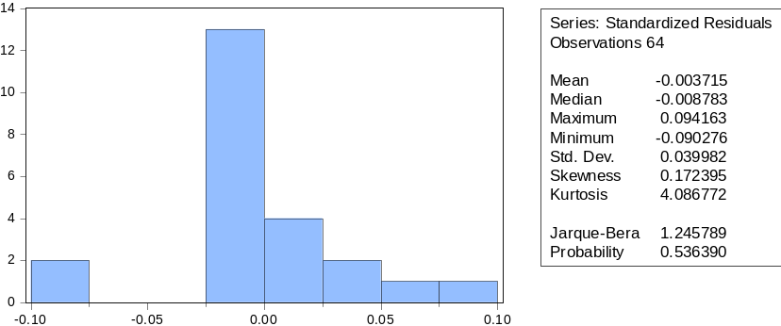
Uji Normalitas Model ATM
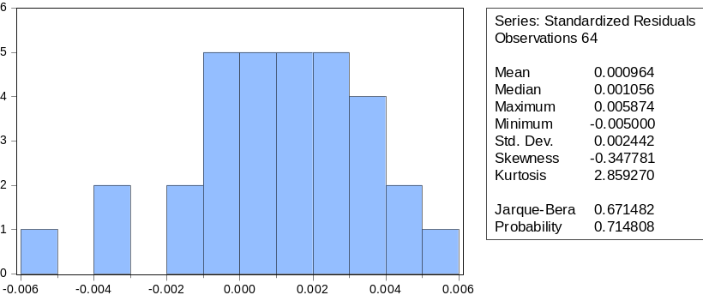
Uji Normalitas Model BOPO
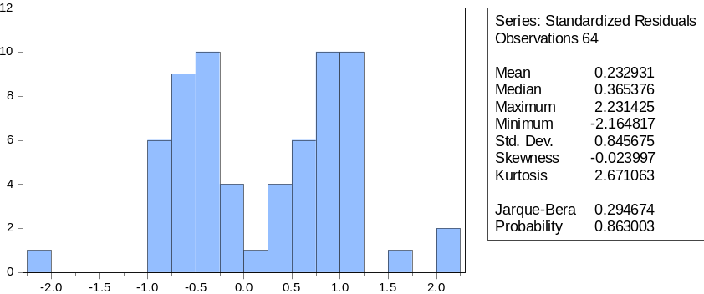
Uji Normalitas Model NII
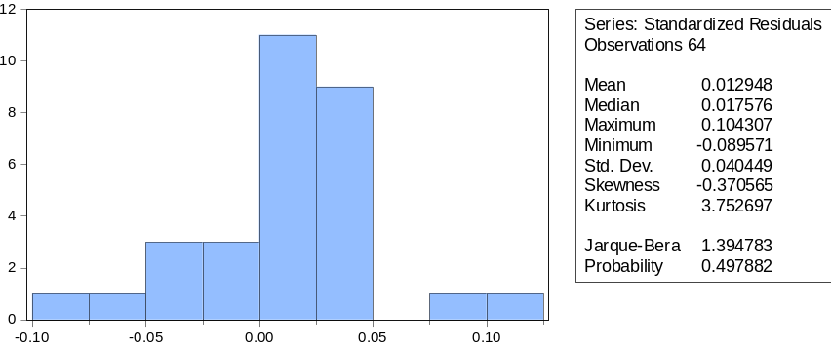

Lampiran 9 Uji Heteroskedastisitas

Heteroskedasticity Test: ARCH (Model Cabang)
F-statistic | 0.538614 | Prob. F(1,15) |  | 0.4743
Obs*R-squared | 0.589270 | Prob. Chi-Square(1) |  | 0.4427

Heteroskedasticity Test: ARCH (Model ATM)
F-statistic | 0.335421 | Prob. F(1,20) |  | 0.5690
Obs*R-squared | 0.362877 | Prob. Chi-Square(1) |  | 0.5469

Heteroskedasticity Test: ARCH (Model BOPO)
F-statistic | 0.347970 | Prob. F(1,61) |  | 0.5574
Obs*R-squared | 0.357340 | Prob. Chi-Square(1) |  | 0.5500

Heteroskedasticity Test: ARCH (Model NII)
F-statistic | 2.507169 | Prob. F(1,22) |  | 0.1276
Obs*R-squared | 2.455284 | Prob. Chi-Square(1) |  | 0.1171

Lampiran 10 Uji Multikolinieritas
Variance Inflation Factors
Included observations: 65
 | Coefficient | Uncentered | Centered
Variable | Variance | VIF | VIF
MB | 5.22E-05 | 5155.907 | 9.456907
IB | 0.000111 | 13649.88 | 5.898140
DQRIS | 2.51E-05 | 10.44829 | 2.732630
C | 0.007346 | 4146.819 | NA

Lampiran 11 Uji Autokorelasi
Breusch-Godfrey Serial Correlation LM Test: (Model Cabang)
F-statistic | 2.418999 | Prob. F(2,16) |  | 0.1208
Obs*R-squared | 5.339955 | Prob. Chi-Square(2) |  | 0.0693

Breusch-Godfrey Serial Correlation LM Test: (Model ATM)
Obs*R-squared | 0.000000 | Prob. Chi-Square(2) |  | 1.0000

Breusch-Godfrey Serial Correlation LM Test: (Model BOPO)
F-statistic | 4.382242 | Prob. F(54,5) |  | 0.0513
Obs*R-squared | 62.67572 | Prob. Chi-Square(54) |  | 0.1956

Breusch-Godfrey Serial Correlation LM Test (Model NII)
F-statistic | 2.026232 | Prob. F(5,20) |  | 0.1184
Obs*R-squared | 10.08706 | Prob. Chi-Square(5) |  | 0.0728

DAFTAR PUSTAKA

Akbar, A., & Iradianty, A. (2020). Pengaruh Biaya Operasional, Pajak Tangguhan, Dan Net Interest Margin Terhadap Laba Bersih Pada Perbankan Syariah Yang Terdaftar Di Bursa Efek Indonesia Periode 2014-2018. E-Proceeding of Management, 7(2), 2238–2245.
AlHaliq, H. A., & AlMuhirat, A. A. (2016). Customer satisfaction with electronic banking services in the Saudi banking sector. Asian Social Science, 12(5), 139–146. https://doi.org/10.5539/ass.v12n5p139
Almurni, S., Fatin, A. S., & Mustika Maya. (2023). Pengaruh Electronic Banking dan Electronic Money Terhadap Kinerja Keuangan Perbankan yang Terdaftar di Bursa Efek Indonesia. BPJP) Sekolah Tinggi Ilmu Ekonomi Indonesia Jakarta, 32(1), 30–45. https://doi.org/10.36406/jam.v18i02.1323
Aqilah, S., & Fathoni, M. A. (2023). Factors Determining the Use of Mobile Banking in Indonesia. International Journal of Banking and Finance, 18(2), 29–52. https://doi.org/10.32890/ijbf2023.18.2.2
ASPI. (2024). Statistik QRIS. Https://Www.Aspi-Indonesia.or.Id/Statistik-Qris/.
Awintasari & Nurhidayati. (2021). PENGARUH NON PERFORMING FINANCING, CAPITAL ADEQUACY RATIO, BEBAN OPERASIONAL PENDAPATAN OPERASIONAL DAN NET IMBALAN TERHADAP RETURN ON ASSETS (STUDI PADA BANK MAYBANK SYARIAH PERIODE 2012-2019). Land Journal, 1(2), 167–178. https://doi.org/10.47491/landjournal.v1i2.709
Ayuningtyas, M., & Sufina, L. (2023). Pengaruh Penggunaan Mobile Banking, Internet Banking, dan Atm terhadap Kinerja Keuangan Perbankan (Studi Kasus Sektor Bank Konvensional yang Terdaftar di Bursa Efek Indonesia) Tahun 2017- 2021. Jurnal Keuangan Dan Perbankan, 19(2), 119–130. https://doi.org/10.35384/jkp.v19i2.394
BI. (2024). QRIS. Https://Www.Bi.Go.Id/QRIS/Default.Aspx.
Burhan. (2024). https://finansial.bisnis.com/read/20240123/90/1734767/1064-kantor-bank-tutup-setahun-terakhir-terbanyak-dari-kelompok-bumn.
CNBC. (2024). No TitBank di Indonesia Ramai-Ramai Tutup Ribuan ATM, Ini Alasannyale. Https://Www.Cnbcindonesia.Com/Market/20240616182929-17-547024/Bank-Di-Indonesia-Ramai-Ramai-Tutup-Ribuan-Atm-Ini-Alasannya.
Desmadirega, L. A., & Hermana, B. (2023). The Comparison of ATM/Debit Card, Credit Card, and E-Money Transactions in Indonesia Before and After the Covid-19 Pandemic Period January 2018 - August 2023. Journal of Economics, Finance and Management Studies. https://doi.org/10.47191/jefms/v6-i12-10
Ermawan, S. D., & Raharja, S. (2022). Analysis Of The Influence Of Digital Payment Systems On Banking Efficiency In Indonesia. International Journal of Education, Business and Economics Research (IJEBER), 2(1), 34–52. https://ijeber.com
Firjatullah, F., NST, U. I., Daulay, W. E., & ... (2021). Pengaruh Telectronic Banking Pada Perbankan Di Indonesia. Jurnal Ekonomi …, 03(04), 127–134. https://www.jurnalintelektiva.com/index.php/jurnal/article/view/670%0Ahttps://www.jurnalintelektiva.com/index.php/jurnal/article/download/670/506
Fitria, A., Munawar, A., & Pratama, P. P. (2021). Pengaruh Penggunaan Internet Banking, Mobile Banking Dan SMS Banking Terhadap Kepuasan Nasabah Bank BNI. Jurnal Informatika Kesatuan, 1(1), 43–52. https://doi.org/10.37641/jikes.v1i1.406
FUDDIN, M. K., FIRJATULLAH, A. N., HIZBULLAH, M. A., SYA’DIYAH, P. A., & ERLITASARI, R. N. (2023). Revolusi Perbankan Digital: Game Changer Dalam Era Digitalisasi. Al-Masraf: Jurnal Lembaga Keuangan Dan Perbankan, 8(2), 174. https://doi.org/10.15548/al-masraf.v8i2.598
Haris. (2024). Jumlah Mesin ATM Terus Berkurang, Ada Apa? Https://Katanetizen.Kompas.Com/Read/2024/07/25/150732285/Jumlah-Mesin-Atm-Terus-Berkurang-Ada-Apa?Page=all.
Maharani, S., Ulum, M., & ... (2020). Electronic Banking: Opportunities and Future Challenges of Islamic Economy in Indonesia. International Journal on Islamic Applications in Computer Science And Technology, 8(1), 1–10. http://repository.iainponorogo.ac.id/553/%0Ahttp://repository.iainponorogo.ac.id/553/1/Article for International Conference IMAN 2019 Malaysia.pdf
Nada, D. Q., Suryaningsum, S., & Negara, H. K. S. (2021). Digitalization of the Quick Response Indonesian Standard (QRIS) Payment System for MSME Development. Journal of International Conference Proceedings, 4(3), 551–558. https://doi.org/10.32535/jicp.v4i3.1358
Nurbaiti.et.al. (2021). The Model Of Capability Toward The Intention To Use Internet Banking In Indonesia. Turkish Journal of Computer and Mathematics Education (TURCOMAT), 12(4), 585–592. https://doi.org/10.17762/turcomat.v12i4.540
OJK. (2015). Bijak Ber-ebangking. Bijak Ber-Ebanking, 6. https://www.ojk.go.id/Files/box/buku bijak ber-ebanking.pdf.
OJK. (2016). Panduan Penyelenggara Digital Branch Oleh Bank Umum. Penyelenggaraan Digital Branch Oleh Bank Umum, 1(1), 1–9.
OJK. (2020). PEDOMAN PENYUSUNAN LAPORAN PUBLIKASI BANK UMUM KONVENSIONAL. 21(1), 1–9.
OJK. (2023). Laporan Surveillance Perbankan Indonesia (LSPI) TW II 2023. 1–104. https://ojk.go.id/id/kanal/perbankan/data-dan-statistik/laporan-profil-industri-perbankan/Documents/Laporan Surveillance Perbankan Indonesia - Triwulan II 2023.pdf
Ong, H.-B., Jaffar, N., Yap, V.-C., & Norhashim, M. (2023). Empirical analysis of internet and mobile banking in Malaysia. Asian Economic and Financial Review, 13(2), 138–147. https://doi.org/10.55493/5002.v13i2.4717
Oppusunggu, L. S., Suwarno, Lisdiono, P., & Djanegara, M. S. (2024). Quantitative analysis of the impact of electronic banking on the financial performance of rural banks in Indonesia. International Journal of Data and Network Science, 8(2), 1179–1186. https://doi.org/10.5267/j.ijdns.2023.11.016
Otoritas Jasa Keuangan. (2024). Statistik Perbankan Indonesia Volume 25 No.4. 25(4). https://www.ojk.go.id/id/kanal/perbankan/data-dan-statistik/statistik-perbankan-indonesia/Documents/Pages/Statistik-Perbankan-Indonesia---Maret-2024/STATISTIK PERBANKAN INDONESIA - MARET 2024.pdf
POJK. (2016). Financial Services Authority Regulation No. 6/POJK.03/2016 BUKU. Financial Services Authority Regulation, 1–29. www.ojk.go.id
POJK. (2021). Peraturan Otoritas Jasa Keuangan Republik Indonesia Nomor 12/POJK.03/2021 tentang Bank Umum. Www.Ojk.Go.Id, 2, 1–113. https://sikepo.ojk.go.id/SIKEPO/DatabasePeraturan/PeraturanUtuh/84c36c57-c4bb-4815-9b13-c229
Pranata &Sakti. (2024). STUDI KOMPARATIF PROFITABILITAS SEBELUM DAN SESUDAH PENERAPAN BRANCHLESS BANKING DAN DAMPAK TERHADAP KEUANGAN BERKELANJUTAN. 3(1), 26–41.
Pratama.et.al. (2022). Analysis of Factors Affecting Intention to Use Internet Banking in Indonesia. 2021 International Seminar on Machine Learning, Optimization, and Data Science, ISMODE 2021, 8(10), 301–306. https://doi.org/10.1109/ISMODE53584.2022.9742958
Putera KOSIM, K., & Legowo, N. (2021). Factors Affecting Consumer Intention on QR Payment of Mobile Banking: A Case Study in Indonesia. Journal of Asian Finance, 8(5), 391–0401. https://doi.org/10.13106/jafeb.2021.vol8.no5.0391
Rachman, A., Julianti, N., & Arkoyah, S. (2024). Challenges and Opportunities for QRIS Implementation as a Digital Payment System in Indonesia. EkBis: Jurnal Ekonomi Dan Bisnis, 8(1), 1–13. https://doi.org/10.14421/ekbis.2024.8.1.2134
Rakhmayanti. (2024). Banyak ATM Tutup di Indonesia, Ini Alasan Sebenarnya. Https://Www.Cnbcindonesia.Com/Market/20240713165501-17-554308/Banyak-Atm-Tutup-Di-Indonesia-Ini-Alasan-Sebenarnya.
Riptiono, S., Susanti, D. N., Rhamdhani, I. M., Anggraeni, A. I., & Prasetyo, A. (2021). Parsing religiosity and intention to use Islamic mobile banking in Indonesia. Banks and Bank Systems, 16(4), 34–44. https://doi.org/10.21511/bbs.16(4).2021.04
Setiawan. (2024). Digitalisasi, Jumlah Kantor Cabang Bank Menyusut. Https://Money.Kompas.Com/Read/2024/01/29/061700726/Digitalisasi-Jumlah-Kantor-Cabang-Bank-Menyusut.
Sitorus, H. M., Govindaraju, R., Wiratmadja, I. I., & Sudirman, I. (2019). Examining the role of usability, compatibility and social influence in mobile banking adoption in Indonesia. International Journal of Technology, 10(2), 351–362. https://doi.org/10.14716/ijtech.v10i2.886
Sudarsono, H., Nugrohowati, R. N. I., & Tumewang, Y. K. (2020). The Effect of Covid-19 Pandemic on the Adoption of Internet Banking in Indonesia: Islamic Bank and Conventional Bank. Journal of Asian Finance, Economics and Business, 7(11), 789–800. https://doi.org/10.13106/jafeb.2020.vol7.no11.789
Sulistianingsih&Sari. (2019). Model Koreksi Kesalahan (Ecm) Pada Kasus Data Runtun Waktu Indeks Harga Konsumen Di Jawa Tengah. Bimaster : Buletin Ilmiah Matematika, Statistika Dan Terapannya, 8(1), 111–116. https://doi.org/10.26418/bbimst.v8i1.30647
Sulistianingsih, I., & Trishananto, Y. (2021). Faktor Yang Mempengaruhi Minat Menggunakan Ulang E-Banking. Indonesian Journal of Economics, Entrepreneurship and Innovation, 2(1), 2721–8287. https://doi.org/10.31960/ijoeei.v2i1.1013
Triwardhani, D., Pinem, D. B., Yuliniar, Y., Aryani, L., & Bernadin, B. (2023). Effect of trust, risk perception and diffusion of innovation on the adoption/use of internet banking in Indonesia. JPPI (Jurnal Penelitian Pendidikan Indonesia), 9(3), 1657. https://doi.org/10.29210/020232206
Uchechukwu, N. M., & Stella, M. (2019). International Digital Organization for Scientific Research Impact of Electronic Banking on Customer Satisfaction. Idosr Journal of Science and Technology, 4(1), 23–35. www.idosr.org
Usman, O., Monoarfa, T. A., & Marsofiyati. (2020). E-banking and mobile banking effects on customer satisfaction. Accounting, 6(6), 1117–1128. https://doi.org/10.5267/j.ac.2020.7.006
UU no 10, 1998. (1998). Undang-Undang Republik Indonesia Nomor 10 Tahun 1998 Tentang Perubahan Atas Undang-Undang Nomor 7 Tahun 1992 Tentang Perbankan. Lembaran Negara Republik Indonesia, pasal 1 ayat 2. http://www.bphn.go.id/data/documents/98uu010.pdf
Wiadnyani, D. A. P. M., & Artini, L. G. S. (2023). Influence of NPL, BOPO, LDR, and ROA on Firm Value: Study of Banking Sub-Sector Companies on the Indonesia Stock Exchange 2019-2021. European Journal of Business and Management Research, 8(4), 261–266. https://doi.org/10.24018/ejbmr.2023.8.4.2062
Widarjono. (2009). Ekonometrika Pengantar dan Aplikasinya, Edisi Ketiga. Yogyakarta: Ekonesia.
Widarjono. (2018). Ekonometrika pengantar dan aplikasinya disertai panduan eviews, UPP STIM YKPN, Yogyakarta.

